|  |
| --- |
| **Dimension 3 – Digital competences related to pluralistic approaches**  **Discovering the potential of digital tools and artificial intelligence for**  **pluralistic approaches [1]**  **Document for participants** |

Digital competence enables all citizens to participate responsibly in social life and, according to the European Commission, constitutes one of the eight key competences for lifelong learning [2]. However, one of the difficulties in developing this competence stems from the speed at which digital tools are changing.[3]

This sequence aims to provide teachers undergoing training with the knowledge and competences they need to make reasoned use of digital tools and Artificial Intelligence (AI) in the classroom to promote plurilingualism and communicative equity, and to create flexible educational scenarios centred on learners' repertoires.

These tasks are for teachers undergoing training and are specifically aimed at developing digital competences that are useful for implementing plurilingual approaches in teaching-learning situations, as defined in the *Reference framework of teacher competences for pluralistic approaches*– Dimension 3.[4]

|  |
| --- |
| **Targeted competences** |
| **3. Digital competences related to pluralistic approaches** |
| * *Competence in analysing new multilingual and multimodal usage in digital environments to enrich one’s didactic repertoire* (**3-b**); * *Competence in selecting and adapting digital tools and resources for specific uses in pluralistic approaches and in managing their implementation in one’s practice* (**3-c**); * *Competence in engaging in critical reflection on the use and impact of digital resources on one’s own and learners’ motivation to activate and develop plurilingual and intercultural competences* (**3-h**). |

**Step 1 - Familiarisation with AI**

***AI in my daily life***

**1.a.** Individually, write a list of five technologies you have used in the last two years. You can refer to the list of ICT tools for education compiled by the ECML, [*Inventory of ICT tools and open educational resources*](https://www.ecml.at/Resources/ICT/tabid/5865/language/fr-FR/Default.aspx).

How many of them do you think involve AI? [5]

Share with your colleagues.

***AI in social life***

**1.b.** Now take a look at the [infographic](https://www.europarl.europa.eu/topics/en/article/20200827STO85804/what-is-artificial-intelligence-and-how-is-it-used) showing examples of the use of AI in everyday life, published on the European Parliament’s website in June 2023

.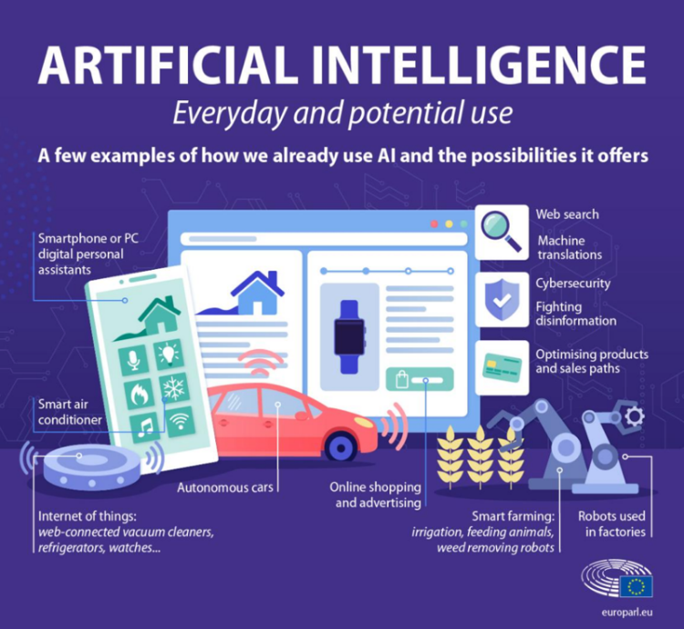

Which ones, in your opinion, offer potential for plurilingual and intercultural education? Explore in a group how this potential could be exploited to implement pluralistic approaches in your teaching contexts.

**Step 2 - Using digital resources to facilitate the use of pluralistic approaches**

***Learning to manage information on the internet and developing intercultural awareness***

**2.a.**

Read the [following definition](https://www.treccani.it/vocabolario/filter-bubble_res-b92bdbdc-89c2-11e8-a7cb-00271042e8d9_%28Neologismi%29/), taken from the Treccani Online dictionary:

**Filter Bubble**

*“The virtual environment that each user builds on the Internet through their preferred selections, characterised by low permeability to novelty and a high level of self-referentiality. Let's now try to apply this concept to the stories we read every day on social media, to what Facebook offers us daily in the news feed, to the news that is transmitted to us through a process that experts have called the 'filter bubble': in short, Facebook only shows us on the homepage what it considers to be important, the statuses and photos that we might 'like,' the content that we would most easily 'like' (in fact), excluding what is different, that we might not approve of or that wouldn't interest us. It is literally a bubble that prevents us from looking beyond it. (Eugenio Maddalena, Huffington Post.co.it, 28 avril 2016 Le Blog) - Only 5% of adult Facebook users say that they read opinions on the social network that are very different from their own. This is essentially the filter bubble, the content bubble, measured by the company Morning Consult.”* (Federica Colonna, Corriere della sera, 30 avril 2017, La Lettura, p. 9). (our translation)

Do you think that helping learners to develop the ability to manage information consciously and critically could contribute to the development of intercultural competence?

Discuss this with your colleagues.

***Learning to design activities to foster the attitudes and skills described in the FREPA.***

**2.b.** What types of activities can you offer your learners to develop the ability to distance themselves as described below (FREPA)[6] from the information circulating on the Internet? ***Une image contenant texte, capture d’écran, Police
***

***Exploiting the potential of online teaching resources for pluralistic approaches***

**2.c.** Click [here](https://en.edilic.org/autres-liens-bandes) to view a web page.

Based on the brief description of each site and/or project, choose one to explore, and select an activity that you consider appropriate for your teaching context.

(cf. [FREPA](https://carap.ecml.at/Pluralisticapproaches/tabid/2681/language/en-GB/Default.aspx))

|  |  |  |
| --- | --- | --- |
| Pluralistic approaches | Site | Activity |
| Awakening to languages |  |  |
| Intercomprehension between related languages |  |  |
| Integrated didactic approach to languages |  |  |
| Intercultural approach |  |  |

Based on your context, explain to your colleagues the reasons for your choice.

**Step 3 – Critical reflection on AI, pluralistic approaches and teachers’ roles**

**3.a. *Knowing how to make critical use of the potential of generative AI***

Choose two of the following texts, read them individually and identify some of the key principles and concepts which, in your opinion, underpin the design of educational activities within the framework of pluralistic approaches:

* The General Presentationof the project *Developing teacher competences for pluralistic approaches.* (a pdf version of the whole text is downloadable)
* [The presentation of pluralistic approaches to languages and cultures on the FREPA website](https://carap.ecml.at/Pluralisticapproaches/tabid/2681/language/en-GB/Default.aspx)
* [the Recommendation to member states on **The Importance of Plurilingual and Intercultural Education for Democratic Culture** (Recommendation CM/Rec (2022)1)](https://rm.coe.int/prems-013522-gbr-2508-cmrec-2022-1-et-expose-motifs-couv-a5-bat-web/1680a967b4ECML#:~:text=This%20recommendation%20aims%20to%20give,and%20participation%20in%20democratic%20culture)
* a text produced for the Platform of resources and references for plurilingual and intercultural education of the Council of Europe, [*Plurilingual and intercultural education as a project*](https://rm.coe.int/plurilingual-and-intercultural-education-as-a-project-this-text-has-be/16805a219f)

1. Together with your colleagues, draw up a joint list of the key principles and concepts selected.
2. Connect to a Generative Artificial Intelligence system such as [ChatGPT](https://openai.com/), [Copilot](https://copilot.microsoft.com/) or [Gemini](https://gemini.google.com/) and ask it to answer questions about some of the principles and concepts you have selected.
3. Once you have the answers, compare them with the key principles and concepts you have identified in the documents analysed.

Discuss the following aspects with your colleagues:

- The clarity, accuracy and comprehensiveness of the answers

- The transparency of the sources on which the system based its answers

- The possible manifestation of any bias (cognitive or discriminatory) in the answers provided.

**3.b.** ***Becoming aware of the teacher's role in implementing pluralistic approaches in a digital society***

Read the following text:

“*And technology must never replace well-trained human teachers who guide their students in their holistic  development,  as  individuals  and  members  of  society.  To unlock  the  promise  of  digital  opportunities  for  all,  we  must  steer  technology  in  education  on  our  terms,  guided  by  the  principles  of  inclusion, equity, quality and accessibility”*

Stefania Giannini UNESCO Assistant Director-General for Education, [*The Unesco Courier*](https://unesdoc.unesco.org/ark:/48223/pf0000387029_eng.).

Comment on it in the light of the principles and values of pluralistic approaches referred to in Dimension 1 of the *Reference framework of teacher competences for pluralistic approaches* - FTC-PA

**References**

Beauchemin, D., Monty M.-Ch. (2022) La discrimination en intelligence artificielle est-elle

suffisamment encadrée ? HAL Id: hal-03736828 <https://hal.science/hal-03736828v2>

Bocquet, F. (2020). L’éducation, la formation des enseignants et l’apprentissage de l’intelligence artificielle : un aperçu des questions clés. *Éducation, numérique et recherche*. Consulté le 18 avril 2024, à l’adresse <https://doi.org/10.58079/o347>

Vuorikari, R., Kluzer, S. and Punie, Y., DigComp 2.2: The Digital Competence Framework for Citizens - With new examples of knowledge, skills and attitudes, EUR 31006 EN, Publications Office of the European Union, Luxembourg, 2022, ISBN 978-92-76-48883-5, doi:10.2760/490274, JRC128415. <https://publications.jrc.ec.europa.eu/repository/handle/JRC128415>

Cavalli, M., Coste, D., Crişan, A., & Van de Ven, P. H. (2009). Plurilingual and intercultural education as a project. *Languages in Education*. <https://rm.coe.int/plurilingual-and-intercultural-education-as-a-project-this-text-has-be/16805a219f>

de la Higuera, C. (2019). *A report about Education, Training Teachers and Learning Artificial*

*Intelligence: Overview of key issues.* Knowledge 4 All Foundation Ltd (K4A).

<https://www.k4all.org/wp-content/uploads/2019/11/Teaching_AI-report_09072019.pdf>

de la Higuera, C., Iyerest, J. (2024) *IA pour les enseignants : un manuel ouvert* 2024 sous licence Licence Creative Commons Attribution 4.0 International. <https://pressbooks.pub/iapourlesenseignants/>

DNE-TN2 (2024). Intelligence artificielle et éducation : Apports de la recherche et enjeux pour les politiques publiques (édition 2024) [Billet]. Éducation, numérique et recherche. <https://edunumrech.hypotheses.org/10764>.

Giannini, S. (2023)**.** *Intelligence artificielle générative dans l’éducation*. UNESCO, https://unesdoc.unesco.org/ark:/48223/pf0000385877_fre

Iannella, A., Labruna, T., Santercole, L. e Viti, B. (2021). Reclaiming Conversation: Introducing

a Novel Approach to Using Conversational AI at School. In G. Trentin (ed.), *Conversational*

*Agents as Online Learning Tutors,* 119-152. Nova Science.

Ji, H., Han, I. & Ko, Y. (2023) A systematic review of conversational AI in language education:

focusing on the collaboration with human teachers, *Journal of Research on Technology in*

*Education*, 55:1, 48-63, <https://doi.org/10.1080/15391523.2022.2142873>

*Les Compétences clés pour l’éducation et la formation tout au long de la vie – Un cadre de référence européen.* (2007). Luxembourg : Office des publications officielles des Communautés européennes.

[*https://competencescles.eu/sites/default/files/attachements/keycomp_fr.pdf*](https://competencescles.eu/sites/default/files/attachements/keycomp_fr.pdf)

Christian OLLIVIER, Catherine JEANNEAU, Teija NATRI, Elke HÖFLER, Ulrike SZIGETI, Catherine CAWS, Marie-Josée HAMEL (2023), *Digital citizenship through language education*, Council of Europe (European Centre for Modern Languages), Graz, available at [www.ecml.at/elangcitizen](https://www.ecml.at/elangcitizen), accessed 25 Aug 2024.

*AI competency frameworks for school students and teachers*UNESCO.

<https://www.unesco.org/en/digital-education/ai-future-learning/competency-frameworks>

1. Thanks to Alessandro Iannella for his proofreading and contribution to the final version of this sequence.
2. European Commission, Directorate-General for Education, Youth, Sport and Culture, Key competences for lifelong learning, Publications Office, 2019, <https://data.europa.eu/doi/10.2766/569540>
3. In this respect, the *[European Digital Competence Framework for Citizens](https://joint-research-centre.ec.europa.eu/digcomp_en)* (DigComp) identifies 5 areas of competence: information and data literacy, communication and collaboration, digital content creation, safety, and problem solving. Artificial Intelligence (AI), defined by the European Parliament as “the ability of a machine to display human-like capabilities such as reasoning, learning, planning and creativity”.
4. From September 2024, it will be possible to consult the AI framework of competences for teachers and learners developed by [UNESCO](https://www.unesco.org/en/data-center).
5. Activity proposed in : Colin de la Higuera et Jotsna Iyerest (2024) *IA pour les enseignants : un manuel ouvert* 2024 sous licence Licence Creative Commons Attribution 4.0 International, p. 19. <https://pressbooks.pub/iapourlesenseignants/>
6. [FREPA, 3.2 Attitudes](https://carap.ecml.at/Portals/11/CARAP-EN_Attitudes_38-49.pdf?ver=2014-12-05-100045-890) Section III. Attitudes / stances of: questioning – distancing – decentring – relativizing (A 9 to A 12). In [*L’IA pour les enseignants : un manuel ouvert*](https://pressbooks.pub/iapourlesenseignants/)(2024) (in French), you can find a few tips to guide your learners in searching the web, in particular: Part II Searching for information. [Chapter 7](https://pressbooks.pub/iapourlesenseignants/chapter/search-engines-part-1/), [Chapter 8](https://pressbooks.pub/iapourlesenseignants/chapter/search-engines-part-2/), Search engines 