WORKSHEET B
Title Branching approach
Objective(s) To think about the advantages of the flexible branching approach proposed by the CEFR for the definition of differentiatied curricula
Keywords levels – distinction and specification of descriptors – degree of refinement and
customisation
Ref to the Guide  IV. 9 | Ref to the CEFR  3.4, 3.5, 3.6
To complete this worksheet you need... examples of European Portfolios of Languages, A3 or big format sheets, felt-tip pens, cards, drawing pins.
Task A ()

Step 1

Read this example from CEFR (p. 31):

The 1994–5 Swiss National Science Research Council Survey, which developed and scaled the illustrative
descriptors, identified a band of language use, limited to the performance of isolated tasks, which can be presupposed in the definition of Level A1. In certain contexts, for example with young learners, it may be appropriate to elaborate such a ‘milestone’. The following descriptors relate to simple, general tasks, which were scaled below Level A1, but can constitute useful objectives for beginners:
• can make simple purchases where pointing or other gesture can support the verbal reference;
• can ask and tell day, time of day and date;
• can use some basic greetings;
• can say yes, no, excuse me, please, thank you, sorry;
• can fill in uncomplicated forms with personal details, name, address, nationality, marital status;
• can write a short, simple postcard.
The descriptors above concern ‘real life’ tasks of a tourist nature. In a school learning context, one could imagine a separate list of ‘pedagogic tasks’, including ludic aspects of language – especially in primary schools.

Then observe this example of differentiation of the descriptors proposed for work with an ELP for young learners (My Languages Portfolio. European Language Portfolio – Junior version : revised edition, CILT (2001, 2006)) and relate them to the example above:
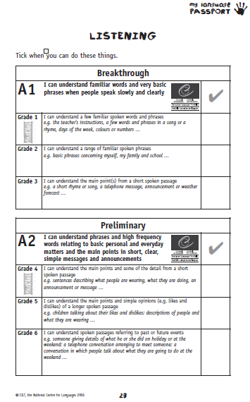

Step 2

Now consider one fairly low level of the scale, either for young learners or for beginning adults, and prepare ‘differentiated’ descriptors for the different objectives (you can decide whether you want to refer to a unique task, to one competence, to one communicative activity or to a combination of these elements).
If you consider it more useful to turn to an advanced level, feel free to do so.

Task B ()

Looking at pages 33, 34 and 35 of the CEF, Chapter 4 (paragraph 9) of the Guide and Card A, prepare the branching that you consider best for your own specific context.
You might decide to develop at least a part of the objectives of each sub-level.

