WORKSHEET A
Title Situation and situational context

Objective(s) To become aware of the relationship between the communication situation and the use of language
Keywords Situation - context – speech act - domain
Ref to the guide  II | Ref to the CEFR  4.1, 4.1.2
Task

Step 1 ()
Read this extract from the CEFR and think about the notion of “situation". Note down your reflections with the help of key words:
"It has long been recognised that language in use varies greatly according to the requirements of the context in which it is used. In this respect, language is not a neutral instrument of thought like, say, mathematics. The need and the desire to communicate arise in a particular situation and the form as well as the content of the communication is a response to that situation." (CEFR, 4.1)

Step 2 ()
With reference to chapter II of the Guide (par. 2), discuss how the situation ties to the context. Moving from the variables useful to understand and describe a situation, provide concrete examples.

Step 3 ()
Bearing in mind the graphical representation below, consider the following speech acts and envisage different ways to accomplish them within different situations.

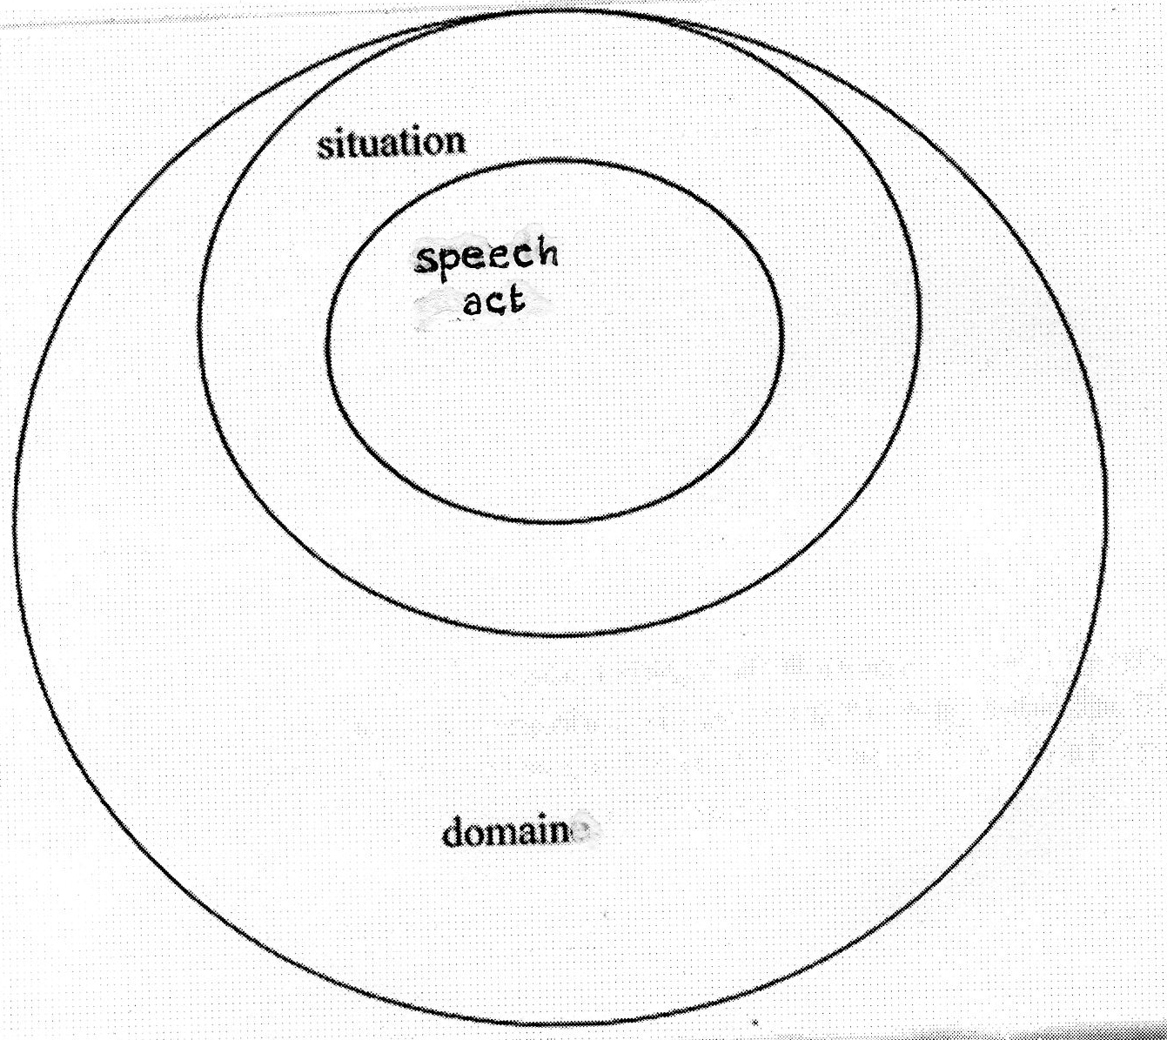
Give an oral account of something
Share impressions
Reply to a phone call
Participate in a conversation on the bus
Make a presentation
Ask for information
Listen to a doctor’s advice and respond
Explain where you feel unwell and reply to questions about this

In the light of your reflection, bear in mind the different useful elements to describe situations in the different domains, namely: place, objects, time, institutions, social actors and their roles, themes, procedures, events, texts. Make use of table 5 in the CEFR.

