Using Wikis for language teaching

A Wiki is a collaborative website that can be edited by visitors to the site, allowing users to easily create and edit webpages collaboratively.

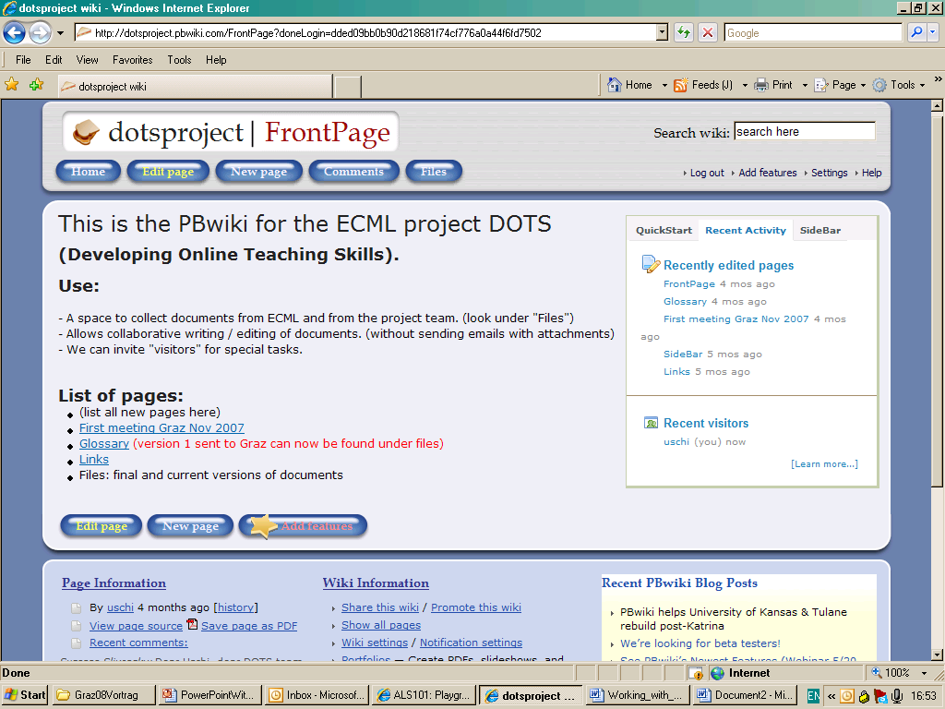

This DOTS activity is designed to guide you through basic steps of understanding and using wikis, with practical examples of wiki tasks for language teaching, and evaluative exercises and reflections on the usefulness of wikis.

The DOTS activity is built in a modular format so you can start it at any point; you can choose to do just one part or follow the whole training sequence. Don’t forget, at the end, to evaluate and reflect on what you have done and to share your findings with colleagues in the Moodle workspace.

What can I do in this DOTS activity? | Where can I find the information? (click on the link to go to the section)
Part 1
Find out what wikis are and how people use them. | A. What is a wiki?
Consider some pedagogical reasons for using wikis in language teaching and learning. | B. Why would I want to use wikis in my teaching?
Part 2
Learn about how wikis work and find some free wiki tools on the web. | C. Some basic functions of wikis
Consider what I need to keep in mind when using wikis in my teaching.  Explore some pedagogical issues.  One sample activity and further reading. | D. Pedagogical considerations and sample activity
Find out about tasks suitable for beginners.  Find ways of encouraging students to contribute. | E. Practical suggestions
Part 3
Check my understanding of wikis using a quiz and questions. | F. Check your understanding
Think back over what worked and what didn’t work (in the DOTS activity and/or in my use of this tool). | G. Reflect!
Check out what other teachers do with wikis.  Discuss and evaluate ideas and activities in the DOTS forum.  Create additional tasks and share them with colleagues online. | H. Explore and share!
Learn about students’ privacy online when using public wikis.  Learn about creating wiki privacy settings to protect your students. | I. Protecting students’ privacy

PART 1

What is a wiki?

“Wiki wiki” is Hawaiian and means “very quick”.

If Wikipedia is the only wiki you know, you might want to find out more before starting to use wikis in your language teaching. You can love or loathe the basic idea behind Wikipedia – that a community of people can generate more knowledge more quickly than any commercial publisher – but wiki-technology has a lot more to offer for language teachers and learners.

Wikis are simple webpages with only two functionalities, namely reading and editing. They can be written and updated very quickly using text editing. The skills users need to write and update a wiki are comparable to simple text production using word processing software, e.g. Word. Wikis also allow the import of images and other media files into the webpage.
Because the wiki is so simple, wikipages can be edited within seconds and made available to the next user. This makes them ideal collaborative writing and reading spaces on the web.

Why would I want to use wikis in my teaching?

Wikis fit in well with the practice of constructivist teaching and learning. Basically, if you believe that students learn better by actively participating in the learning process, generating their own “theories” about how language works, and practising language in collaboration with peers, then wikis are a tool you cannot neglect.
Wikis support this kind of collaborative learning as they allow users to develop their own rough version of a text (or theory) which can then be updated and edited by others. Writing becomes a collaborative process, and every contributor becomes at once a critic of other entries, an author or co-author and a reader. Checking, correcting and up-dating the wiki entries can be a potentially valuable way of learning to write in a foreign language, with help and support from peers (rather than solely from the teacher), and also with a ready audience.

A few good reasons for using wikis in language teaching:

- They are quick and simple to use and allow collaboration, independently of time and space, via easily accessible online spaces.
- They offer authentic writing practice.
- They allow students to be actively engaged in reading and writing: correcting, editing, and up-dating.
- They teach students the skills of collaboration alongside language skills.
- They present the student writers with a ready audience and critics.
- They are flexible enough to incorporate multi-media content (without clogging up your email).
- They can potentially be shared with a wider audience and made public (but see F below).
- Most students will already know at least one wiki (“Wikipedia”).
- Wikis can help students become better organised because they can store their work in folders.

In addition, wikis can also support teachers in their classroom management.
Of course, wikis are more suitable for some tasks and pedagogies than for others. To find out more about suitable tasks, go to section D below.

PART 2

Some basic functions of wikis

This section provides details on the following functions of a wiki:
Setting up a wiki
Creating and linking pages
Entering content
Sharing content
Comparing versions
Links to free wiki providers

Setting up a wiki

To set up a wiki, you will need a wiki provider. You do not need your own webpage, as the wiki will be hosted on the wiki provider’s site.

In Moodle, setting up a wiki is as simple as adding any other activity:

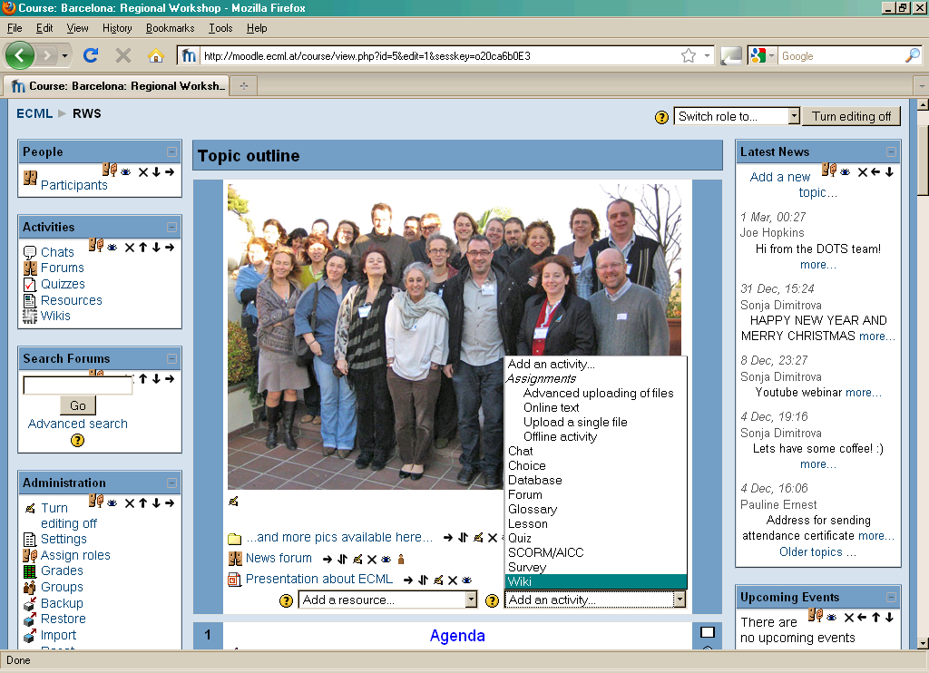

To combine theory with practice, we’ve set up a practice wiki on the Moodle workspace: http://moodle.dots.ecml.at/

Creating and linking pages

To link to an existing page within the wiki type its title inside single or double square brackets: [[Page title]].
To create a new page in an existing wiki, just add a CamelCase* word or a word in [[double square brackets]].
*CamelCase is a word with a capital letter at the beginning and in the middle.

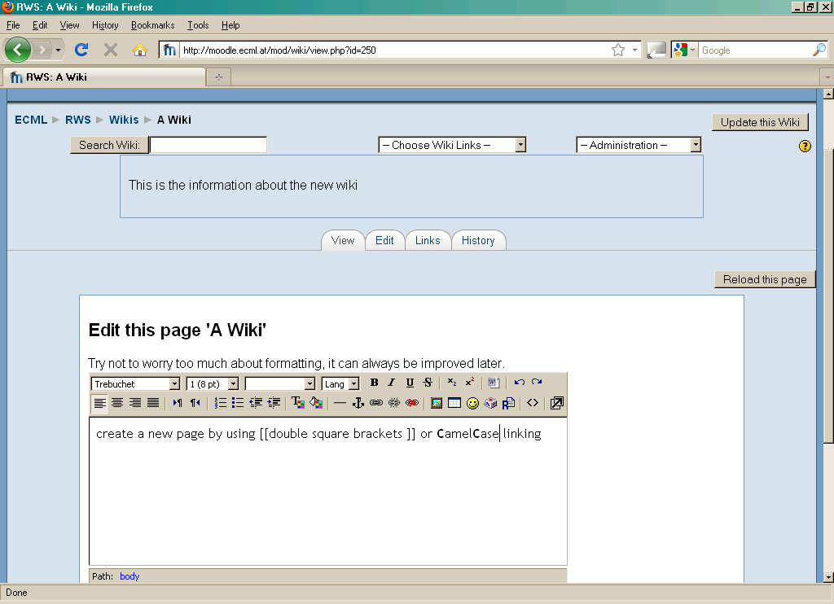

Entering content

Entering content in a wikipage is a simple as writing in a Word document.

Set the wiki to “editing mode” by clicking on the “Edit” tab. A window similar to the following will appear.
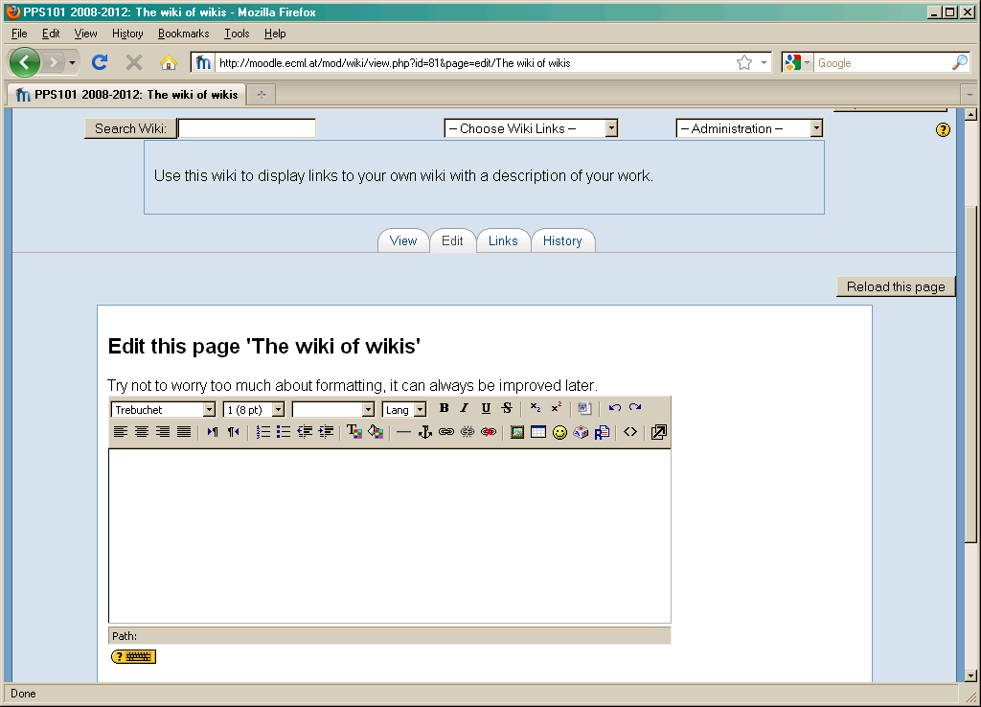

You can type within the window and add text as normal by typing or copy-paste. Layout options are limited and some text may not appear exactly as in the document you have copied it from.

Sharing content

To share any text you have entered, you must save the new edits by clicking on the “save” button.

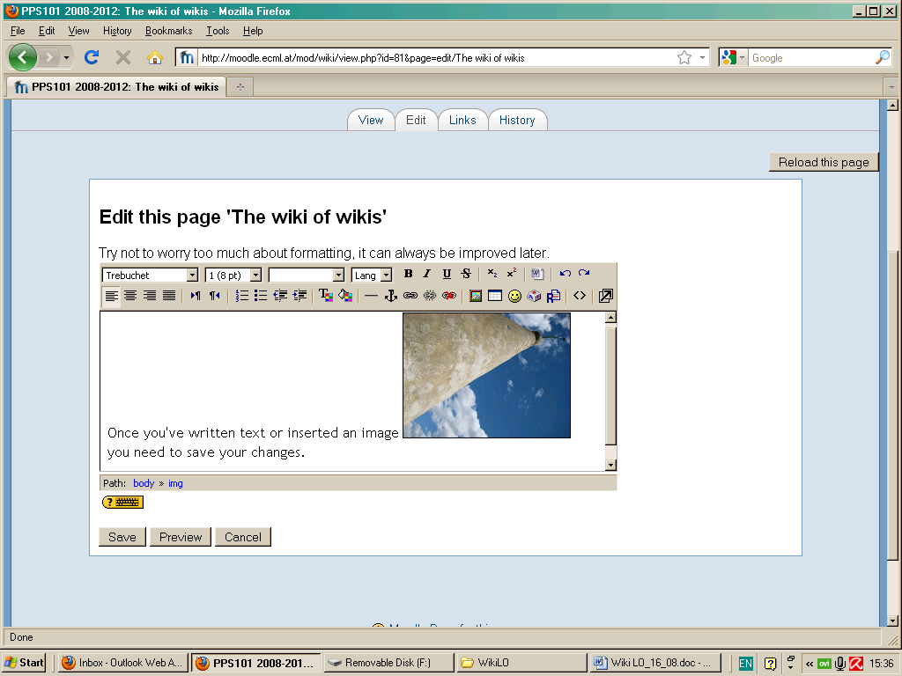

You can always go back and edit your entries when they need correcting or updating by following the same steps as for “entering content”.

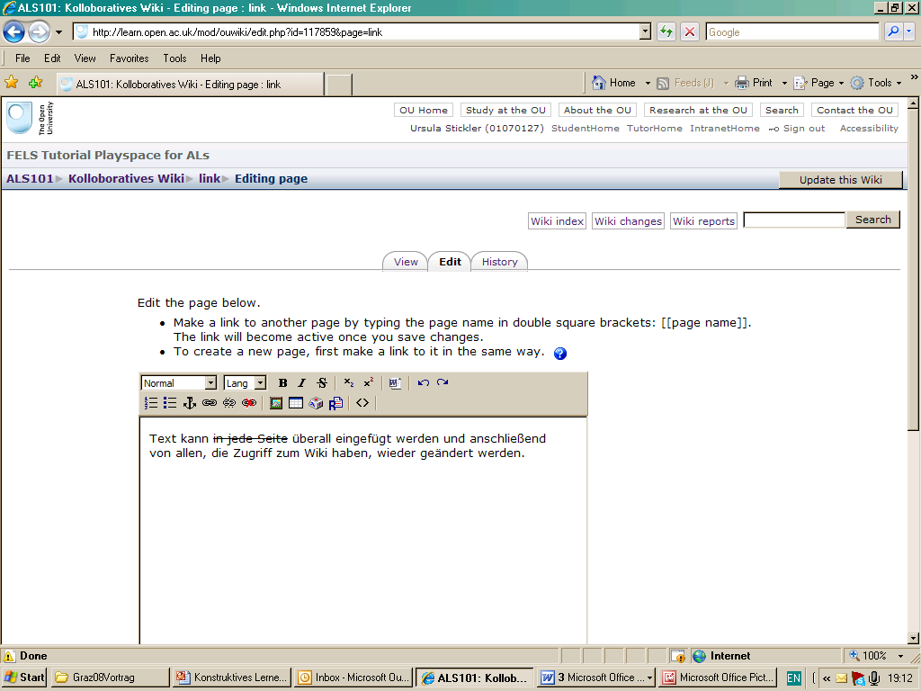

Everyone who has access to the wiki can add to it and change existing entries.

You can also use the public MediaWiki Sandbox to practise your editing skills:
http://www.mediawiki.org/wiki/Sandbox .

Comparing versions

Most wikis will allow you to compare versions of edited text by showing the original version alongside the changes entered by users. Wikis also store a history of every edit, so users can follow up who has made which changes to the wiki text and when.
This can be very useful for teachers, if they need to evaluate groupwork, for example.

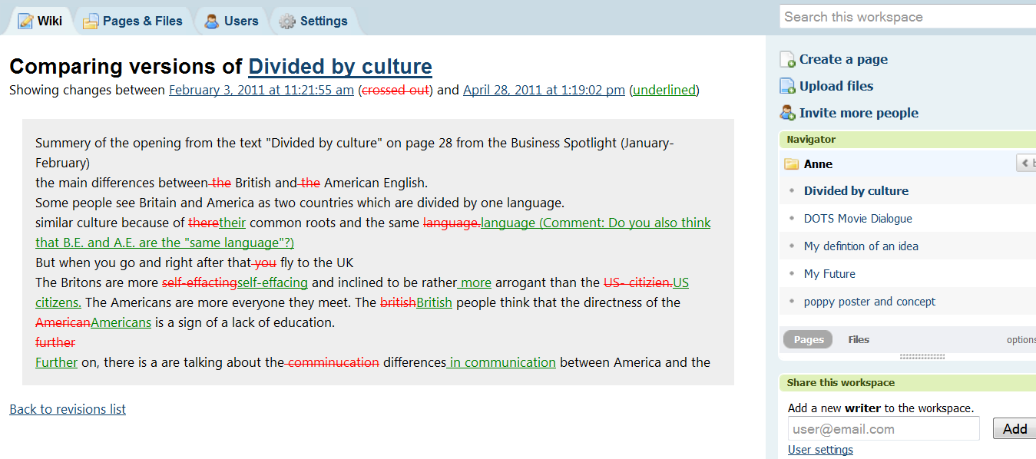

This is a sample of a PBworks wiki with editing changes.

Free wiki providers

Below is a list of wikis freely available to educators. If you have your own favourite free wiki provider, please add it on the Moodle workspace with a very brief description.

Moodle wiki:
http://docs.moodle.org/en/Wiki_module
If you already have a Moodle workspace, wikis are included as one of the possible “modules”. Add a wiki to your course by clicking the “add new activity” tab and choose “wiki”.

Wikispaces:
http://www.wikispaces.com/site/for/teachers
Free to educators; commercial version available for business.

PeanutButter (PBworks) wiki:
http://pbworks.com/
PBworks also offers free training sessions.

MediaWiki:
http://www.mediawiki.org/wiki/MediaWiki
This is the software behind Wikipedia (hence the familiar look). MediaWiki offers free software for educators and is very scalable. However, you need a server space to host your own wiki. Only suitable if you are planning a HUGE wiki.

Pedagogical considerations and sample activity

This section provides details on the following points:

What do I need to keep in mind when using wikis in class?
Explore some pedagogical issues
Encounter two sample activity plans involving wiki work
Find out about tasks suitable for beginners
Further reading

What do I need to keep in mind when using wikis in class?

Wikis are especially suitable for reading and writing. They are less useful for listening activities.
Because most wikis focus on writing, students need to already have a minimum level in the L2 and be able to produce some words, phrases, or sentences.

Explore some pedagogical issues

Benefits and Drawbacks of wikis

++++++++
Wikis are suitable for …
- group work
- telecollaboration
- students working on their own or independently
Wikis can support …
- motivation
- group cohesion
- reflective learning
- “ownership” of content

---------------

Wikis are less suitable for …
- beginners (lack of vocabulary)
- competitive groups

Wikis can be used for …
- assessed work
(identify author through history function)
- authentic authorship (e.g. real Wikipedia entries – only for quite advanced learners)

For suggestions on encouraging wiki participation, see section E below.

Encounter two sample activity plans involving wiki work

This wiki activity is part of a language course for intermediate to advanced students working at a distance. It can also be used as a homework task.
Start a wiki page with the title of a story. You can also indicate the genre or style (e.g. fairy tale, science fiction).
Start the first sentence but leave it unfinished (this is called a “seedcorn”).
Invite your students to continue the story with their own ideas and in their own style. Suggest a minimum number of sentences depending on the language level of your students.
Encourage students to write directly into the wiki page. If they write in a word document first and then copy and paste into the wiki, the story might have moved on in the meantime, and their contribution might confuse the storyline.
Set a deadline when the story will be finished and the wiki closed.
You can offer to correct language mistakes and ask students to look at “changes” in the wiki history to reflect on their errors.
This task is not suitable for classroom work as attempting to edit the same wikipages at the same time by multiple users leads to lockdown. Only one user can make changes at any one time.

The second activity plan is part of an advanced language class for business English, the students are familiar with working on wikis.

Introduction

Your boss is preparing for a series of business trips. Before she goes, she wants to know more about the countries she is visiting and their ways of doing business.

Instructions

1. Choose a country and find out more about

- business hours

- socializing

- meetings

- cultural differences
and any other points you think are important to know for doing business successfully in this country.
You should use the Internet for finding appropriate information.

2. Write a short report on a wiki page that contains your findings and provides useful advice and post it online. Don't just copy and paste information from the Internet!

Deadline

The task must be completed until the lesson.

N.B: If somebody else has chosen the same country that you want to write about, make sure that you don't write the same! Rather, the reports should complement each other.

Find out about tasks suitable for beginners
Wiki tasks for beginners:
Even students who have limited language skills can use wikis in a collaborative way. They can:
- collect vocabulary in the L2
- write language learning tips in the L1
- collect links to interesting L2 websites and comment on them in the L1
- share pictures from travels to the L2 country

Further reading
Technical guidelines and introductions:
Cunningham, Ward; Leuf, Bo (2001) The Wiki Way: Quick Collaboration on the Web. Reading, Mass: Addison-Wesley
O'Reilly, Tim (2005), What Is Web 2.0. Design Patterns and Business Models for the Next Generation of Software. In: http://oreilly.com/web2/archive/what-is-web-20.html [25.01.2009].
Robb, Thomas N. (2004), Moodle: A Virtual Learning Environment for the Rest of Us. In: TESL-EJ: Teaching English as a Second or Foreign Language, Vol. 8/ 2, 8.
Successful wiki use in other academic subjects:
Augar, Naomi; Raitman, Ruth; Zhou, Wanlei (2004), Teaching and Learning Online with Wikis. Paper Presented at the 21stASCILITE Conference, Perth, Australia. In: http://www.ascilite.org.au/conferences/perth04/procs/augar.html [06.08.2009].
Educause Learning Initiative (2005), 7 Things You Should Know About Wikis. In: http://www.educause.edu/LibraryDetailPage/666?ID=ELI7004 [28.05.2008].
Engstrom, Mary E.; Jewett, Dusty (2005), Collaborative Learning the Wiki Way. In: TechTrends, Vol. 49/ 6, 12-15.
Glassman, Michael; Kang Min Ju (2011), The logic of wikis: The possibilities of the Web 2.0 classroom. In: International Journal of Computer-Supported Collaborative Learning, article preview, online Jan 2011, n.p.
Larusson, Johann Ari; Alterman, Richard (2009), Wikis to support the " collaborative " part of collaborative learning. In: International Journal of Computer-Supported Collaborative Learning, Vol. 4, 371-402.
Zorko, Vida (2007), A Rationale for Introducing a Wiki and a Blog in a Blended-Learning Context. In: CALL-EJ Online, Vol. 8/ 2 (Online: http://www.tell.is.ritsumei.ac.jp/callejonline/journal/8-2/zorko.html [31.05.2011].
Wikis in language classes (general introductions):
Brandl, Klaus (2005), Are you ready to ‚Moodle'? In: Language Learning & Technology, Vol. 9/ 2, 16-23.
Godwin-Jones, Robert (2003), Emerging Technologies: Blogs and Wikis: Environments for On-line Collaboration. In: Language Learning & Technology, Vol. 7/ 2, 12-16.
Wikis in language classes (reports on successful projects):
Lund, Andreas (2008), Wikis: A Collective Approach to Language Production. In: ReCALL, Vol. 20/ 01, 35-54.
McDonald, Kurtis (2007), Wikipedia Projects for Language Learning. In: CALL-EJ Online, Vol. 9/ 1 (Online: http://callej.org/journal/9-1/mcdonald.html [31.05.2011].

Practical suggestions

Here are some tips from experienced wiki users.
The basics:
- make sure all students know how to access the wiki
- explain the principle of “collective knowledge”, i.e. the sum of all contributions will make a better wiki
- set ground rules but also allow creativity
- explain that editing a wiki is not about “correcting” somebody else’s work

Seven Steps towards successful wikis

Step 1:
Show students an example of a successful wiki to motivate them.
Step 2:
Allow students to choose their own tasks, agreed upon collaboratively, in order to stimulate and maintain their interest.
Step 3:
Seedcorn the wiki. Writing on an empty page is always difficult, so start the wiki yourself with a short entry or a set of linked pages.
Step 4:
Set clear guidelines and time limits for all tasks but allow the wiki to stay open even after the tasks are officially completed.
Step 5:
During the wiki task phase, check regularly to prevent excess corrections and “wiki-wars” (i.e.: two students or two groups fighting about editing and reverting to previous versions).
Step 6:
Comment on the wiki entries. and encourage writing, editing and linking.
Step 7:
Celebrate the completion of a task, e.g. by publishing the wiki content to another class or group, inviting their comments.

PART 3

Check your understanding

 | I can do this  ☑ | I would like to look at that again
Describe wikis to others (e.g. colleagues) briefly | □ | Click here.
Give three reasons for using wikis in language teaching | □ | Click here.
Describe and use basic features of wikis | □ | Click here.
Understand the pedagogical benefits of using wikis in your teaching | □ | Click here.
Understand practical considerations around setting up a wiki | □ | Click here.

If you feel you need more information on any point, go back to the equivalent section in this document.

You can also check your understanding online in a Moodle Quiz on the DOTS workspace: http://moodle.dots.ecml.at/

Reflect!

Here are two possible ways of guiding your reflection. Select the questions that are the most relevant for you.

I. Think about the following issues concerning the activities in this section:
(To do when you have finished this activity sequence)

 | 
- Has this worksheet given you enough information/confidence to try out a wiki?  - Will you be able to take this worksheet and implement the suggestions straightaway? If not, what else do you need? | - Go to the DOTS forum, find out what other people use wikis for.  - Discuss your planned use of wikis in the DOTS forum to get helpful tips from experts and teachers.
* Credit for illustrations: fotographic1980/FreeDigitalPhotos.net

II. Reflect on the following questions concerning your use of wikis as a tool and a resource for your teaching:
(To do after your first attempt at using wikis in your teaching / your class)
- Is this tool/resource relevant for  your course?  - Does it fit with your teaching approach and aims?  - Does it help bring more linguistically and culturally accurate material?  - Is this tool relevant for your learners  (age, level, interest, …)  - Is the level appropriate for the intended users?  - Can the tool accommodate learners with a range of levels? If so, how?  - Is the language used in the instructions and reference material suitable?  - For which skills and activities do you think wikis are best used?  - Does it allow for interactive activities to maintain student interest?  - Are there a variety of exercises and tasks that can be built with this tool?  - How user-friendly is the tool?  - Is the wiki clear and easy to use for your students?  - Does writing in a wiki necessitate some training activities for your students?  - Technical considerations  - What equipment and technical support is required?  - Is this available in your institution?  - What on-going costs are involved (e.g. server space)? | - After you’ve used wikis in your class, share your experience in the DOTS forum available at: http://moodle.dots.ecml.at/mod/forum/view.php?id=38.  - Share suggestions for new uses of wikis in the DOTS forum available at: http://moodle.dots.ecml.at/mod/forum/view.php?id=38.  - When you have developed a wiki task, share it with colleagues on the DOTS wiki available at: http://moodle.dots.ecml.at/mod/wiki/view.php?id=24.  Our forums and wikis are multilingual, so whatever the language you teach, please upload your material and you can be sure that you will be helping less experienced colleagues.  - Share what you have done with  your colleagues in your institution.  Here is the place to brag about it!  Don’t hide your light under the  bushel.
* Credit for illustrations: fotographic1980/FreeDigitalPhotos.net

Explore and share!

Here are some suggestions on where to go from here. Please feel free to add your own suggestions to this section on the DOTS workspace at http://moodle.dots.ecml.at/ – they can be your own lesson plans, ideas, problems, etc.

- Talk to your students about wikis. Do they like them? Do they see a benefit in doing them? If you have different opinions in your class, you can discuss the pros and cons and perhaps link them to different learning styles. Emphasise the relevance of realistic self-evaluation for progress and independent learning.

- Talk to your colleagues about wikis. Do they use them? Have they created any new wiki task themselves? Perhaps you can work together to build your own repository of ideas which can be adapted to different topics, levels and languages.

- Discuss wiki tasks in the DOTS forum available at: http://moodle.dots.ecml.at/mod/forum/view.php?id=38 and find new ideas for language specific use of wikis. Do other teachers use wikis differently? Have they reported any problems?

Protecting students’ privacy

Most educational wikis allow different setting for access. You can limit the people who can see what is written in your wiki to a specific group, either by setting a password for the wiki (and only giving this to your students) or by restricting access through email invitation. The exact method will depend on your wiki provider.
For discussions of privacy issues you can go online to the Privacy forum available at: http://moodle.dots.ecml.at/mod/forum/view.php?id=29.

This work is licensed under a Creative Commons Attribution 3.0 Unported License.
Attribution: Original activity from DOTS, Developing Online Teaching Skills, Bite-size Training for Language Professionals. Medium-term project 2008-2011 – ECML. http://dots.ecml.at/.

