Using Moodle quizzes for language teaching

You can create quizzes as self-assessment tools for students as well as part of course assessment.

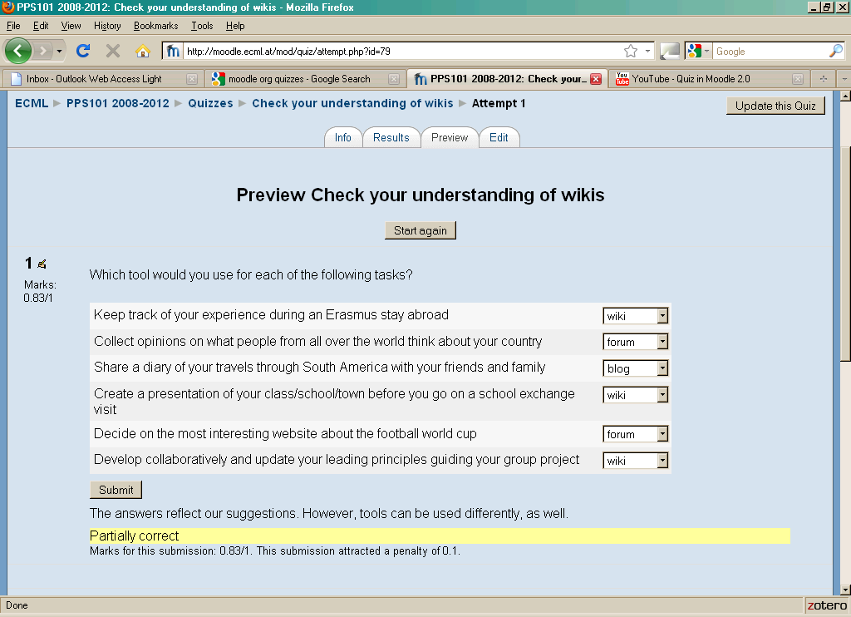

This DOTS activity discusses how the use of Moodle quizzes can help reduce the workload for teachers during the busy teaching time and give learners almost instant feedback on their individual performance. This DOTS activity is built in a modular format, so that you can choose to do just one part of it or the whole training sequence – depending on your needs and the time you have available.

What can I do in this DOTS activity? | Where can I find the information?  (click on the link to go to the section)
Part 1
Find out about what Moodle quizzes are and how people use them. | - What is a Moodle quiz?
Think about some pedagogical reasons why I would want to use Moodle quizzes for my teaching. | - Why would I want to use Moodle quizzes in my teaching?
Part 2
Learn about how people use Moodle quizzes and about some question types of Moodle quizzes. | - Some basic functions of the Moodle quiz module
Consider what I need to keep in mind when using Moodle quizzes for my teaching.  Explore some pedagogical issues and read one sample activity. | - Pedagogical considerations and sample activity
Find out about some easy and more advanced technical steps that can help me in using Moodle quizzes in my teaching. | - Practical suggestions
Part 3
Check my understanding using a quick and easy checklist | - Check your understanding
Think back over what worked and what didn’t work (in the DOTS activity and/or in my use of this tool) | - Reflect!
Check out what other teachers do with Moodle quizzes.  Discuss and evaluate ideas and activities in a DOTS forum.  Create additional tasks and share them with colleagues online. | - Explore and share!
Explore different settings of quizzes used for different purposes, e.g. exams or revision. | - Protecting students’ privacy.

Part 1

What is a Moodle quiz?

In this section you will find out what Moodle quizzes look like and how people use them. If you decide to use a quiz for your teaching, it will be helpful to know some basics.

Particularly in distance learning, independent study and blended teaching contexts, the frequent self-assessment of progress is invaluable. Online quizzes are an easy and sound way of offering students a tool for self-assessment. More and more, online quizzes are also used as an integral part of course assessment.

Moodle is a free, open source software, used for course management, it can even build a whole course or series of courses online. For more information on Moodle see the DOTS activity Using the Moodle platform in class (available at: http://moodle.dots.ecml.at/).
Moodle offers various modules (“activities”) with different functionalities for online teaching and learning. One of these modules is called the “quiz module”. In the quiz module, you can write questions, provide answers and give feedback on the learner’s performance. Learners can be given various levels of support to increase their chances of coming up with the correct answers. The quiz questions can be combined in sets to form a complete “quiz”.

Moodle quizzes are fully integrated into the Moodle VLE and can be presented as part of it. There are other quiz formats, e.g. HotPotatoes, that allow you to design and present stand-alone quizzes for your own website. The general, pedagogical principles of this activity will still be relevant for these types of quizzes, however, any technical information would need to be adapted for different applications.

The content of a Moodle quiz depends entirely on you and can be as light-hearted or as serious as you make it. Some institutions use Moodle quizzes as part of their formal assessment, and learners get marks on their performance. In other cases, the Moodle quiz is an optional activity for students to check their progress independently.

You can download Moodle from http://moodle.org/. If you are already using a Moodle VLE, you can activate the Moodle module when you are in editing mode.

Why would I want to use Moodle quizzes in my teaching?

1. Because regular evaluation of progress is important in language study:
- Delivering tests on paper and correcting them takes a long time. With an online quiz you can save time and use it for other in–class activities.
2. Because it enables your learners to choose the time and place for checking their progress:
- All that learners need is internet access and log-in details for the Moodle workspace. They can take the quiz-test in their own time and receive feedback almost instantaneously.
3. Because it allows you to develop your own questions tailored to the content you are teaching:
- You can write your own questions and feedback and you can upload images or audio files. See Using Audacity for language teaching (available at: http://moodle.dots.ecml.at/) for a simple way of creating your own audio.
- You can re-assemble existing questions into new quizzes and adapt them if necessary.
4. Because you can check your learners’ progress at a glance:
- You can set the Moodle quizzes so that a summary of results for all your students is visible to you.
5. Because it encourages learners to become more skilled in self-evaluation:
- You can set the Moodle quizzes so that your students can also see a summary of their results and get a sense of their own progress.
6. Because you can share questions with other teachers:
- Moodle is widely used, and you can export and import sets of Moodle quizzes if you want to share your resources with colleagues.
7. Because Moodle is built along constructivist principles and encourages students’ exploratory learning.
- For the theoretical basis, see:
  - http://docs.moodle.org/en/Philosophy
  - and Dougiamas 2003 http://dougiamas.com/writing/constructivism.html

As with any other teaching material, you need to keep the pedagogical considerations in mind when creating a useful quiz for your learners. To find out more about these pedagogical considerations, please refer to section D.

Part 2

Some basic functions of the Moodle quiz module

First steps

If you want to download your own Moodle VLE, start with the introduction activity Using the Moodle platform in class (available at: http://moodle.dots.ecml.at/). You may also be using your institution’s Moodle VLE or a VLE that your colleagues have set up. If you have editing rights, i.e. the rights to change settings and upload your own content, you can start this activity.

You will need to create a quiz before you can add questions by editing the quiz. Every question is created separately in Moodle quizzes. This gives you the flexibility to use the same question in different quizzes, e.g. for different courses.

When writing the questions you also decide what feedback to give to your learners, e.g. whether they get the correct answer immediately or only after the second or third attempt. This will vary depending on the question and on what you are trying to do with the quiz.

For technical details on how to add and edit quizzes and questions, please see Section E.

Frequent uses

A quiz can be added at the end of a thematic section or a study week in Moodle. You can make the quiz part of your assessment strategy and collect your students’ results in a grade book. Or you can use quizzes as self-assessment tools for students.

Questions within a quiz can be presented in random order or in the same sequence for every student and every attempt.

Many teachers use Moodle quizzes to test grammar points or vocabulary. You can integrate images and audio files within the Moodle quiz question. However, question types are limited (see below).

Question types

Moodle quizzes offer the following question types:
- multiple choice
- true/false
- short answer
- numerical questions
- matching
- description
- short answer matching
- embedded answer (drag-and-drop).
For more details, see the following pdf document, p. 2-3:
http://www.buddyproject.org/resources/moodle/pdf/MoodleQuizQuestionsS.pdf

Pedagogical considerations and sample activity

If you or your institution already use a Moodle platform, Moodle quizzes are the easiest way to integrate self-assessment or progress-check activities into your course. Here are some issues you may want to consider when creating a Moodle quiz:

1. Avoiding ambiguous questions
When writing questions for online quizzes make sure that only one answer is possible. Students will get frustrated when a correct answer is counted as wrong. You should also consider whether a particular type of question, e.g. multiple choice is is appropriate for a specific task.
An example of a bad quiz question is available here:
http://moodle.dots.ecml.at/mod/quiz/view.php?id=88

2. Computer feedback
When writing Moodle quiz questions, you will need to keep in mind that the feedback students receive is limited to what you have programmed the computer to say. Responses need to be as self-explanatory as possible to avoid student disappointment.

Examples of some different types of quiz questions are available here: http://moodle.dots.ecml.at/mod/quiz/view.php?id=87

3. Immediate feedback or several attempts?
Decide whether it is more important for students to receive corrective feedback instanteneaously or whether you want to encourage them to attempt a quiz question until they find the correct answer themselves.
You also need to keep quizzes for assessment separate from quizzes for students’ independent use: For assessment quizzes, disable the “check” function so students do not receive answers and share them.

4.Linking to topics
Make sure that the content of the Moodle quiz questions is closely linked to what you have been presenting in class. Asking students to answer random grammar question is not a good way of motivating them.

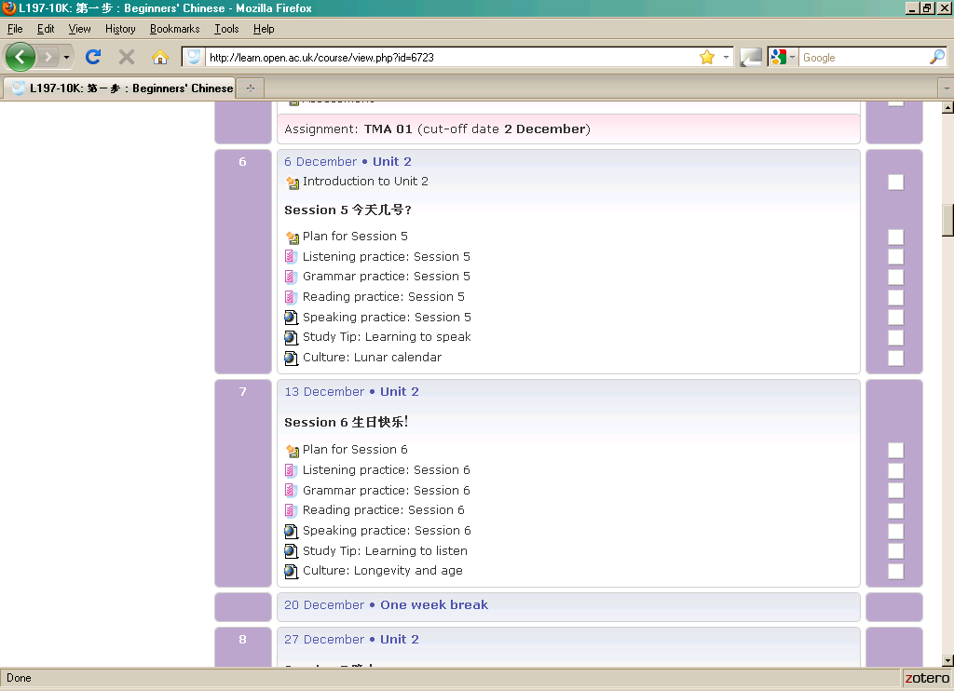

5. Allowing for differentiation
When creating quiz questions, take into account weaker students as well as those getting ahead of the class. Make sure that some questions are easy enough to give even the bottom set a sense of satisfaction. Moodle quizzes can be easily graded from simple to more complex by fixing the arrangement of questions (rather than randomising the order of questions).

6. Time limitation
Some teachers decide to limit the time that quizzes are open. This is particularly important if quizzes feed directly into student assessment. In other courses it might be of interest to students to be able to go back to earlier work and re-check their understanding of a particular point. As quiz author you will need to make these decisions and programme the Moodle quiz setting accordingly.

Sample activity

In a beginners’ distance learning course, students work three weeks offline with print and audio materials. The fourth week is devoted to online revision in a Moodle workspace. Here is an overview of the tasks in Week 4.
The table below shows different tasks given to the students, the purposes of these tasks as well as the kind of feedback students are expected to get by fulfilling the tasks.

Task | purpose | feedback
Checklist of progress | self-evaluation of students before attempting the revision quizzes | general feedback on their level of confidence; advice to review course materials if confidence is too low
Language quiz | testing students’ understanding of new grammar points and vocabulary | detailed feedback on individual questions, overall feedback indicated by green (success) and red (low number of correct answers) bars
Listening | testing students’ listening comprehension with simple integrated audio files, linked closely to topics and structures covered in the three previous weeks | detailed feedback on individual questions, overall feedback indicated by green, orange and red bars;  access to transcripts of audio files after the questions have been completed
Reading | testing students’ reading comprehension using short texts linked closely to topics and structures covered in the three previous weeks; occasional use of images integrated in question | detailed feedback on individual questions, overall feedback indicated by green, orange and red bars

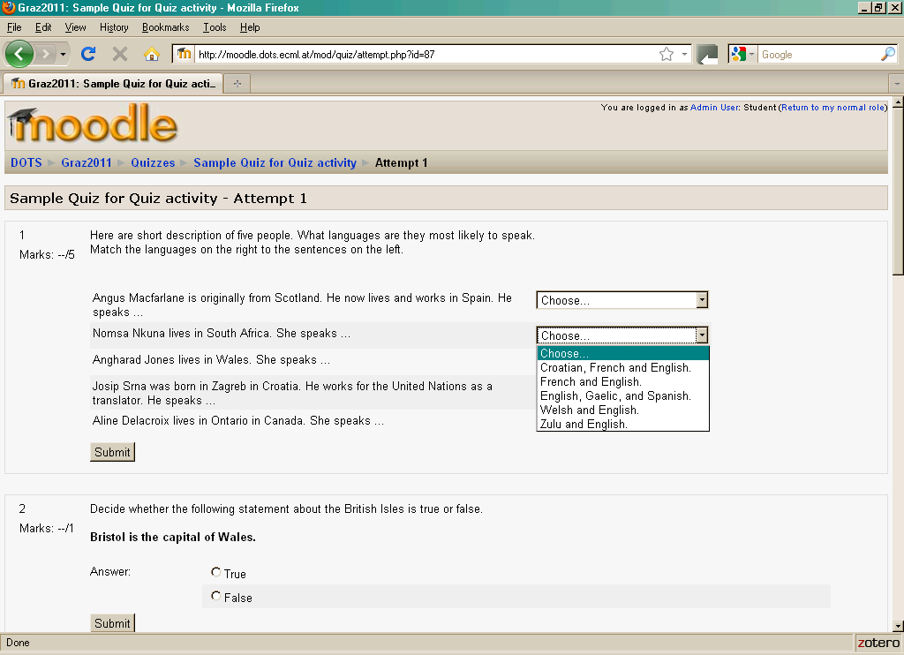

The learning objective of this activity is to support students in developing a realistic assessment of their performance with respect to different aspects of their learning. The first activity encourages students to evaluate their own progress. The quizzes will then confirm or disprove their evaluation. The setting of Moodle quizzes to give feedback at the end of a series of questions (“submit quiz”) allows students to get a more realistic impression of their performance in listening, reading or grammar (red vs. green bars).

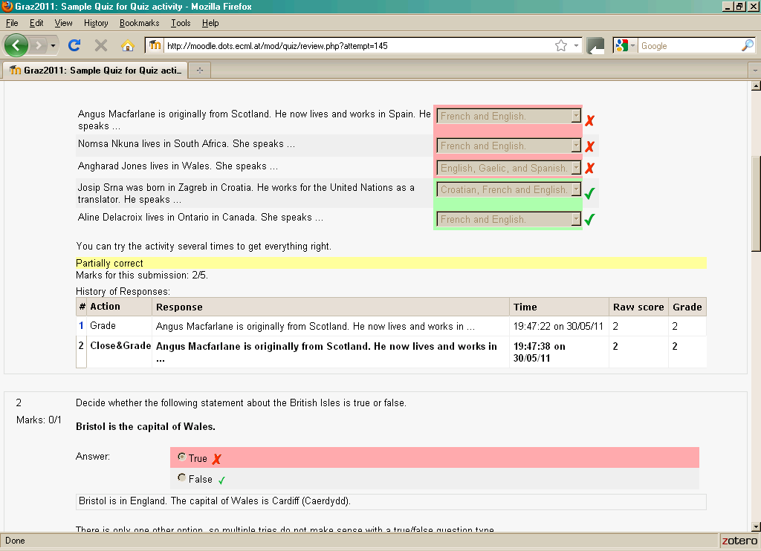

Practical suggestions

Within a Moodle VLE you can activate the Moodle quiz module when you are in editing mode. Click on the button “add an activity” and choose “Quiz”in the dropdown menu.

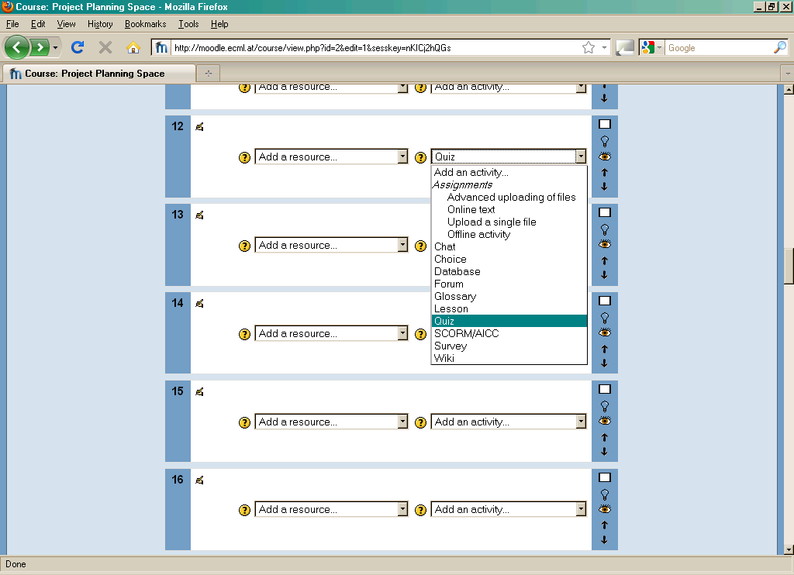

This creates the empty shell of a quiz. Give it a title and select the settings you want. These can always be changed later.

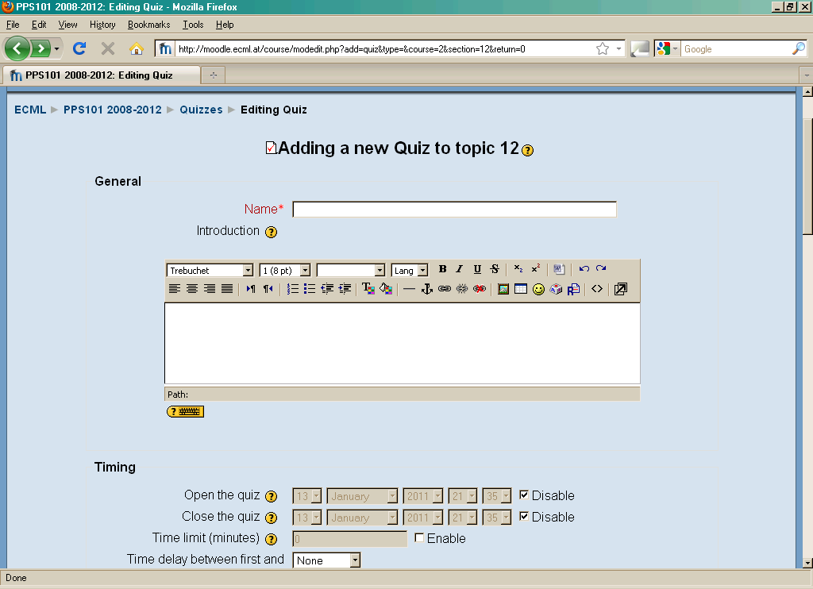

You now need to add questions: Click on “Save and display”.

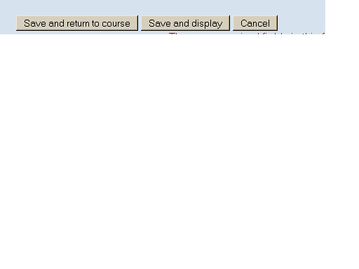
This will open the quiz for editing. The left hand side of the screen represents your quiz which at the moment is still empty. The right hand side of the screen represents the question bank (if this is your first quiz, the question bank will also be empty). Create new quiz questions choosing from the different formats available in the dropdown menu. Examples of formats are: multiple choice, true/false, short answer, etc.

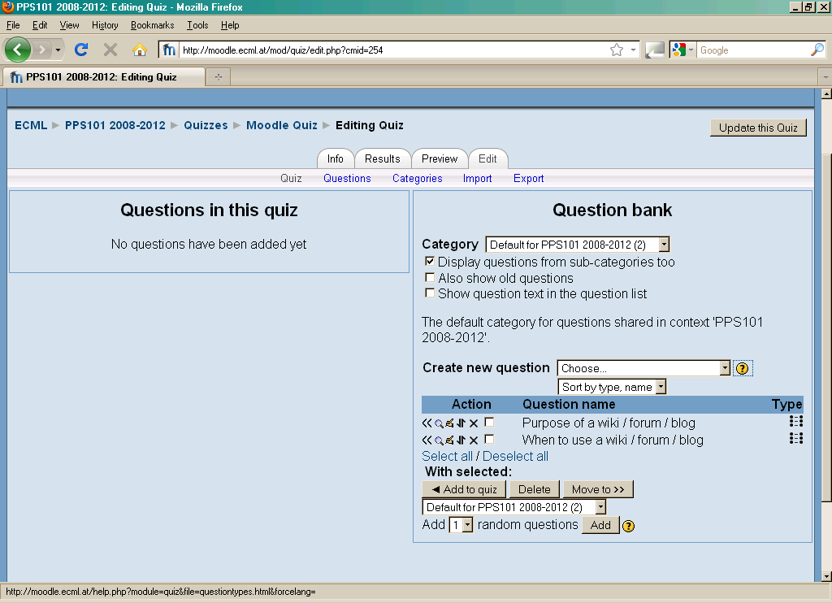

In your next step you add questions to the quiz by selecting them and choosing “Add to quiz”. In “Preview” mode you can then look at the quiz as it will appear to students and check for any mistakes.

You can start straight away by trying out the basic functions of Moodle quizzes in a trial-and-error method, or you can access the online user guides and tutorials that are available on the Moodle website. The general user guides are available in many languages at http://docs.moodle.org/overview/. You can start with the general Moodle quiz guide <http://docs.moodle.org/en/Quiz_module> which will help you to understand how Moodle quizzes work, or with the more practical tips on “Adding/updating a quiz”.

The FAQ section < http://docs.moodle.org/en/Quiz_FAQ> and the specifc forum on Moodle quizzes < http://moodle.org/mod/forum/view.php?id=737> will help with any problems and you normally get very quick responses to any specific questions.

If you want to watch a video that guides you through creating a Moodle quiz, try searching YouTube with the keywords: “Moodle quiz create”. Currently there are two short videos in English that seem helpful:
http://www.youtube.com/watch?v=rFnoNNrTx3c

http://www.youtube.com/watch?v=dNVTrD5O1qc&feature=related

For information on how to search YouTube see the DOTS activity Using YouTube in class (available at: http://moodle.dots.ecml.at/).

If you are working with the “trial-and-error” method, you can click on the question mark in Moodle to open an additional help page.

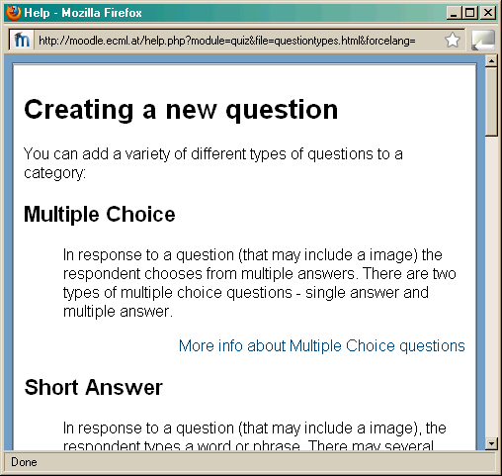

If you are worried about experimenting, you can make a back-up of your quiz questions and export a file in Moodle XML format to keep them safe.

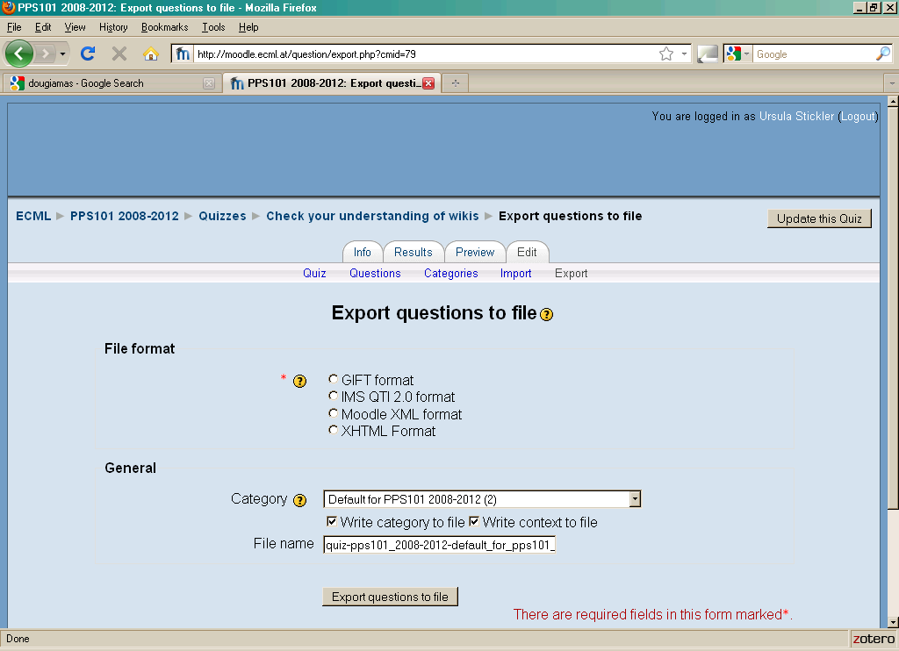

Part 3

Check your understanding

 | I can do this ☑ | I would like to look at that again
Describe Moodle quizzes to others (e.g. colleagues) briefly | □ | Click here.
Give three reasons for using Moodle quizzes in language teaching | □ | Click here.
Describe and use basic features of Moodle quizzes | □ | Click here.
Understand the pedagogical gains of using online quizzes in general | □ | Click here.
Set up a simple Moodle quiz module | □ | Click here.
Understand practical considerations around using different settings for Moodle™ quizzes in your class (experimenting with the tool; different purposes for quizzes; computer needs and settings; support and feedback) | □ | Click here.

Reflect!
Here are two possible ways of guiding your reflection. Select the questions that are the most relevant for you.

I. Think about the following issues concerning the activities in this section:
(To do when you have finished this activity sequence)

 | 
- Has this worksheet given you enough information/confidence to try out a Moodle quiz?  - Will you be able to take this worksheet and implement the suggestions straightaway? If not, what else do you need? | - Go to the DOTS Explore and share forum (available at: http://moodle.dots.ecml.at/mod/forum/view.php?id=38), find out what other people use Moodle quizzes for.  - Discuss your planned use of Moodle quizzes in the DOTS forum (available at: http://moodle.dots.ecml.at/mod/forum/view.php?id=38) to get helpful tips from experts and teachers.
* Credit for illustrations: fotographic1980/FreeDigitalPhotos.net

II. Reflect on the following questions concerning your use of Moodle quizzes as a tool and a resource for your course:
(To do after your first attempt at using Moodle quizzes in your teaching / your class)
- Is this tool/resource relevant for  your course?  - Does it fit with your teaching approach and aims?  - Does it help bring more linguistically and culturally accurate material?  - Is this tool relevant for your learners  (age, level, interest, …)  - Is the level appropriate for the intended users?  - Can the tool accommodate learners with a range of levels? If so, how?  - Is the language used in the instructions and reference material suitable?  - For which skills and activities do you think quizzes are best used?  - Does it allow for interactive activities to maintain student interest?  - Are there a variety of exercises and tasks that can be built with this tool?  - How user-friendly is the tool?  - Is the quiz clear and easy to use for your students?  - Does the quiz necessitate some training activities for your students?  - Technical considerations  - What equipment and technical support is required?  - Is this available in your institution?  - What on-going costs are involved (e.g. licences for software)? | - After you’ve used Moodle quizzes in your class, share your experience in the DOTS forum (available at: http://moodle.dots.ecml.at/mod/forum/view.php?id=38).  - Share suggestions for new uses of Moodle quizzes in the DOTS forum (available at: http://moodle.dots.ecml.at/mod/forum/view.php?id=38).  - When you have developed a Moodle quiz, share it with colleagues by exporting the questions as Moodle XML file and uploading this file to the DOTS wiki (available at: http://moodle.dots.ecml.at/mod/wiki/view.php?id=24).  Our forums and wikis are multilingual, so whatever the language you teach, please upload your material and you can be sure that you will be helping less experienced colleagues.  - Share what you have done with  your colleagues in your institution.  Here is the place to brag about it!  Don’t hide your light under the  bushel.
* Credit for illustrations: fotographic1980/FreeDigitalPhotos.net

Explore and share!
Here are some suggestions on where to go from here. Please feel free to add your own suggestions in this section – they can be your own lesson plans, ideas, problems, etc.

- Talk to your students about online quizzes. Do they like them? Do they see a benefit in doing them? If you have different opinions in your class, you can discuss the pros and cons and perhaps link them to different learning styles. Emphasise the relevance of realistic self-evaluation for progress and independent learning.

- Talk to your colleagues about Moodle quizzes. Do they use them? Have they created any new quiz questions themselves? Perhaps you can work together to build your own repository of questions which can be adapted to different topics, levels and languages.

- Discuss Moodle quizzes in the forum and find new ideas for language specific use of quizzes. Do other teachers use quizzes differently? Have they reported any problems? Perhaps you can share your question files and build your own repository of questions which can be adapted to different topics, levels and languages.

- You might want to consider running some of the comprehension tests and exams on Moodle quiz to save the time and effort spend on marking. You can explore the use of “grade book” with your colleagues. http://docs.moodle.org/en/Grades

- If you need additional information on various aspects of Moodle quizzes, check out the technical section or the Moodle.org website (http://docs.moodle.org/en/Quiz_module).

Protecting students’ privacy

Rather than protecting your students privacy (for general considerations check the Privacy forum available at: http://moodle.dots.ecml.at/mod/forum/view.php?id=29) quiz settings can helpt to protect the validity of quiz results.
The purpose of quizzes is important when deciding on the appropriate settings. If you use the quiz for exam purposes, you need to keep the correct answers hidden from students. Your feedback can give general encouragement or explain when the answers will be revealed.
If the quiz is used for revision, your settings might allow students a number of attempts before revealing the answer, to encourage reflection and self-correction. Your feedback can help students to find the correct answer themselves by revealing part of it or giving general hints and tips.

This work is licensed under a Creative Commons Attribution 3.0 Unported License.
Attribution: Original activity from DOTS, Developing Online Teaching Skill, Bite-size Training for Language Professionals. Medium-term project 2008-2011 – ECML. http://dots.ecml.at/.

By downloading the Moodle XML file, any other user can integrate your questions into their own quizzes on a Moodle workspace.

