Using blogs for language teaching
You can use blogs as a source of reading material for your classes, create a class blog for your students, or blog yourself!

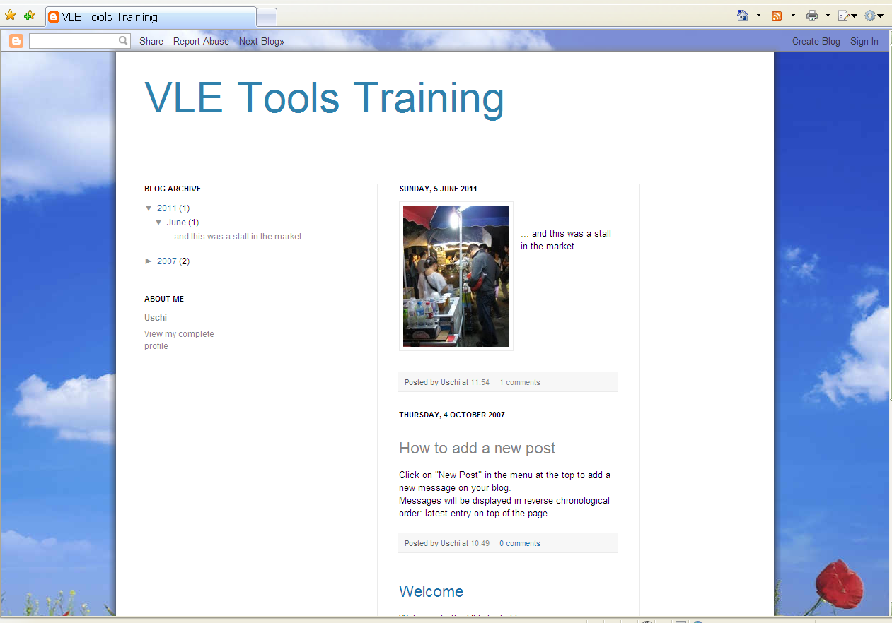

This DOTS activity explains how blogs work and discusses points you will need to think about when you use blogs in your language classes. It is built in a modular format, so that you can use one or more of the sections, depending on your needs and the time you have available.

What can I do in this DOTS activity? | Where can I find the information?  (click on the link to go to the section)
Part 1
Find out about what blogs are and how people use them. | - What is a blog?
Think about some pedagogical reasons why I would want to use blogs in my teaching. | - Why would I want to use blogs in my teaching?
Part 2
Learn about the basic functions of blogs. | - Some basic functions of blogs
Consider what I need to keep in mind when using blogs for my teaching.  Explore some pedagogical issues and read one sample activity. | - Pedagogical considerations and sample activity
Find out about some technical suggestions that can help me in using blogs in my teaching. | - Practical suggestions
Part 3
Check my understanding using a quick and easy checklist | - Check your understanding
Think back over what worked and what didn’t work (in the DOTS activity and/or in my use of this tool) | - Reflect!
Check out what other teachers do with blogs  Discuss and evaluate ideas and activities in the DOTS forum.  Create additional tasks and share them with colleagues online. | - Explore and share!
Explore different privacy settings of blogs and their implications. | - Protecting students’ privacy.
 | - References

Part 1

What is a blog?

In this section you will find out what blogs are, what they look like and how people use them. If you decide to use blogs in your teaching, it will be helpful to know some basics.

A blog is a type of website. The word is a contraction of web + log. Blogs enable users to post regular entries (or blog posts) and these can include news, comments, descriptions of events, photos or videos. In a blog, entries are commonly displayed in reverse-chronological order, with the most recent at the top. There are many free blog services, and blogs are very easy to use and have a clean, professional look that makes them very attractive to use. To blog is also a verb, meaning to maintain or add content to a blog.

Many blogs provide commentary or news on a particular subject; others function as more personal online diaries. A typical blog combines text, images, and links to other blogs, Web pages, and other media related to its topic. Most blogs are interactive, allowing visitors to leave comments and even message each other via widgets on the blogs and it is this interactivity that distinguishes them from other static websites, and makes them particularly attractive in teaching and learning.

If you want to find out more, you might want to check out the short video Blogs in plain English, which will teach you the basics about blogs in just under 3 minutes, And by the way, it is not just available in English, but in other languages too!

Most blogs are mainly text-based, although some focus on art (art blog), photographs (photoblog), videos (vlog), music (MP3 blog), and audio (podcast; for more on podcasting see the DOTS Podcasting activity or visit http://moodle.dots.ecml.at/).

A photo blog:
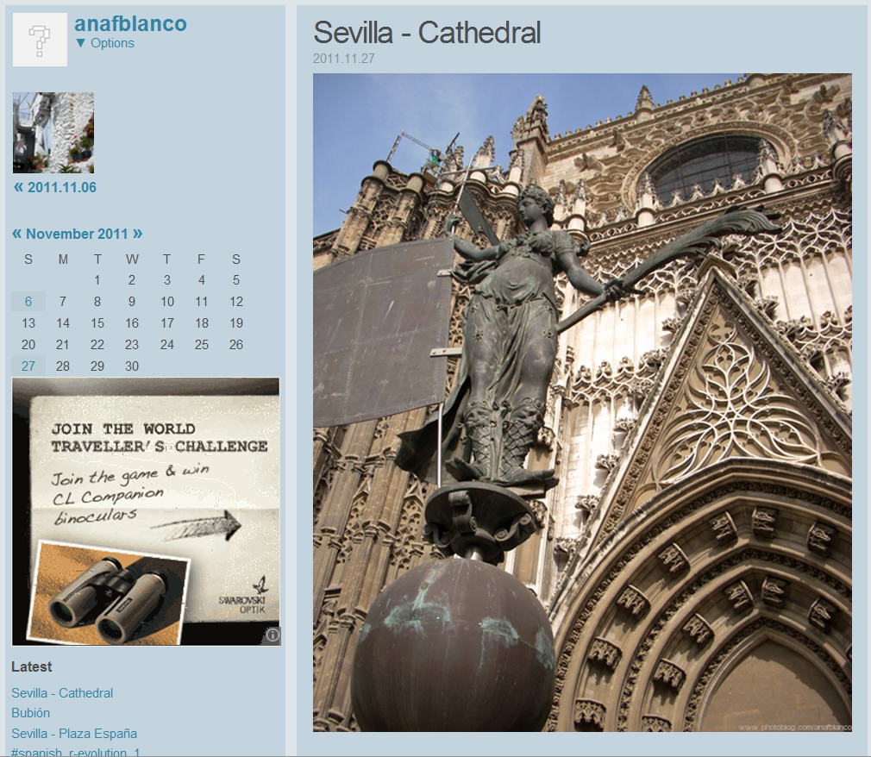
(http://www.photoblog.com/anafblanco/)

Blog search engines:
To find relevant blogs, you can use a blog search engine. The best know ones are Technorati, BlogScope, or Google Blog Search.
You can search for blogs or blog postings about specific topics.

Searching for blogs postings in Spanish on “tourism in Andalusia”, using BlogScope:

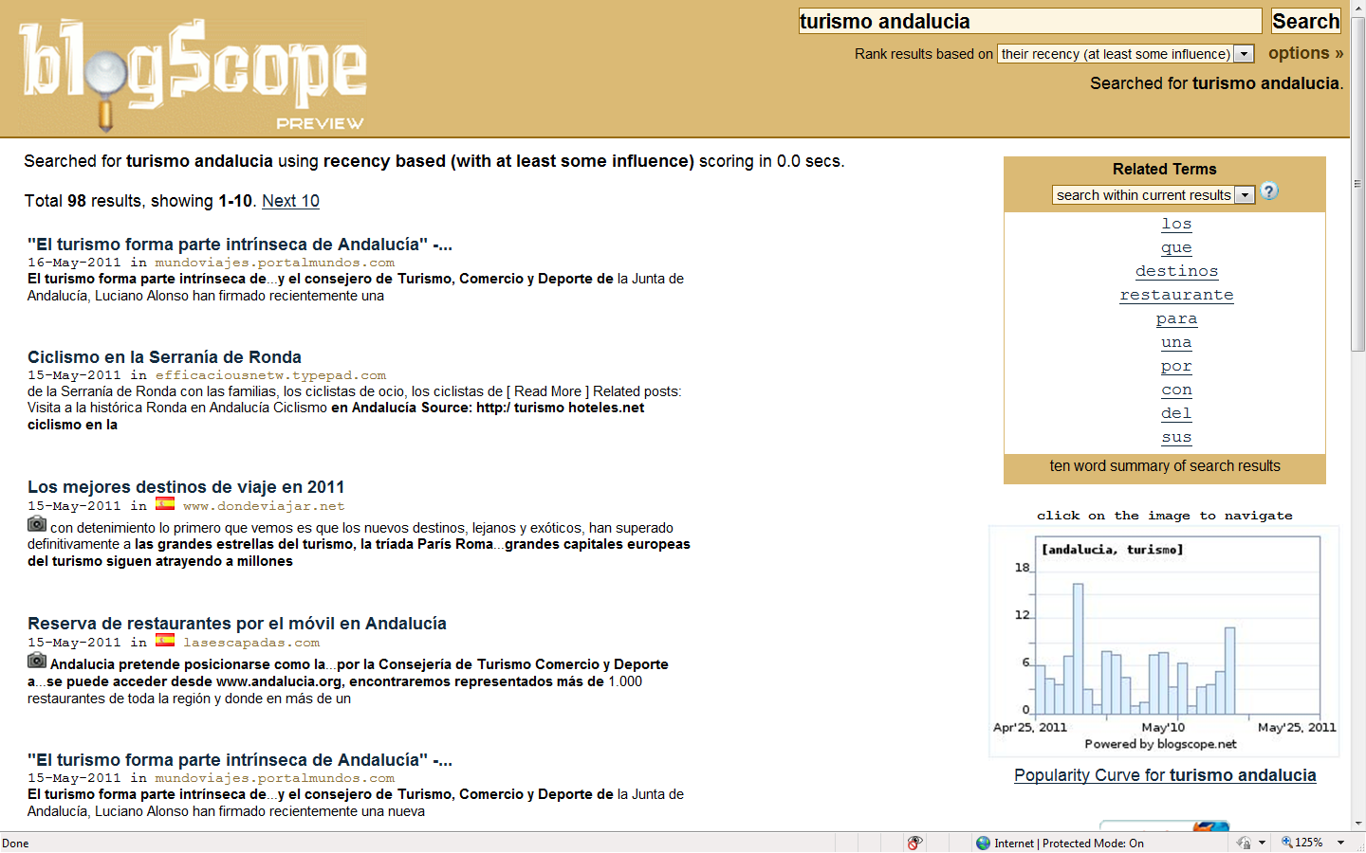

Why would I want to use blogs and blogging in my teaching?

The regular practice of reading and writing is very useful in learning a language, particularly in distance learning, independent study and blended teaching contexts. Blogs are a useful tool to use in your teaching, both a source of reading material and as a way to structure writing activities and peer reviewing.

For language teachers, blogs “can fulfill many of the needs identified for the effective teaching of writing.” Indeed, a blog provides “a genuine audience, is authentically communicative, process driven, peer reviewed, provides a disinhibiting context and offers a completely new form with unchartered creative potential” (Ward, 2004: 3).

In particular, you might want to use blogs and blogging in your teaching:

For reading:
There are currently more than 160 million blogs in existence in April 2011 (http://www.blogpulse.com/), so whatever your interests or hobbies, there’s bound to be a blog that interests you. For that reason, blogs are an excellent source of up to date reading material: encourage your students to find a blog they really enjoy and subscribe to it. This should be motivating, and provide a real reason for reading!

To disseminate student generated content:
A blog can be a window into your classroom. You can encourage your students to post their work there (especially if you use the blog for a particular project): students often get an immense sense of satisfaction from having their work “published”, and blogging is indeed a form of publishing.

For sustained, regular writing:
Blogging regularly has been shown to have a positive impact on learners’ writing fluency and to increase their motivation to write for a broad audience. You might want to encourage your students to keep a blog that they post to regularly (like a diary or journal), or set up a class blog and encourage students to take turns to write blog postings.

For discussion and peer review:
Blogs offer students an opportunity to interact with peers and to learn from each other. Because they enable readers to post comments to blog postings, they offer a forum for discussion. For instance you could encourage students to post about culture, politics, travel, or other areas of personal interest, and ask other students to comment on posts they find interesting. Feedback from your peers on your blog posts can be enormously motivating.

To increase opportunities for interaction outside the classroom:
Students can comment on each others’ blog posts outside the classroom. This contributes to creating a sense of community, and takes learning and peer interaction outside the confines of the classroom.

For reflection and evaluation:
Blogs are often used as a tool for reflection. For instance, students can have a personal blog that they use as a journal of their learning experience. This has been used quite successfully for students spending a period of time abroad (e.g. during an Erasmus study visit).

As a portfolio:
Because they can include photos and videos, and links to other sites, as well as “regular” text postings, blogs are an easy way to get students to produce a multimedia portfolio, documenting their work during a course or a work placement, for instance. You as teacher (and fellow students) can comment if appropriate and, like any other portfolio, it can be submitted as part of the assessment.

As with any other tools, you need to keep the pedagogical considerations in mind when thinking about how you would use blogs and blogging in your context. To find out more about these pedagogical considerations, you can go to section D.

Part 2

Some basic features of blogs

If you decide you would like to use blogging in your teaching, this section gives you some practical advice. If you would just like to ask your students to read (and perhaps comment on) existing blogs, go to section D, but first have a quick look at the typical features of a blog, as shown in the table below.

Here’s what a typical blog looks like:

Main features: | Sample blog: | Additional features:
Blog title | 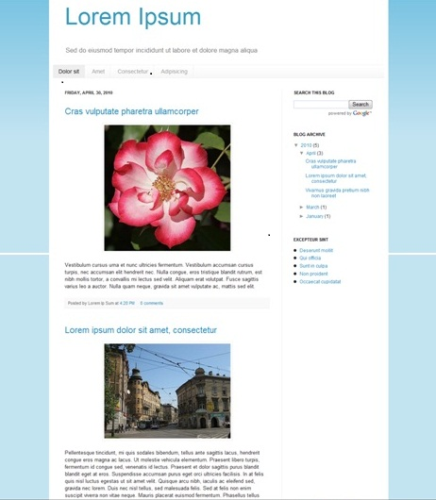 | You can include widgets such as:  - a search facility to search the blog
Short description of the blog
Date of the posting
A blog posting (usually has a title and text, can also include a photo) |  | - a blog archive, to go to earlier postings
The name of the author of the posting, and a link to comments on that posting. These are comments by readers. |  | - a link to other blogs your readers might like
Earlier postings appear below, in reverse chronological order |  | - a link to other blogs your readers might like

Getting started
If you want to set up a blog for one of your classes, here’s some information you might find useful:

There are several providers of free blogs, such as Blogger or Wordpress. We will show you how you can get started with a blog, and look at some of the main features of blogs. We use blogs from Blogger as an example, as they are easy to set up, and most of the features are standard across blogs.

To start with, you might want to watch a short clip on how to create a blog on Blogger:

http://www.youtube.com/watch?v=rA4s3wN_vK8:

In section E: Practical suggestion, you can find out about more features of blogs.

Pedagogical considerations and sample activity

Behavior
It is important to highlight to students that they should adhere to your institution’s Computer Code of Conduct (if there is one) when posting blog posts or commenting on them. This might include issues about copyright (for instance before you post something on a blog, such as a photo, make sure you are the owner of the copyright, you have received permission from the copyright holder, or you use Creative Commons materials, which you must acknowledge.). Other issues often included in institutional computing codes of conduct include the prevention to publish material that is obscene, libelous or defamatory, or constitutes harassment. Whilst there is usually no need to be heavy-handed, it is useful to make your Blogger's Code of Conduct known to your students. Tim O'Reilly proposed such a self-regulated code of conduct to encourage civility on blogs.
O'Reilly and others came up with a list of seven proposed ideas:
- Take responsibility not just for your own words, but for the comments you allow on your blog.
- Label your tolerance level for abusive comments.
- Consider eliminating anonymous comments.
- Ignore the trolls.
- Take the conversation offline, and talk directly, or find an intermediary who can do so.
- If you know someone who is behaving badly, tell them so.
- Don't say anything online that you wouldn't say in person.
From: http://en.wikipedia.org/wiki/Blog

Sample activity

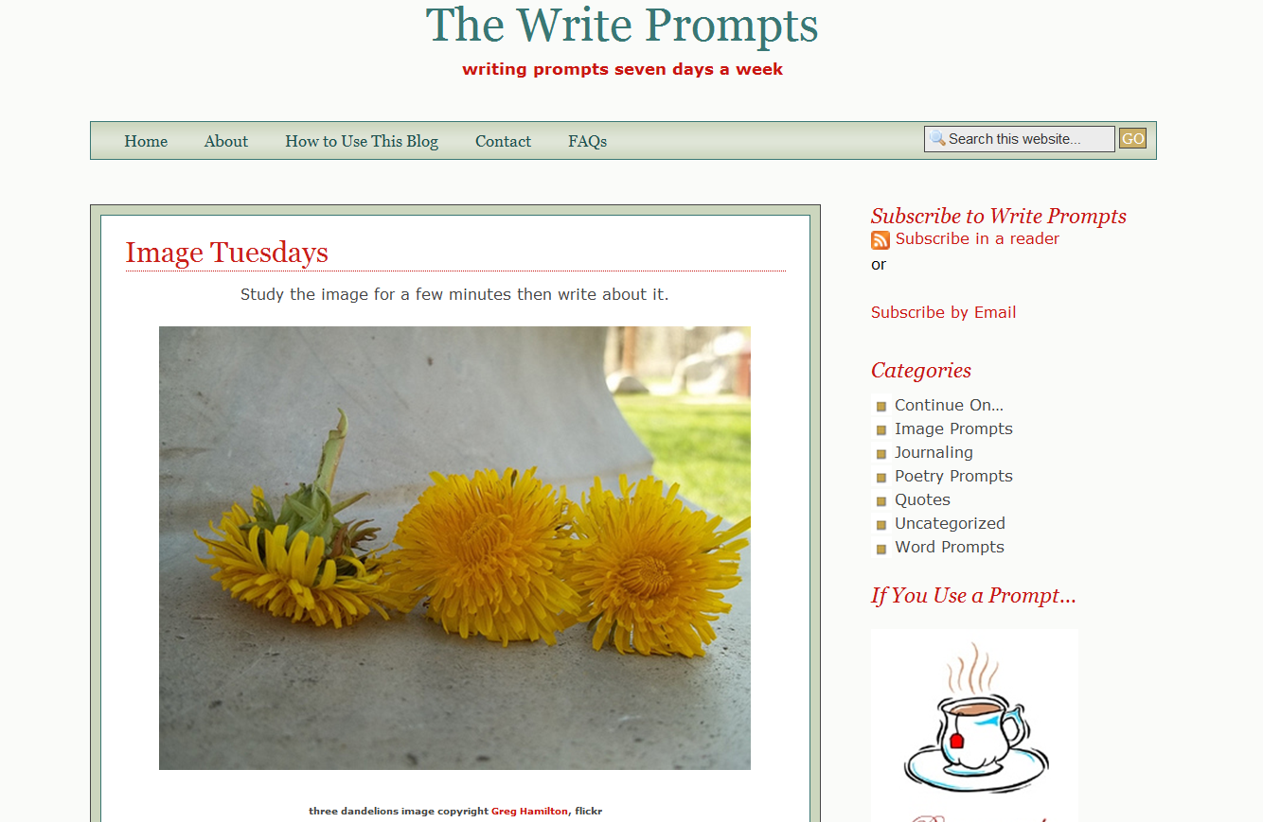

Task | Purpose | feedback
In class, go to a photo blog, such as The Write Promts (http://www.thewriteprompts.com/), select an image, and ask students to brainstorm for words they associate with it.  If you want, you could set up your own photoblog for this purpose (see below for some ideas). | Create an interest in the task, generate some useful vocabulary and ideas | Depending on the level, you might want to write some of the vocabulary on the board
Using the image as a prompt, ask students individually to write without stopping and in full sentences whatever comes into their mind. It can be a description, a dialogue, a few verses, the beginning of a story, a dream… | Practice free writing | In pairs, they read each other’s writing. Then they make a suggestion about how to improve it (eg correct a mistake, use a different word, etc), and one thing they really appreciate or enjoy about the piece of writing
For homework, ask them to polish their piece of writing and publish it in the blog, as a comment to the photo. If you would prefer to work in a private space, you can set up a class blog for this, or do the activity in a forum (to find out more about forums go to the DOTS Forum activity or visit http://moodle.dots.ecml.at/), for instance. Ask them as well to comment on the piece of another student, saying one thing they really like about it. You might want to remid them about the code of conduct, i.e. that they should be civil to their peers! | Writing to be published, and giving and receiving feedback | In the next class, you can ask students how they found the experience of publishing something, and of giving and receiving feedback.

Extension: You might want to use this activity as a way to enable your students to practice writing regularly. You could set up your own photo blog and post a photo one a week. Make sure that you don’t infringe copyright, though! You might ask student to contribute a photo to the photo blog (but don’t forget to acknowledge them!), or you could find Creative Commons photos online (you can use a photosharing service such as Flickr, http://www.flickr.com/, where you can do an advanced search for photos that are published under Creative Commons licenses, so that you can use them in your blog – although you must always acknowledge the author, by putting a link to the page where you found it).

Flickr, the photo sharing service, is a great place to find resources for your blog:
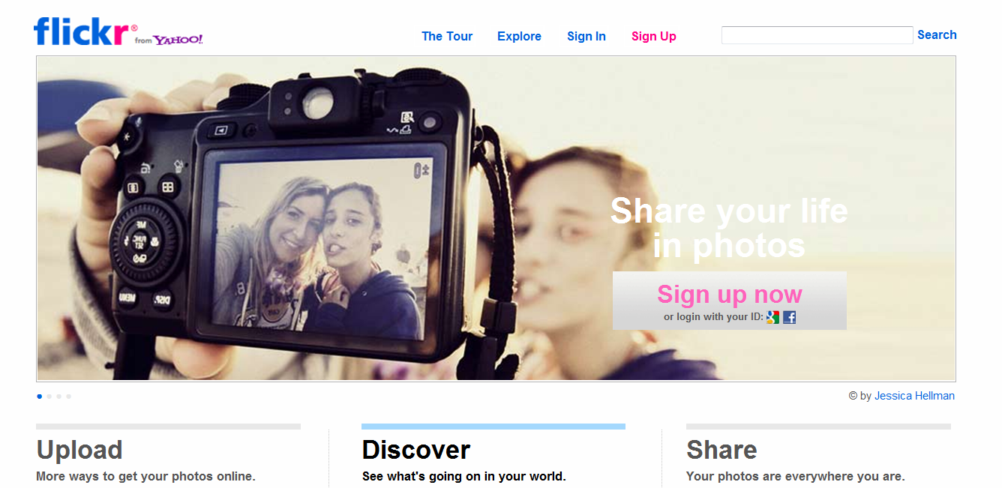

The advanced search feature in flickr:

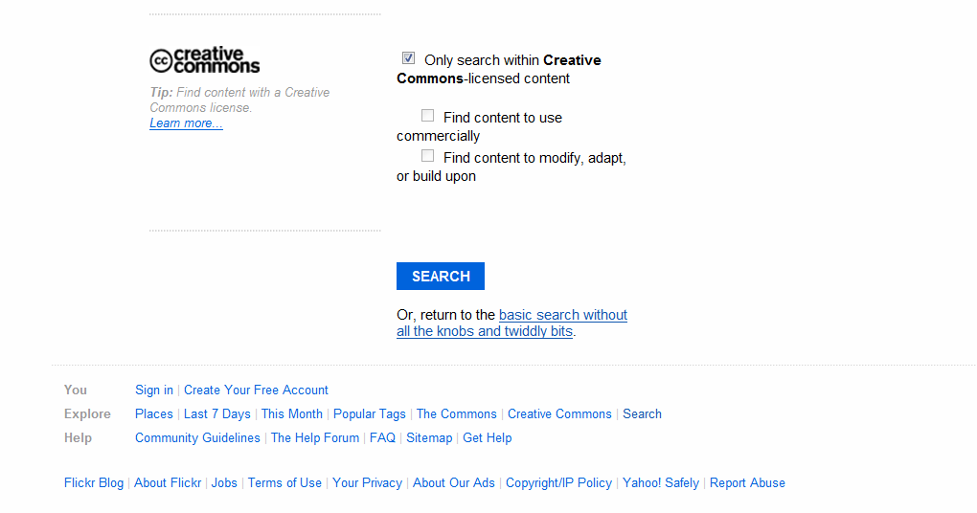

Practical suggestions
In this section you will find some practical advice about setting up and using blogs.

Blog design: Most blogging services, including Blogger, have templates that enable you to select a design, and then customise it by changing the colours, font and layout. This enables users to create attractive looking blogs very easily. Page elements (posts, archives, etc) can be dragged and dropped into different parts of the page to suit your preferences.
Access Controls: This is probably the most important feature to think about when you start a blog: it lets you decide who can write on your blog (for example, you can set up the blog and then invite all your class to be writers, so it becomes a communication tool for your class) and who can read it (you might want to restrict this just to your class, or open the blog up so that it can be read by anyone).
You might decide that rather than have a single blog for your class, students will set up their own individual blogs which they can keep private (for reflection, or to use as a portfolio), or share with others (everyone, or selected individuals, such as their class members and you as their teacher). You might want to look at section I. Privacy for more information.
Examples of Blog Reader settings:
a: Only people you choose can read the blog:
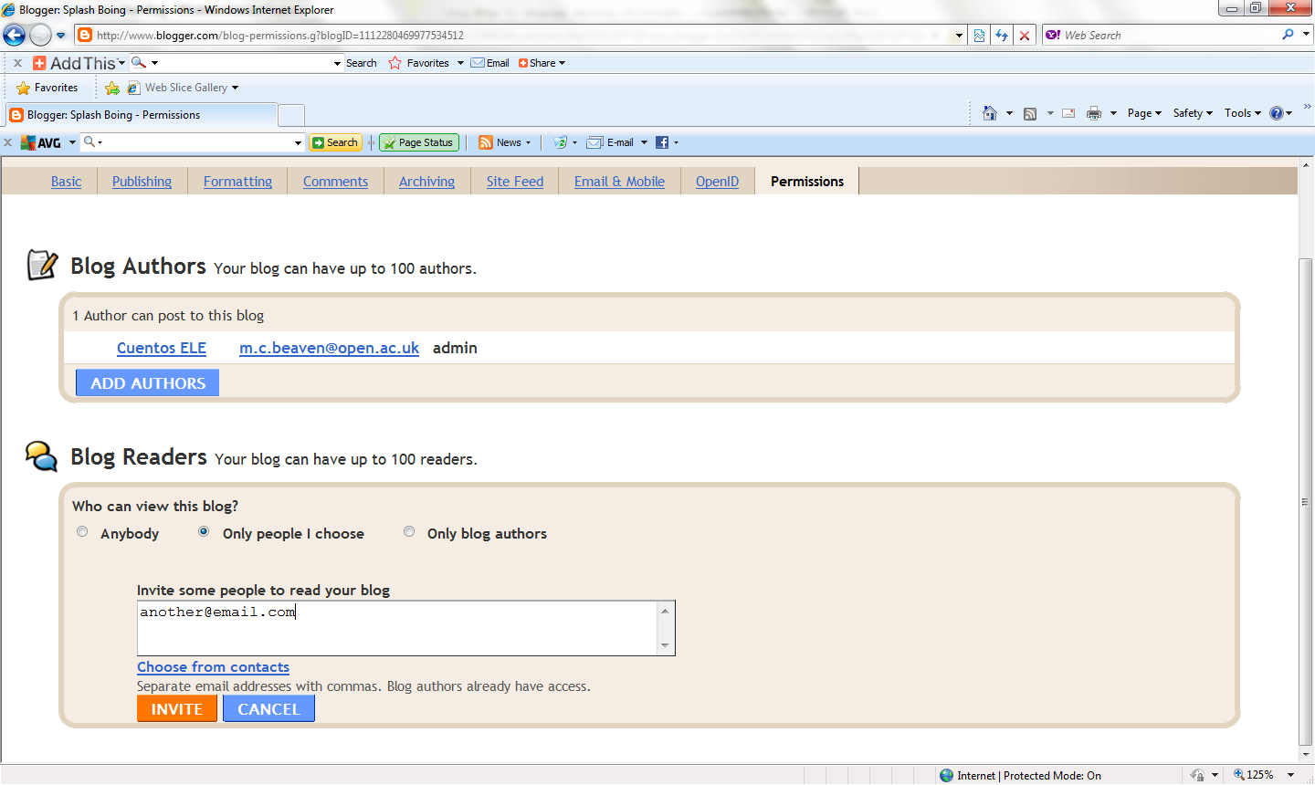
b: Only blog authors can read the blog:
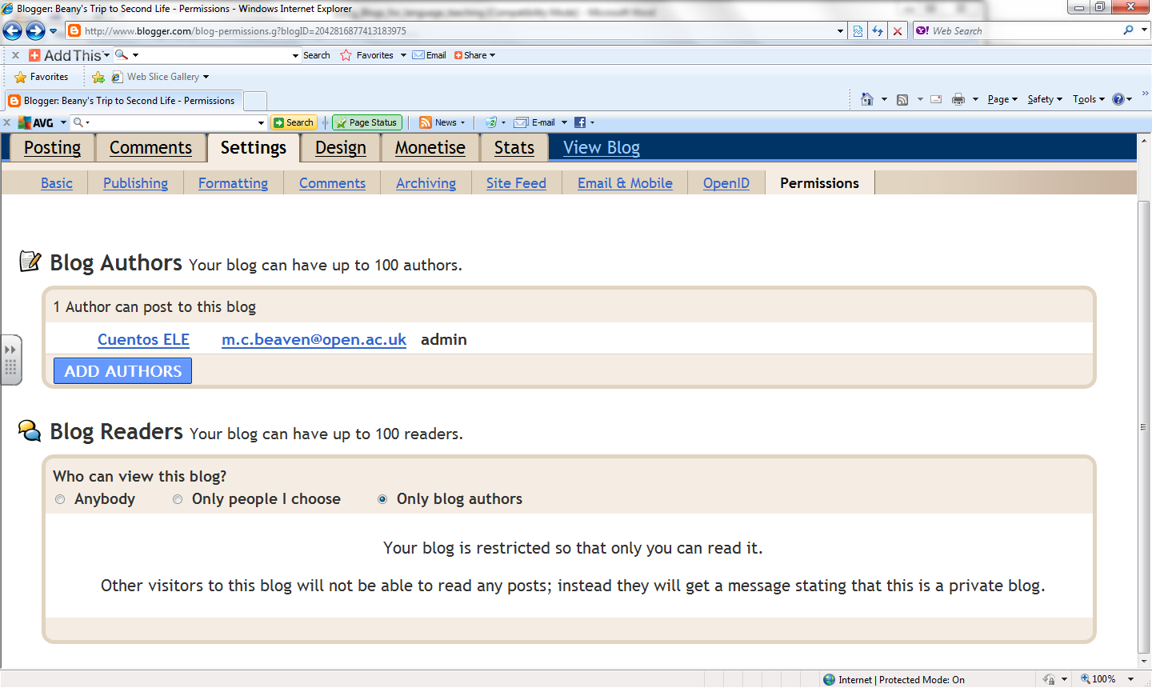
Comments: You can allow anyone to give feedback on your posts, or make the feedback visible only after you have checked it out yourself. You can also delete any comments you don’t like. This is particularly useful if you have a class blog that is readable by anyone: you might want to encourage external readers to leave comments on your students’ work, as it can be very motivating, but at the same time be able to exercise control over what comments get published, to screen out spam or offensive comments, for instance.
Photos: You can also easily add photos to your blog, which will make it even more attractive. Photos in blogs can also be a great focus for language teaching activities: see the sample activity for an example.

Languages: Many blog service providers localise their products, so they are available in different languages. Blogger is available in more than 40 languages, so you can easily change the language of the interface to suit your context.

Changing the language interface in Blogger:

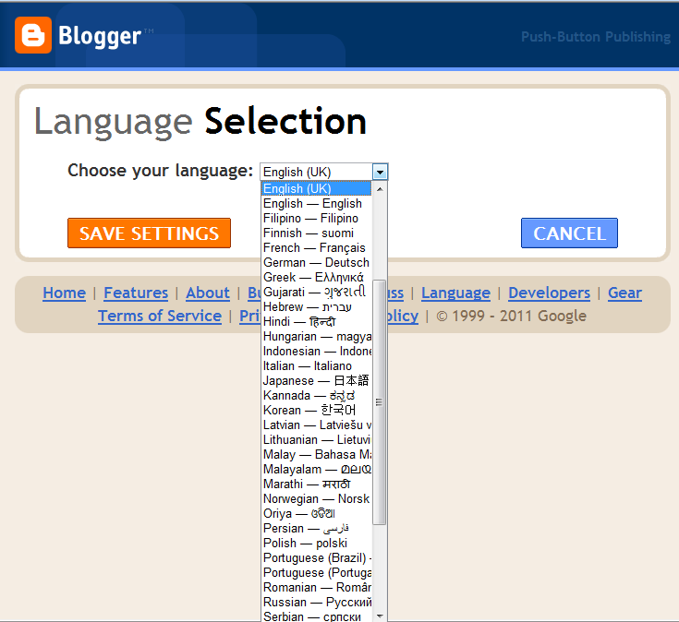

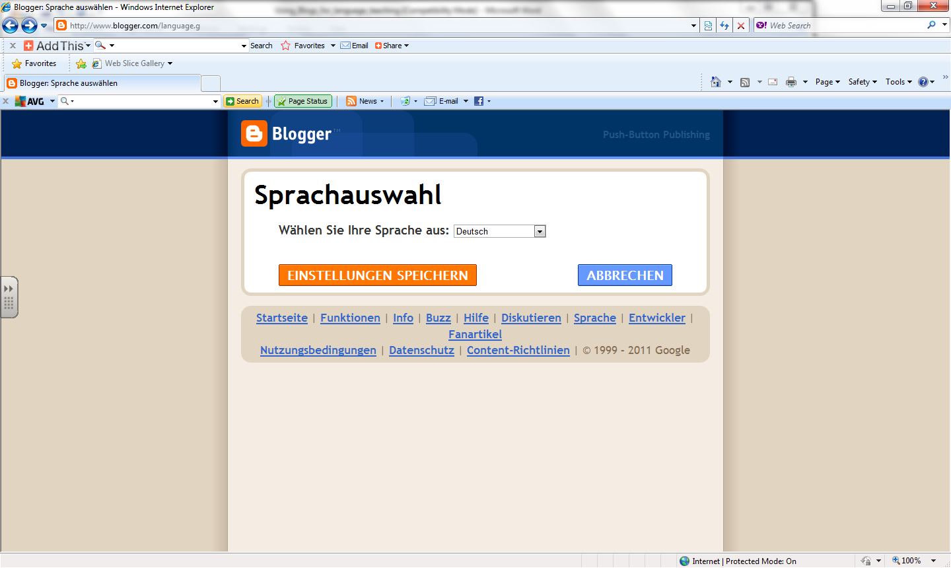

NOTE: If you are teaching beginners or lower intermediate classes, you might want to leave the interface in the students’ mother tongue, to make it easier for them to use the blog features.
Blogger Profiles: Your Blogger Profile enables you to list your blogs, your interests, etc, and enables others to find you (if you choose to let them). You can also leave your profile blank. There are issues around privacy you might want to consider here, both for yourself and for your students. Section I. Privacy deals with this.

Part 3

Check your understanding

 | I can do this ☑ | I would like to look at that again
Describe blogs and blogging to others (e.g. colleagues) briefly | □ | Click here.
Give three reasons for using blogs or blogging in language teaching | □ | Click here.
Describe and use basic features of blogs | □ | Click here.
Understand the pedagogical benefits of using blogs and blogging in your teaching | □ | Click here.
Understand practical considerations around setting up a blog | □ | Click here.

Reflect!
Here are two possible ways of guiding your reflection. Select the questions that are the most relevant for you.

I. Think about the following issues concerning the activities in this section:
(To do when you have finished this activity sequence)

 | 
- Has this worksheet given you enough information/confidence to use blogs or blogging in your teaching?  - Will you be able to take this worksheet and implement the suggestions straightaway? If not, what else do you need? | - Go to the DOTS Explore and share forum (available at: http://moodle.dots.ecml.at/mod/forum/view.php?id=42), find out what other people use blogs and blogging for.  - Discuss your planned use of blogs and blogging in the DOTS Explore and share forum (available at: http://moodle.dots.ecml.at/mod/forum/view.php?id=42) to get helpful tips from experts and teachers.
* Credit for illustrations: fotographic1980/FreeDigitalPhotos.net

II. Reflect on the following questions concerning your use of blogs and blogging as a tool and a resource for your course:
(To do after your first attempt at using blogs/blogging in your teaching / your class)
- Is this tool/resource relevant for  your course?  - Does it fit with your teaching approach and aims?  - Does it help bring more linguistically and culturally up to date material to your teaching?  - Is this tool relevant for your learners  (age, level, interest, …)  - Is the level appropriate for the intended users?  - Can the tool accommodate learners with a range of levels? If so, how?  - Is the language used in the instructions and reference material suitable?  - For which skills and activities do you think blogs and blogging are best used?  - Does it allow for interactive activities to maintain student interest?  - Are there a variety of exercises and tasks that can be used around blogs and blogging?  - How user-friendly is the tool?  - Are blogs clear and easy to use for your students?  - Does blogging necessitate some prior training for your students?  - Technical considerations  - What equipment and technical support is required?  - Is this available in your institution?  - Do students have private access to these? | - After you’ve used blogs or blogging in your class, share your experience in the DOTS Explore and share forum (available at: http://moodle.dots.ecml.at/mod/forum/view.php?id=42).  - Share suggestions for new uses of blogs and blogging in the DOTS Explore and share forum (available at: http://moodle.dots.ecml.at/mod/forum/view.php?id=42).  - Share a new blog activity for your classroom on the activities wiki available at: http://moodle.dots.ecml.at/mod/wiki/view.php?id=24.  Our forums and wikis are multilingual, so whatever the language you teach, please upload your material and you can be sure that you will be helping less experienced colleagues.  - Share what you have done with your colleagues in your institution. Here is the place to brag about it!  Don’t hide your light under the bushel.
* Credit for illustrations: fotographic1980/FreeDigitalPhotos.net

Explore and share!
If you have any questions or comments about using blogs or blogging in your teaching, go to the Explore and share forum (available at: http://moodle.dots.ecml.at/mod/forum/view.php?id=42) and ask the community for some advice. You can also post links to any useful blogs (including your own!), or to any resources about blogging and language teaching.
If you find a teacher of the same level and language with similar interests, you can also decide to set up a shared class-blog for your two classes. This will add an external “audience” for your students without the risk of fully opening the blog to the entire world.

Protecting students’ privacy

When setting up a blog, it is important that you think about privacy issues, in particular in relation to access and profiles.

Access:
Ask yourself the following questions:
Do you want the blog to be visible just to your class, or to all?
Who in your class should have rights to post in the blog? (it might be just you, or the whole class)
Who should be able to comment on blog postings? (just members of your class, or everyone?)
All these variables can usually be controlled (see the section on Access Control for more information)

Profiles:
Blogs allow users to have a profile page. You might want to discuss with your students what information if any they want to post here, bearing in mind that others might see it.

In general, it is wise to be cautious when using social website, so remind your students not to give out too much information, such as addresses, telephone numbers, emails or their date of birth in their profile. You might also suggest they use a user name that does not identify exactly who they are, such as a nickname, or their name (or part of it) followed by a combination of numbers (e.g.: Lau543).

For general considerations about protecting your students’ privacy, you can also check the privacy forum available at: http://moodle.dots.ecml.at/mod/forum/view.php?f=3.

References:
Lina Lee (2010). Fostering reflective writing and interactive exchange through blogging in an advanced language course. ReCALL, 22, pp 212-227
Ward, J. M. (2004) Blog assisted language learning (BALL): Push button publishing for the pupils. TEFL Web Journal 3:1 , pp. 1-16.

This work is licensed under a Creative Commons Attribution 3.0 Unported License.
Attribution: Original activity from DOTS, Developing Online Teaching Skill, Bite-size Training for Language Professionals. Medium-term project 2008-2011 – ECML. http://dots.ecml.at/.

