FOR THE TEACHER
Tower of Babel – WhatsApp group
Type of task: Project on written communication

Educational level: Secondary education - ISCED 2/3

Proficiency level: B1 Level

Short description and aim of the activity:
The aim of this activity is to practise the student’s reception and production skills in an authentic situation. Firstly, the students discuss the features of a typical social media (WhatsApp) message. Then, working in small groups, they read five different WhatsApp messages (Language B/C), and provide an answer either in Language A and/or B(/C), depending on the instructions given in the message. Finally, they share their answers with the rest of the groups. As a follow-up activity, students have to write their own message in Language A as part of their homework, and next time, in pairs, they answer their own messages in Language B (/C).

CEFR mediation scale and descriptor (to which the activity refers):
Translating a written text in writing
- Can produce approximate translations from (Language A) into (Language B) of information contained in short, factual texts written in uncomplicated, standard Language; despite errors, the translation remains comprehensible.

Processing text in writing
- Can summarise in writing (in Language B) the main points made in straightforward informational written texts (in Language A) on subjects that are of personal or current interest. Can paraphrase short written passages in a simple fashion, using the original text wording and ordering.

CEFR mediation strategies involved:
LINKING TO PREVIOUS KNOWLEDGE
- Can show how new information is related to what people are familiar with by asking simple questions.
BREAKING DOWN COMPLICATED INFORMATION
- Can make a short instructional or informational text easier to understand by presenting it as a list of separate points.
ADAPTING LANGUAGE
- Can paraphrase more simply the main points made in short, straightforward spoken or written texts on familiar subjects (e.g., short magazine articles, interviews) to make the contents accessible for others.
- Can paraphrase short written passages in a simple fashion, using the original order of the text.
STREAMLINING A TEXT
- Can identify and mark (e.g. underline, highlight etc) the essential information in a straightforward, informational text, in order to pass this information on to someone else.

Languages involved (Language A –Language B – Language C):
- Language A (English) – Language B (various)
*** Note: This activity could also be adapted for Languages A-B-C

Linguistic objectives. Students will be able to:
- produce approximate translations from (Language A) into (Language B) of information contained in short, factual texts.
- summarise in writing (in Language B) the main points made in straightforward informational written texts (in Language A).
- produce short informational written texts in Language B
- rewrite posts, adding information that was not given in the source text
- evaluate their performance on text communication

Other competences involved:
- Global citizenship: respect for diversity, intercultural understanding
- Media literacy: analyse media content
- Interpersonal skills: teamwork

Time/lessons needed for the activity: 2 (45 min) lessons

Resources required
- A copy of the handout A for each student, printed or shared via email in advance.
- An A3/A1 copy of the poster
  - Alternatively, Teachers could use a PowerPoint to present the five email messages rather than print copies of all the handouts, and/or only print the poster (A3-A1 paper) and the self-evaluation handout (Handout C)
- Post-it/sticky notes (5 per group of students to write their messages on)

Procedure:
 |  | Class organisation | Ideas for differentiation
Step 1 | The teacher starts with a warm-up, focusing students’ attention on social media text messages.  The class is split into groups, and the teacher asks them which social media they know.  Examples of these questions could be:  - Name all the social platforms you know.  - Do you use any of these? / Which one do you use quite often?  - Which one do you prefer to use when you chat with your friends?  - Which are some of the main characteristics/features of your text messages?  - Do you use only text? Can you think of anything else?  Students are then asked to write down in their groups all the features of an informal social media group (e.g., text/ abbreviations/ photos/ GIFs/ emojis/ length/ voice messages, videos, etc).  Then, they have a class/plenary discussion of their answers (Language A or B). | groups | The teacher can focus on a social media platform the students are familiar with in their context (e.g., WhatsApp/ Facebook)  In this warm-up, you can decide based on your students’ language skills if the students will produce their answers in Language A/ B/both.
Step 2 | Then the teacher introduces the following scenario:  “You live in a block of flats. In this building, families with different cultural traditions and languages live under the same roof. The residents have chosen to use a WhatsApp group as their way of communication so they can deal with any problems they might have quickly and efficiently”.  The teacher can show them the “Tower of Babel” poster -Handout 3. | groups | - If students do not know the WhatsApp application, then use a platform that they do know (e.g., Facebook)  - Teachers can use a PowerPoint to introduce the scenario, print the scenario, or read it out loud if they do not want to use the handouts.  - The “Tower of Babel” poster (Handout 3) should be printed on A3 paper and hung on the wall.
Step 3 | The teacher explains the task to the students.  The task: “As you can see in the poster, there are five floors in this block of flats. You will get a different WhatsApp text message from each floor, which you will have to answer. In order for your message to be similar to a WhatsApp message, you are going to use post-it notes to write your answer."  The teacher can now give the post-it notes to the students. | groups | The teacher can print out the text messages or use a PowerPoint and introduce one message at a time.
Step 4 | In order to get the next text message (Handout A), all groups will have to share their post-it messages by sticking their post-it notes on the “Tower of Babel” poster -Handout C, which is hanging on the wall.  Students have a maximum of 10-15 minutes (based on what they have been asked to do) to answer each message as a group. They can use a dictionary if they need to.  The teacher can read some of the answers out loud at the end of each round. | groups | Assessment options:  - The teacher should avoid pinpointing any mistakes during the lesson and just collect the messages from the poster. In the next lesson, they can show some of the students' common mistakes anonymously and ask the students to correct them.  OR  - In the next lesson, the teacher can shuffle the answers and share messages with different groups. The groups, then, can evaluate and give some alternatives if they spot a mistake on the text (peer-feedback).
Step 5 | The teacher can distribute the Self-evaluation activity (Handout B), which also includes the following homework: You are one of the residents in this building. Write a WhatsApp message either in Language A or Language B (e.g., explain an issue that you have/ ask for help/ invite people to your house, etc) and bring it with you next time. | individual | The idea of the self-evaluation form is to help students:  - identify and collect new phrases that they have used in this activity  - focus on the two languages involved in this project  - use a checklist and think of different aspects of their writing (including cultural awareness)  - introduce the homework and think of a possible scenario they could write about
Step 6 | In the next lesson, the teacher can use as a warm-up one of the assessment options mentioned in “Ideas for differentiation-Step 4”. | pairs /groups | Based on the selected assessment option, the teacher can decide on the group formation.
Step 7 | Students work in pairs and try to answer both their partner’s and their own messages in Language B. The teacher could remind them to use the self-evaluation form and the “common mistakes” warm-up activity. | pairs
Step 8 | Follow-up/discussion: the Teacher asks some of these questions in order to help students reflect on the situation and promote cultural awareness:  - Do you think that this could happen in your own block of flats? Why? Why not?  - What do you think was the residents' first language? Give some examples.  - Does it really matter that you know if someone is using his/her first language? Why? Why not?  - Have you ever sent a text message in another language?  - Can you imagine a situation where a person would need your help with the language used in his/her environment? | plenary | It is highly recommended that the teacher creates a link of these questions with the self-evaluation Handout B.

Further tips and guidance:
This activity is based on a real-life event: During the Covid-19 pandemic, all the residents in a block of flats communicated through a WhatsApp group, sometimes in English and sometimes in Finnish in order to buy each other’s groceries.
Immediate feedback in front of the whole class is not recommended since the students have to produce many texts and they might get stressed. Instead, informal feedback in the small groups might be a better option. The teacher will have the opportunity to assess the written text later and provide feedback (Step 4 Assessment options: Option 1/Option 2).

Suggestions and ideas for adapting/differentiating for different contexts:
- “WhatsApp” is a social media application similar to Facebook Messenger and Viber. People use their phone number to register and can have informal conversations only with the people who have as their phone contacts. In case this application is not popular in your context, you can use one popular with your students.
- All users of social media applications should be 13+. Thus, using the actual application is not recommended, unless all of your students have access to it.
- This activity can be adapted by using Language A-B-C, depending on your context. The students could provide an answer in Language C instead of A or B.

FOR THE STUDENT: ACTIVITY WORKSHEET
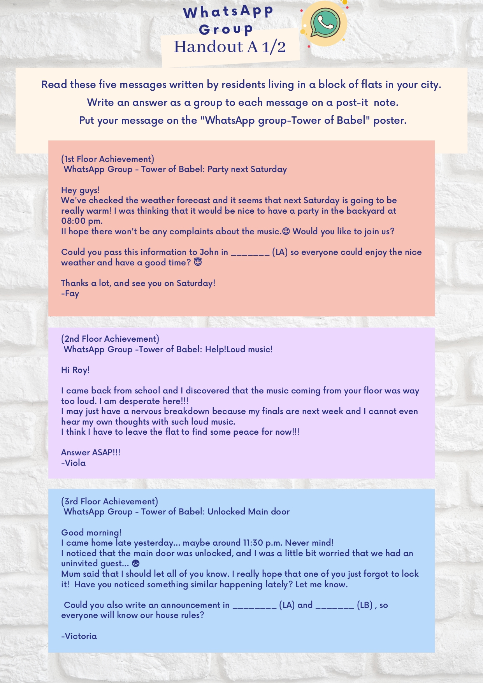
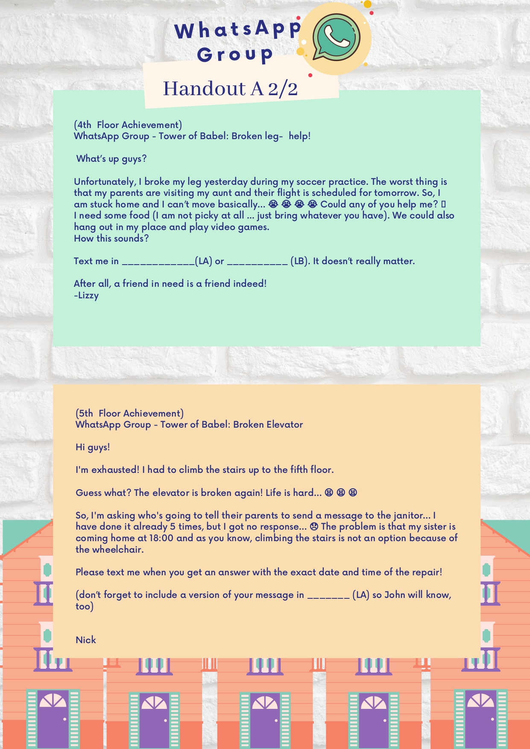

International Standard Classification of Education (ISCED) - Statistics Explained (europa.eu)

