FOR THE TEACHER
World mythology
Type of task: Project on world mythology
Educational level: Upper secondary education - ISCED 3
Proficiency level: C1 Level
Short description and aim of the activity:
The aim of this activity (which could be adapted to include Languages A-B-C) is to familiarise the students with different cultures and media texts. Firstly, the students discuss the features of myths. Then, working in pairs, they listen to a YouTube video about a myth in (Language B/C), and do the activities (e.g., to collect new vocabulary). Next, they listen to another YouTube video or read a text about a myth with the same topic in Language A and take notes in Language B. Based on their notes, they will have to create a short podcast in Language B. Finally, they have to write an article for the school newspaper where they compare the two myths and discuss in Language B (/C) how myths could be used as examples of different cultures.

CEFR mediation scale and descriptor to which the activity refers:
NOTE-TAKING
- Can select relevant, detailed information and arguments on complex, abstract topics from multiple spoken sources (e.g., lectures, podcasts, formal discussions and debates, interviews etc), provided that standard language is delivered at normal speed in one of the range of accents familiar to the listener.
Processing text in Speech
- Can exploit information and arguments from a complex spoken or written text (in Language A) to talk about a topic (in Language B), glossing with evaluative comments, adding his/her opinion, etc.
Processing text in Writing
- Can summarise in writing long, complex texts, interpreting the content appropriately, provided that he/she can occasionally check the precise meaning of unusual, technical terms.
ReLAYING SPECIFIC INFORMATION in Speech
- Can relay (in Language B) which presentations given in (Language A) at a conference, which articles in a book (written in Language A) are particularly relevant for a specific purpose. Educational: (an academic conference, various web talk sites, from academic books and journals – in relation to a particular project)

CEFR mediation strategies involved:
LINKING TO PREVIOUS KNOWLEDGE
- Can spontaneously pose a series of questions to encourage people to think about their prior knowledge of an abstract issue and to help them establish a link to what is going to be explained.

BREAKING DOWN COMPLICATED INFORMATION
- Can facilitate understanding of a complex issue by highlighting and categorising the main points, presenting them in a logically connected pattern and reinforcing the message by repeating the key aspects in different ways.
ADAPTING LANGUAGE
- Can adapt his/her language (e.g., syntax, idiomaticity, jargon) in order to make a complex specialist topic accessible to recipients who are not familiar with it.
- Can paraphrase and interpret complex, technical texts, using suitably non-technical language for a listener who does not have specialist knowledge.
Amplyfying A TEXT
- Can make complex, challenging content more accessible by explaining difficult aspects more explicitly and adding helpful detail.
- Can make the main points contained in a complex text more accessible to the target audience by adding redundancy, explaining and modifying style and register.
STREAMLINING A TEXT
- Can reorganise a complex source text in order to focus on the points of most relevance to target audience.

Languages involved
- Language A (Greek) – Language B (English)
- Language A (Finnish) – Language B (English)
* Note: This activity could also be adapted for Languages A-B-C

Linguistic objectives. Students will be able to:
- summarise in writing/speaking (in Language B) the main points made in complex spoken or written text (in Language A).
- produce informational written/oral texts in Language B.

Other competencies involved:
- Global citizenship: respect for diversity, intercultural understanding
- Media literacy: analyse media content
- Interpersonal skills: teamwork

Time/lessons needed for the activity: Two (45-min) lessons

Resources required
- Copies of the handouts A/B/C/D for each student, printed or shared via email in advance.

Procedure:
 |  | Class organisation | Ideas for differentiation
Step 1 | The teacher starts with a warm-up, focusing students’ attention on mythology and different cultures.  The class is split into groups, and the teacher asks them to discuss which myths they know. Examples of these questions could be:  - What is a myth?  - Which are some of the main characteristics/features of a myth?  - Can you tell us a myth that you know?  - In your opinion, why would people create myths?  Then, they have a plenary discussion of their answers (Language B). | groups / plenary
Step 2 | The teacher splits the groups in pairs. Half of the pairs will focus on the myth about seasons and nutrition (Handout A), while the other pairs will focus on ancient technology and artifacts (Handout B).  The teacher gives the handouts and introduces the following instructions:  “First, you have to watch a YouTube video. The students who have Handout A will focus on the Hindu Myth of Annapurna, goddess of nourishment, while the students who have Handout B will focus on the Finnish myth of the magic Sampo”. | pairs | In case you cannot watch the video in the classroom, you can give Handouts A/Bas part of the previous homework. This will change the order of Steps 1 and 2, i.e., Step 2 becomes Step 1.
Step 3 | After the students have watched the videos, the teacher explains the tasks to the students:  “First you have to complete exercise 2. With the help of a dictionary (if needed) and the video, you have to explain the given terms extracted from the video either in English (Language B) or in Greek (Language A).  Then, you have to complete exercise 3. In exercise 3, you have to watch the video once again. As you listen, you have to fill in the missing words in the video transcript”. | pairs
Step 4 | The teacher checks the answers with the students and asks them to find the meaning of the missing words.  Homework: the students have to write a letter to a friend and explain the myth on their handout and share their opinion about it. The students have to use at least ten of the new words they have learnt. | pairs | If the activity is part of an online lesson, the students could post their homework in a Padlet or a Forum.
Step 5 | In the next lesson, the teacher distributes Handouts C and D. Handout C corresponds to the groups who previously had Handout A, while Handout D is for groups who had had Handout B in the previous lesson. The students watch a Greek (Language A) YouTube and take notes of the story and the historical facts in English (Language B).  *In case you are teaching this lesson plan in Finnish (Language A) the instructions are the same, but the students have to read an article and take notes in English (Language B). | pairs | In case you cannot watch the video in the classroom, you can ask the students to watch the video as part of the homework.
Step 6 | Based on their notes (Handouts C/D), students work in pairs and create a short podcast radio show. In pairs, one student plays the role of the radio host and the other of the interviewee, and they have to create a short dialogue (max.5-7 min) in English (Language B). The pair together have to prepare at least five questions and their answers based on the myth, and then record the dialogue and send it via email to the teacher or upload it to Teams/Padlet. | pairs /groups | The students could perform the dialogue to another pair in class and receive peer feedback. For instance, a pair with Handout C performs the dialogue to a pair with Handout D and vice-versa.
Step 7 | Follow-up/discussion: the teacher asks some of these questions in order to help students reflect on the situation and promote cultural awareness:  - Why do people create tales and myths?  - What is the importance of myths in culture?  - Why is it important to know myths and tales from other cultures? | plenary
Step 8 | Homework: The students should compare the myths they have read, e.g., Handouts A/C or Handouts B/D, and write an article for the school newspaper (250-300 words) in order to inform their fellow students about myths as being examples of different cultures (Handout E).  In the article, the students should include:  - the topic (seasons/nourishment or technology/artifacts) of both myths  - a brief summary of both myths  - at least two similarities/ differences of the myths  - any conclusions we can draw about the different perspectives of the topic based on different cultures.  A self- reflection form (Handout F) is also provided in order to guide the students. | individual

Further tips and guidance:
Immediate feedback in front of the whole class is not recommended since the students have to produce many texts and they might get stressed. Instead, informal feedback in the small groups might be a better option. The teacher will have the opportunity to assess the oral and written text later and provide feedback.
Key (Handout A- Greek version):
Lord Shiva, (1) primordial destroyer of evil, slayer of demons’, protector and (2) omniscient observer of the universe, was testing his wife's patience. Historically, the union between Shiva and Parvati was a glorious one. They maintained the (3) equilibrium between thought and action on which the well-being of the world depended. Without Parvati as the agent of energy, growth and transformation on Earth, Shiva would become a(n) (4) detached observer, and the world would remain static. But together, the two formed a(n) (5) divine union known as Ardhanarishvara, a(n)(6) sacred combination which brought (7) fertility and connection to all living things.
For these reasons, Parvati was worshipped (8) far and(9) wide as the mother of the natural world and the essential (10) counterpart to Shiva’s powers of raw creation. She oversaw humanity’s material comforts and ensured that the Earth's (11) inhabitants were bonded to each other physically, emotionally and spiritually. Yet, a rift had grown between these two (12) formidable forces: While Parvati sustained daily life with care and control, Shiva had begun to belittle his wife's essential work and insisted on (13) quarreling about their roles in the universe. He believed that Brahma, the creator of the world, had conceived the material plane purely for his own fancy, and therefore all material things were (14) merely distractions called Maya, nothing but a(n) (15) cosmic illusion.
For millennia, Parvati had simply smiled knowingly as Shiva dismissed the things, she (16) nurtured. But after his latest (17) rebuke, she knew she had to prove the importance of her work once and for all: She took flight from the world, withdrawing her half of the cosmic energy that kept the Earth turning. At her disappearance, a sudden, terrifying, and all-encompassing (18) scarcity enveloped the world in (19) eerie silence. Without Parvati, the land became dry and (20) barren. Rivers shrank and crops (21) shriveled in the fields; hunger (22) descended upon humanity.
Key (Handout B-Greek version):
After a (1) savage seafaring (2) skirmish and eight long days of being (3) battered by waves, Väinämöinen, a powerful (4) bard and (5) sage as old as the world itself, washed up on the shores of distant Pohjola. Unlike his home Kalevala, Pohjola was a dark and frozen land, ruled by Louhi “the gap-toothed (6) hag of the North”. The (7) cunning witch nursed Väinämöinen back to health, but demanded a reward for returning him home. Not (8) content with mere gold or silver, Louhi wanted what did not yet exist – the Sampo. To be (9) forged “from the tips of white-swan feathers”, “the milk of greatest virtue”, “a single grain of (10) barley” and “the finest wool of lambskins”, this (11) artifact was said to be an endless font of wealth.
But Väinämöinen knew that only Seppo Ilmarinen, an eternal hammerer who had forged the sky (12) dome itself, could craft such an object. So, Väinämöinen convinced Louhi to send him home to fetch the (13) smith. Though the journey was far from easy, the bard finally made it back to Kalevala. But Ilmarinen refused to go to the (14) gloomy North – a land of witches and man-eaters. But keeping true to his word, Väinämöinen tricked Ilmarinen into climbing a giant tree before (15) summoning a mighty storm to carry the smith all the way to Pohjola.
Ilmarinen was well received in the North: Louhi (16) lavished her guest with extravagant hospitality and promised him the hand of her beautiful daughter if he could craft what she wished. When she finally asked if Ilmarinen was capable of forging the Sampo, the powerful smith (17) declared he could indeed accomplish the task. But try as he might to bend the forge to his will, its fires only produced other artifacts – beautiful in appearance, but (18) ill-mannered in nature: An elegant crossbow that thirsted for blood and a gleaming (19) plow that ruined cultivated fields, among others.
Finally, Ilmarinen summoned the winds themselves to work the (20) bellows, and in three-days’ time, he pulled the Sampo with its lid of many colors from the forge’s flames.

Suggestions and ideas for adapting/differentiating for different contexts
- If you decide to teach this lesson plan using a different Language A, you should select a text (e.g., YouTube video or written text) based on a myth/topic the students have previous knowledge of as part of their folklore stories.
- This activity can be adapted by using Language A-B-C, depending on your context. The students could provide an answer in Language C instead of A or B.
FOR THE STUDENT: ACTIVITY WORKSHEET
World mythology
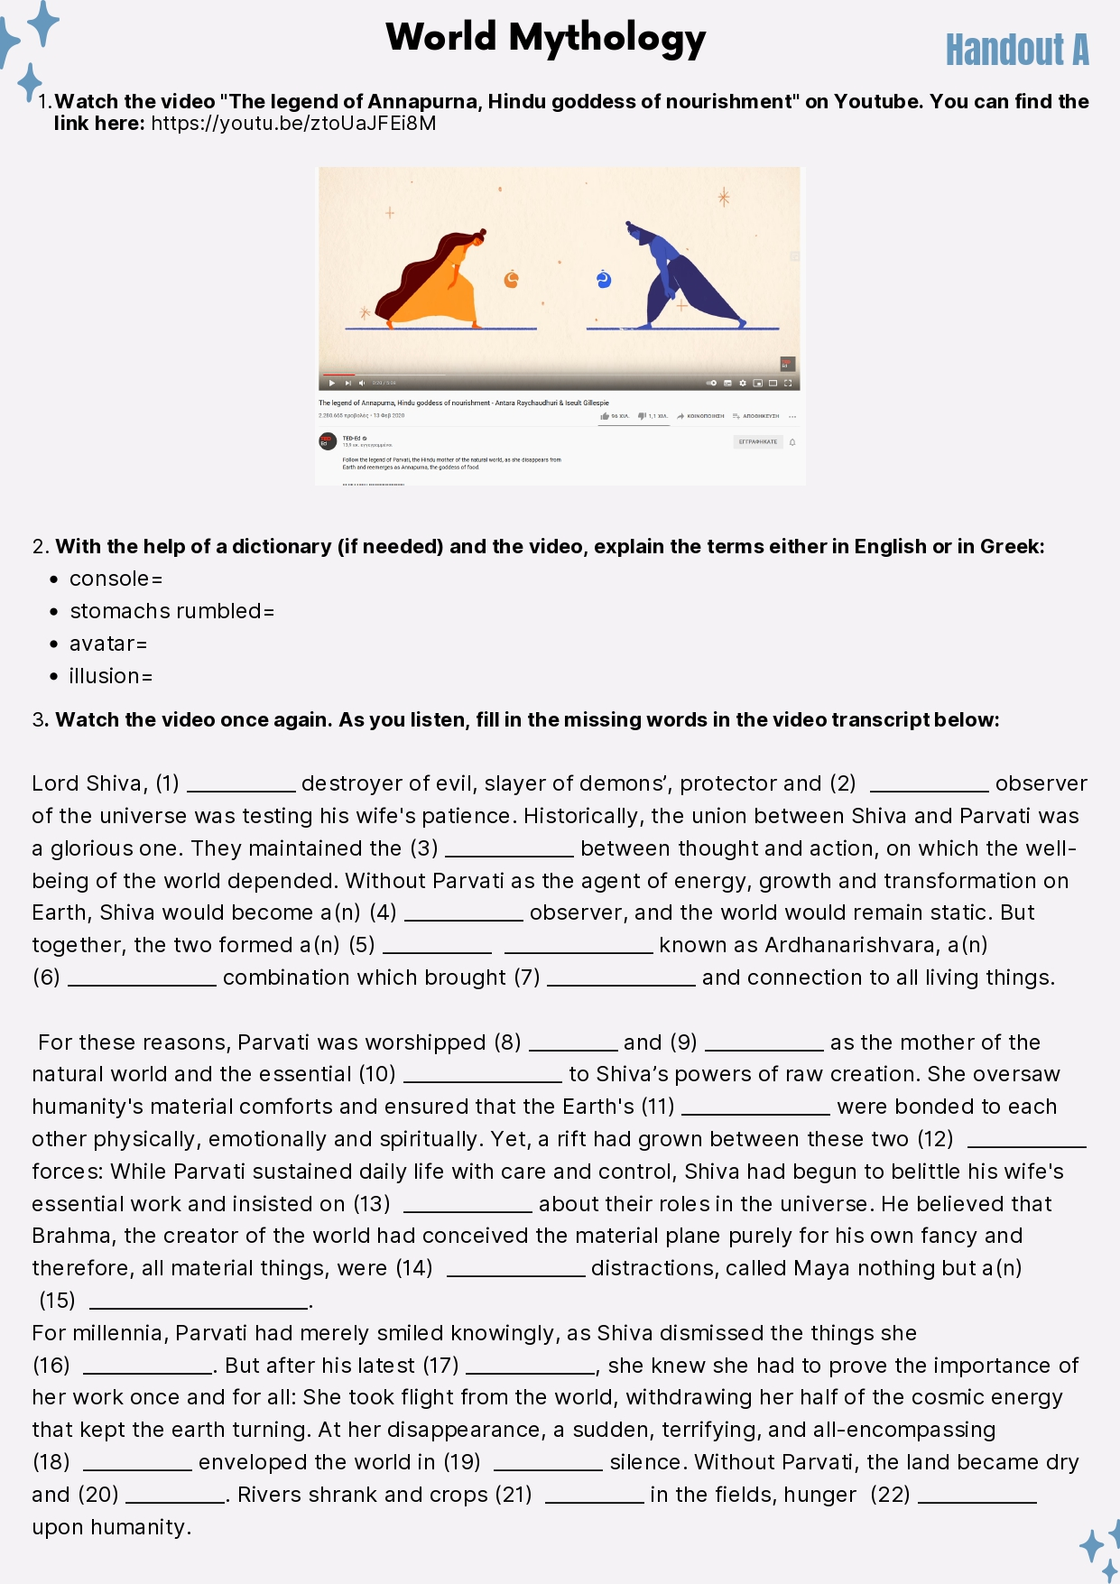
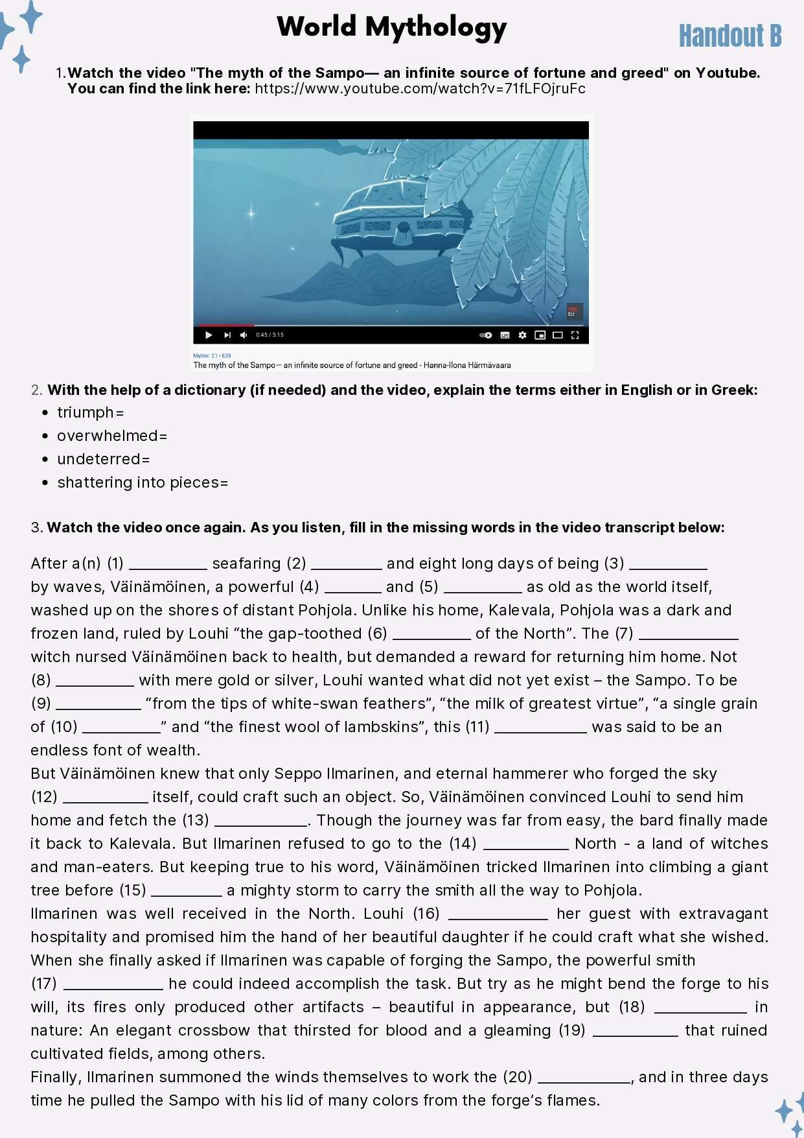
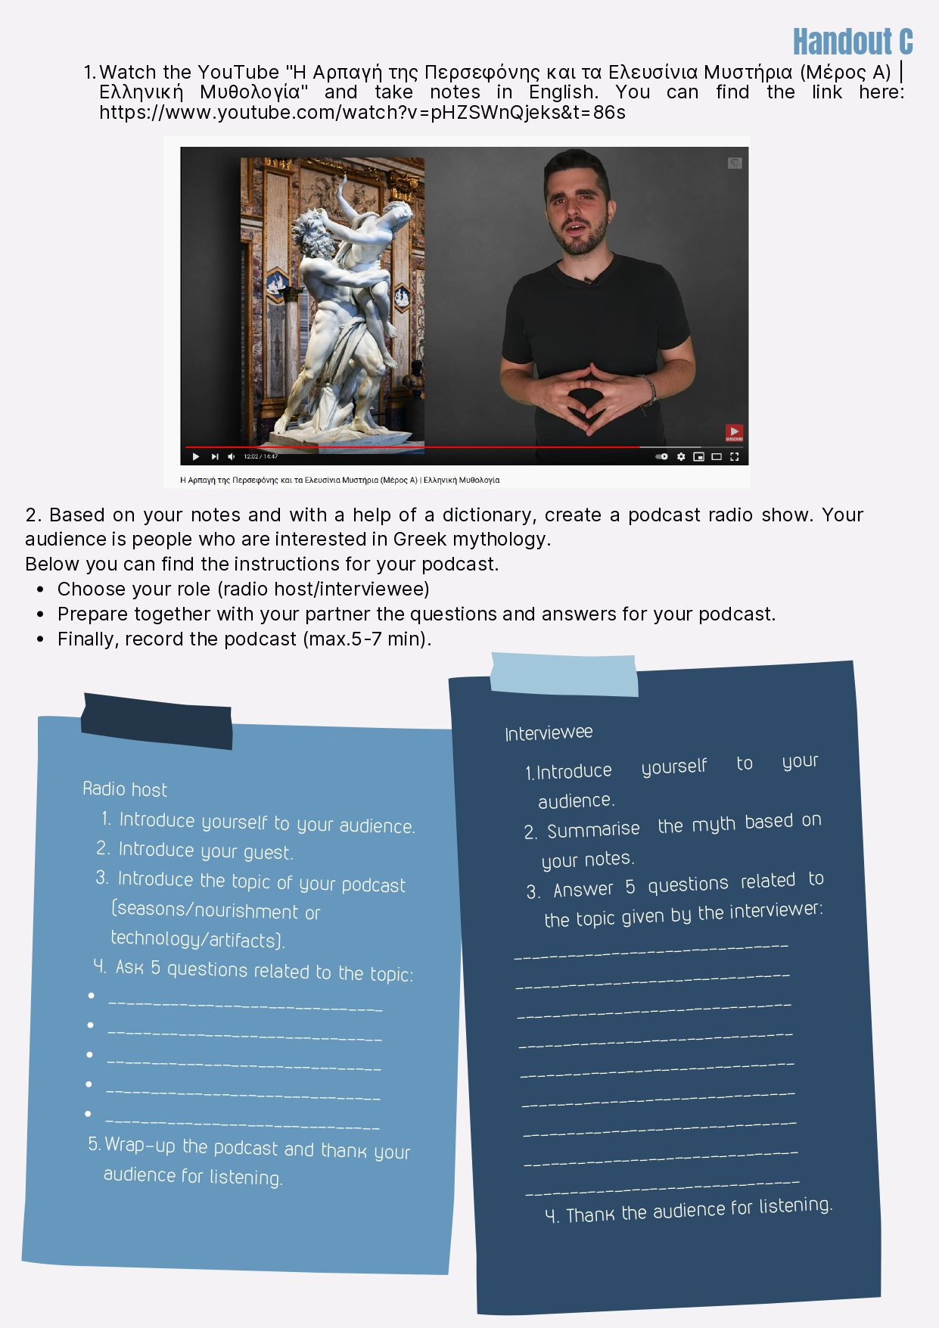
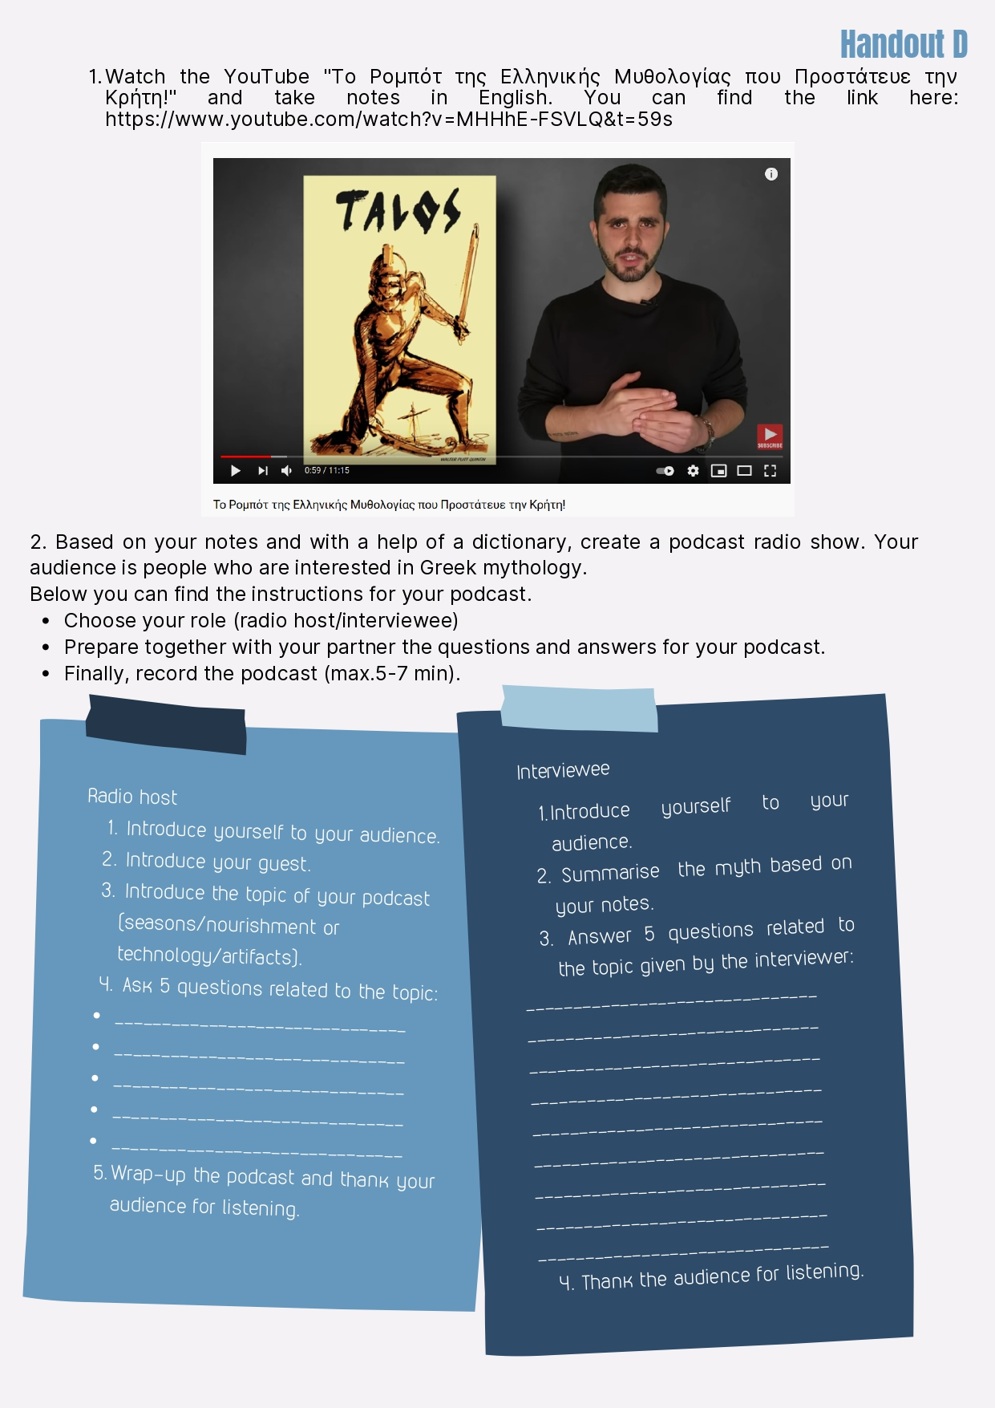
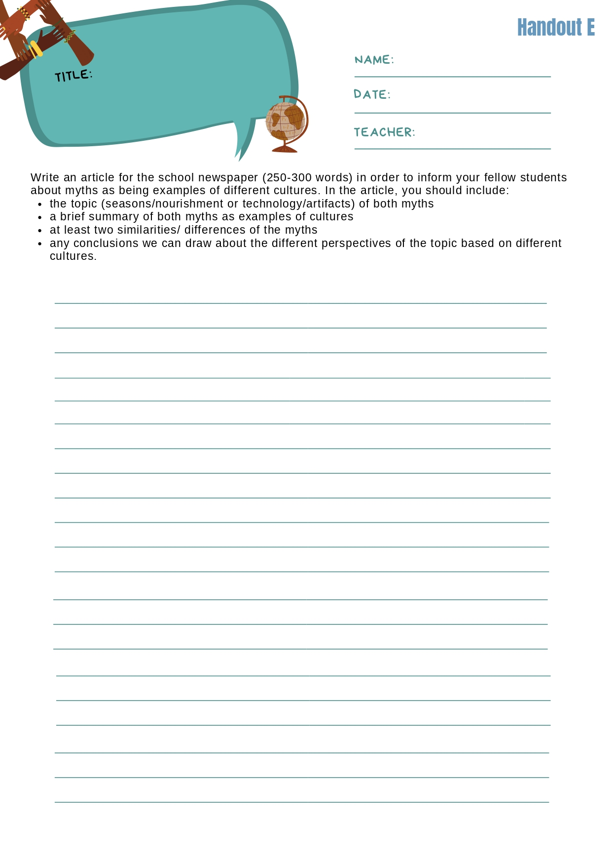

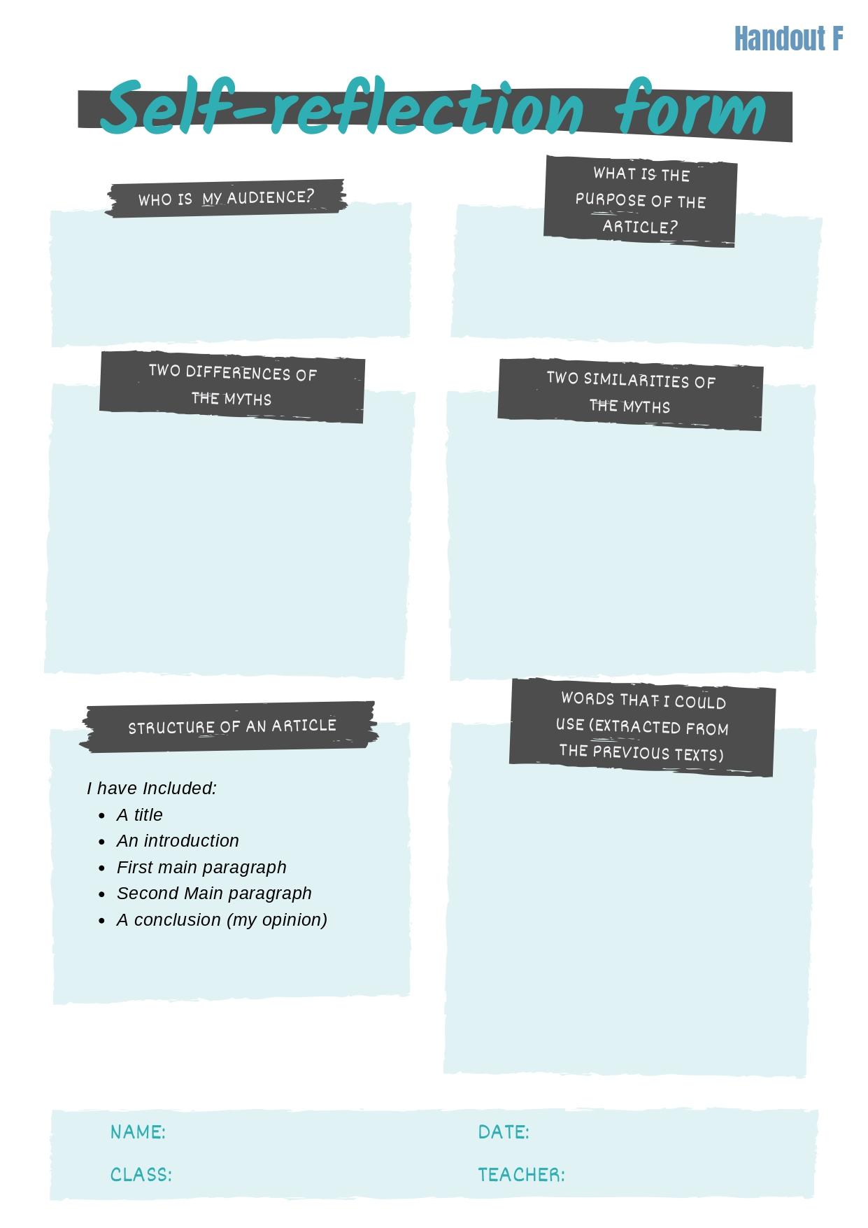

International Standard Classification of Education (ISCED) - Statistics Explained (europa.eu)

