***FOR THE TEACHER***

**Maths Family Connect sessions (English – Italian)**

**Type of task:** Relaying information from a poster.

**Educational level**: Primary/secondary education - ISCED 1/2[1]

**Proficiency level:** A2-B1

**Short description and aim of the activity**:

Students are to relay information and explain data from a poster about Maths evening classes for students accompanied by their parents.

**Background information (if applicable):**

A number of Maths evening classes are being organised where students are invited to attend with their parents to “connect” with Maths and through Maths. These sessions will be held in English, which is one of the two official languages spoken in Malta.

**CEFR mediation scale and descriptor** (to which the activity refers):

RELAYING SPECIFIC INFORMATION IN SPEECH AND IN WRITING

* *Can relay (in Language B) specific information given in straightforward informational texts (such as leaflet, brochure entries, notices and letters or emails) (written in Language A).*

**CEFR mediation strategies involved:**

Strategies to simplify a text

Adapting language:

* *Can paraphrase more simply the main points made in short, straightforward spoken or written texts on familiar subjects to make the contents accessible for others.*

Streamlining a text

* *Can identify and mark the essential information in a straightforward, informational text, in order to pass this information to someone else.*

**Languages involved:**

Language A: English

Language B: Italian

**Linguistic objectives. Students will be able to:**

* use information from a text in Language A to produce another text of a different genre in Language B
* find the main ideas within a text
* explain the main ideas in a text orally and in writing

**Other competences involved:**

* Media and information literacy (ability to obtain and analyse information through ICT)
* Interpersonal skills (communication and collaboration)

**Time/lessons needed for the activity:** 1.5 hours

**Resources required:**

A copy of the worksheet for *Maths Family Connect* for each student

**Procedure**:

|  |  |  |  |
| --- | --- | --- | --- |
|  |  | Class organisation | Ideas for differentiation |
| Step 1 | Students will discuss whether they have ever been asked to read or translate a text in English to somebody who does not speak this language. Was it easy for them to do so? Were there pictures or diagrams which helped them in performing the task? Was it a very important text? Were they helpful? | Plenary |  |
| Step 2 | Students are presented with a copy of the worksheet with the poster *Maths Family Connect* and are asked to orally explain the content of the poster to their grandmother. | Individual/ Pairs | Non-Maltese students might benefit from some information about Malta (a map as an illustration, and just a few words about the languages spoken for example).  Students may wish to role-play this situation with a classmate who plays the role of the grandmother. |
| Step 3 | Peer Feedback– Students reflect on how successful mediation was.  Suggested prompts: What did you think was the most important information from the poster you needed to tell your grandmother about?  What information from the poster did you tell your grandmother? | Class discussion | The criteria for this evaluation could be either provided by the teacher or discussed with  the students. |
| Step 4 | Students are asked to read the information which they found on the website and complete the activity *Vero o Falso*. They are to answer **True** or **False** to each one of the statements. | Individual | This and other similar activities can be used to scaffold understanding in preparation for the mediation task in Step 5. |
| Step 5 | Students are asked to write an SMS to inform their best friend about the Maths classes and invite them to register online. | Individual/Pairs | It is also possible to include written interaction by asking the students to exchange messages and respond in the role of the Italian friend. |
| Step 6 | Peer Feedback– Students reflect on how successful mediation was | Class discussion |  |

**Further tips and guidance:**

Teachers may wish to elicit/give some vocabulary relating to Maths as a warm-up before the lesson, like:

* What kind of things do you learn in Maths? (addition, subtraction, multiplication, division, algorithms, etc).
* Do you like Maths? Why or why not?
* Do you think it is important to know Maths? Why or why not?
* What kinds of events do people register / sign in for online? Why?

In Step 2, on presentation of the poster, a map of the island would be useful to show the locality where lessons are being held (in the village of Safi).

In Step 4, the teacher may wish to pre-teach the following phrases/ words if the text appears too advanced for the intended level: parent/guardian, sessions, critical thinking, decision making, range of strategies, exclusive, hosting schools, register, submit, first come, first served.

The use of dictionaries in English, Italian and any other heritage language should be allowed. Online dictionaries could also help the students with accomplishing the tasks.

***FOR THE STUDENT: ACTIVITY WORKSHEET***

**Maths Family Connect sessions**

**Step 1**

Hai mai dovuto leggere o spiegare un testo scritto in inglese a qualcuno che parla solo italiano? Com’è stato per te, facile o difficile? Il testo conteneva immagini che ti hanno aiutato a capire meglio? Era un testo importante? Sei stato d’aiuto?

**Step2**

Vivi con i tuoi genitori a Malta. Tua nonna è italiana e viene a farvi visita durante l’estate. Sei in sala attesa al comune con la nonna che deve firmare alcune pratiche quando vedi il seguente poster. **Spiega il contenuto del poster alla nonna in italiano.**

**Step 3**

Che informazione avete dato alla nonna? Secondo voi cosa andava assolutamente detto e cosa invece poteva essere tralasciato?

**Step 4**

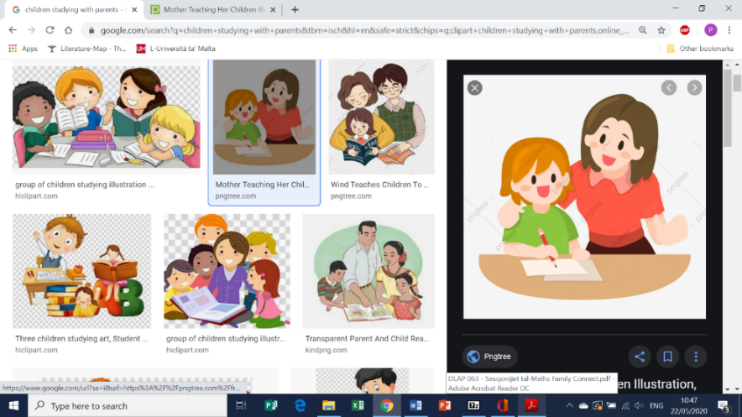A casa parli con i tuoi genitori della possibilità di seguire queste lezioni. Loro sono entusiasti all’idea di frequentare le lezioni di matematica insieme a te. Così potrete passare del tempo insieme e tu migliorerai i tuoi voti! Ti fanno alcune domande alle quali non sai rispondere. Decidi dunque di visitare il sito indicato sul poster per ulteriori informazioni.

**Leggi il seguente test o rispondi *Vero* o *Falso***

The **Maths Family Connect** sessions engage students accompanied by a parent/guardian in exciting, hands-on Maths learning puzzles, games and activities. The sessions are held in the evening, and promote skills such as critical thinking, problem solving and decision making. Furthermore, students are challenged to explore a range of different strategies to solve difficulties while learning from mistakes.

This invitation is open to all Year 5 and Year 6 students attending any state, church and independent school in Malta and Gozo, and is not exclusive for students of the hosting schools. All sessions will be different, so parents/guardians may choose to attend as many sessions as they wish.

All interested participants are requested to register for each session separately. Online registrations are to be submitted by parents/guardians two weeks prior to each session. Participation is free but spaces are limited, so bookings will be accepted on a first come, first served basis.

Registrations for the first session, which is taking place at Safi Primary, will be accepted from Friday 28th February 2020.

**Step 5**

Il tuo migliore amico è italiano, vive a Malta da due anni e viene a scuola con te. Non è molto bravo in matematica, quindi pensi che sarebbe una buona opportunità per lui frequentare le lezioni serali insieme ai suoi genitori.

**Manda un SMS al tuo amico italiano dove lo informi della possibilità di seguire queste lezioni e lo inviti a descriversi online.**

Scrivi un SMS di circa 50-75 parole.

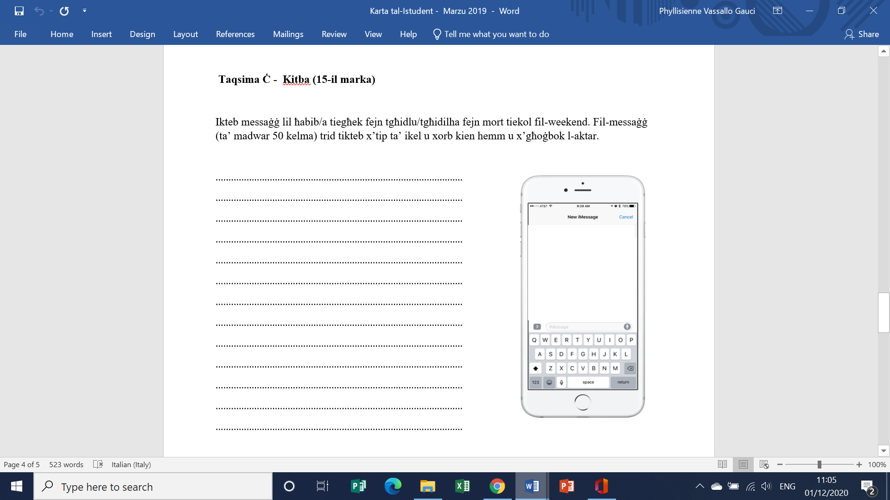



[Primary Mathematics Malta – Quality Mathematics for ALL for life (skola.edu.mt)](https://primarymaths.skola.edu.mt/) (accessed on 8 August 2023)

1. [International Standard Classification of Education (ISCED) - Statistics Explained (europa.eu)](https://ec.europa.eu/eurostat/statistics-explained/index.php?title=International_Standard_Classification_of_Education_(ISCED))