FOR THE TEACHER
First-aid poster
Type of task: project (on first-aid instructions)

Educational level: secondary education - ISCED 2/3

Proficiency level: B2 Level

Short description and aim of the activity:
This is a project activity that focuses on first-aid instructions. Students will create informative posters and present them in front of a small group of students.

Background information (if applicable):
CEFR mediation scale and descriptor (to which the activity refers):
Relaying specific information in writing
- Can relay in writing the significant point(s) contained in formal correspondence (written in Language A).

Processing text in speech
- Can synthesise and report (in Language B) information and arguments from a number of spoken and/or written sources (in Language A)

CEFR mediation strategies involved
LINKING TO PREVIOUS KNOWLEDGE:
- Can clearly explain the connections between the goals of the session and the personal or professional interests and experiences of the participant(s).
- Can formulate questions and give feedback to encourage people to make connections to previous knowledge and experiences.
- Can explain a new concept or procedure by comparing and contrasting it to one that people are already familiar with.

ADAPTING LANGUAGE:
- Can make accessible for others the main contents of a spoken or written text on a subject of interest (e.g. an essay, a forum discussion, a presentation) by paraphrasing in simpler language.

BREAKING DOWN COMPLICATED INFORMATION
- Can make a complicated issue easier to understand by presenting the components of the argument separately.
- Can make a complicated process easier to understand by breaking it down into a series of smaller steps.

STREAMLINING A TEXT
- Can simplify a source text by excluding non-relevant or repetitive information and taking into consideration the intended audience.
- Can edit a source text by deleting the parts that do not add new information that is relevant for a given audience in order to make the significant content more accessible for them.
- Can identify related or repeated information in different parts of a text and merge it in order to make the essential message clearer.

AMPLIFYING A DENSE TEXT
- Can make the content of a text on a subject in his/her fields of interest more accessible to a target audience by adding examples, reasoning and explanatory comments.
- Can make concepts on subjects in his/her fields of interest more accessible by giving concrete examples, recapitulating step by step and repeating the main points.
- Can make new information more accessible by using repetition and adding illustrations.

Languages involved
- Version 1: Language A (Finnish) – Language B (English)
- Version 2: Language A (Greek) – Language B (English)
- This activity could also be adapted for Languages A-B-C.

Linguistic objectives. Students will be able to:
- compare information presented in two different types of texts (YouTube video and article)
- summarise information from Language A to Language B.
- break down information presented in the source texts.
- design a poster about “heat exhaustion” and “choking” in Language B.
- evaluate their performance.
- evaluate their classmates’ poster presentation.

Other competencies involved:
  - Critical thinking
  - Media literacy (analyse media content)
  - Inter-personal skills (teamwork)

Time/lessons needed for the activity:1-2 lessons

Resources required
- A copy of the handout for each group or share the instruction via e-mail in advance.
- Access to the internet (to watch the YouTube videos listed on the Handouts and to access the websites listed on the handout for tools to create a poster.
Procedure:

 |  | Class organisation | Ideas for differentiation
Step 1 | Warm up: The teacher introduces the topic of first aid briefly, e.g.  What kind of injuries commonly occur during the summer months? (Elicit sunburn, heat exhaustion, allergic reaction to insect bites or stings from sea creatures).  What kind of accident commonly occurs while people are eating? (Elicit choking)  Do you know how to give first aid to someone with these problems?  The teacher separates the students into two groups: One will do the activities on Handout A, and the other Handout B. Subsequently, the two groups are sub-divided into smaller groups, each of which will prepare their own poster.  The teacher distributes Handout A and B to the respective groups.  Read the instructions for Step 1 on your handout, and make notes while you watch the video. | groups | The teacher could introduce the topic in advance and practise relevant vocabulary/discuss the structure of a poster.
Step 2 | Students read the respective Handouts A and B they have in Language A relating to each video. | groups
Step 3 | Students have to design a poster based on the YouTube video and text they have on their respective handout. Information about this is included on Handout B, page 2.  Teacher explains to the class that they will have to orally present their poster to the class, and that each group’s poster(s) will be assessed by the other group(s), using Handout C. | groups | If the lesson is online, the teacher could give the students the option of an e-poster.  Free templates can be found online
Step 4 | The teacher discusses the features of a successful presentation, perhaps using the following questions in order to motivate the students to participate:  - Can you describe an effective presentation?  - Is body language important? How does it affect a presentation?  - How important is the voice of the presenter? Can you give an example?  - What is important when you think of the design of a poster? (e.g. design, colours, font, size, pictures).  The teacher could discuss with the students in each small group what information they could add in their posters and how they are planning to present the information. | groups | The students can also use Handout C as a way to actively use mediation strategies.
Step 5 | Presentations Round 1: half of the class becomes the audience, and the other half of the class presents their posters in Language B in small groups. (5-10 minutes) | groups and plenary
Step 6 | The audience has to assess the short presentation using the peer-feedback list on Handout D (5 min) |  | The presenters can also assess their work using Handout D as a way to actively assess their knowledge of mediation strategies.
Step 7 | Presentations Round 2: The roles change, and now the presenters become the audience, and the audience becomes the new presenters, so everyone gets the opportunity to present. | plenary
Step 8 | The audience has to assess the short presentation using the peer-feedback list Handout D (5 min) | individual | The presenters can also assess their work using Handout D as a way to actively assess their knowledge of mediation strategies.
Extra resources and/or tips for the teacher
Students learn the specific vocabulary of the languages involved and about the different styles of a poster, e.g., the students could create an “interactive e-poster”, “e-poster”, printed poster, or a paper poster. This will greatly affect the way students are going to present.

Suggestions and ideas for adapting/differentiating for different contexts

- This activity could become a wider project integrated with other subject courses, e.g., health class, biology etc. A first-aid topic that is relevant to students’ lifestyle and the country they are living in is introduced. For example, “heat exhaustion” is a common phenomenon in Greece and Finland during the summer, in Greece, because of the high temperatures, and in Finland because of the constant sunlight.
- This activity can be adapted by using Language A-B-C depending on your context. Students could also find materials both in Languages A, B and C.

FOR THE STUDENT: ACTIVITY WORKSHEET
First-aid poster
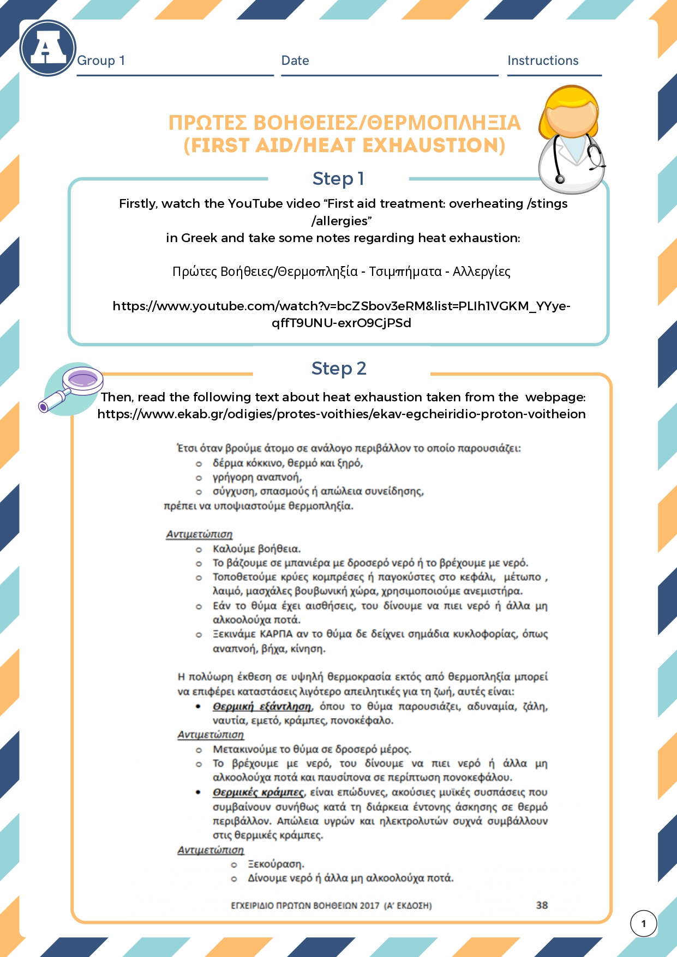
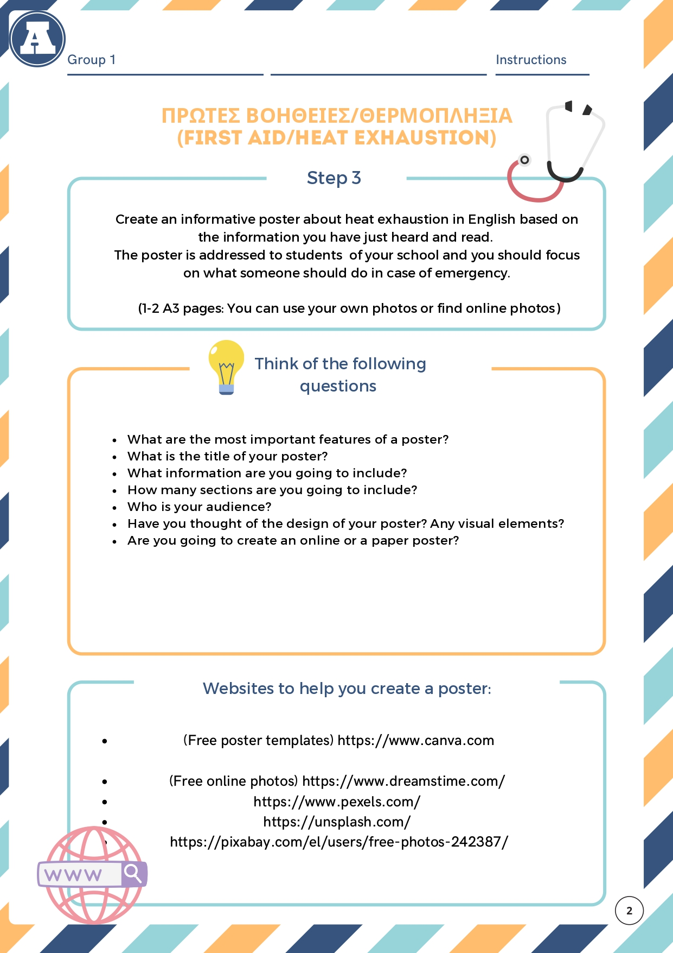
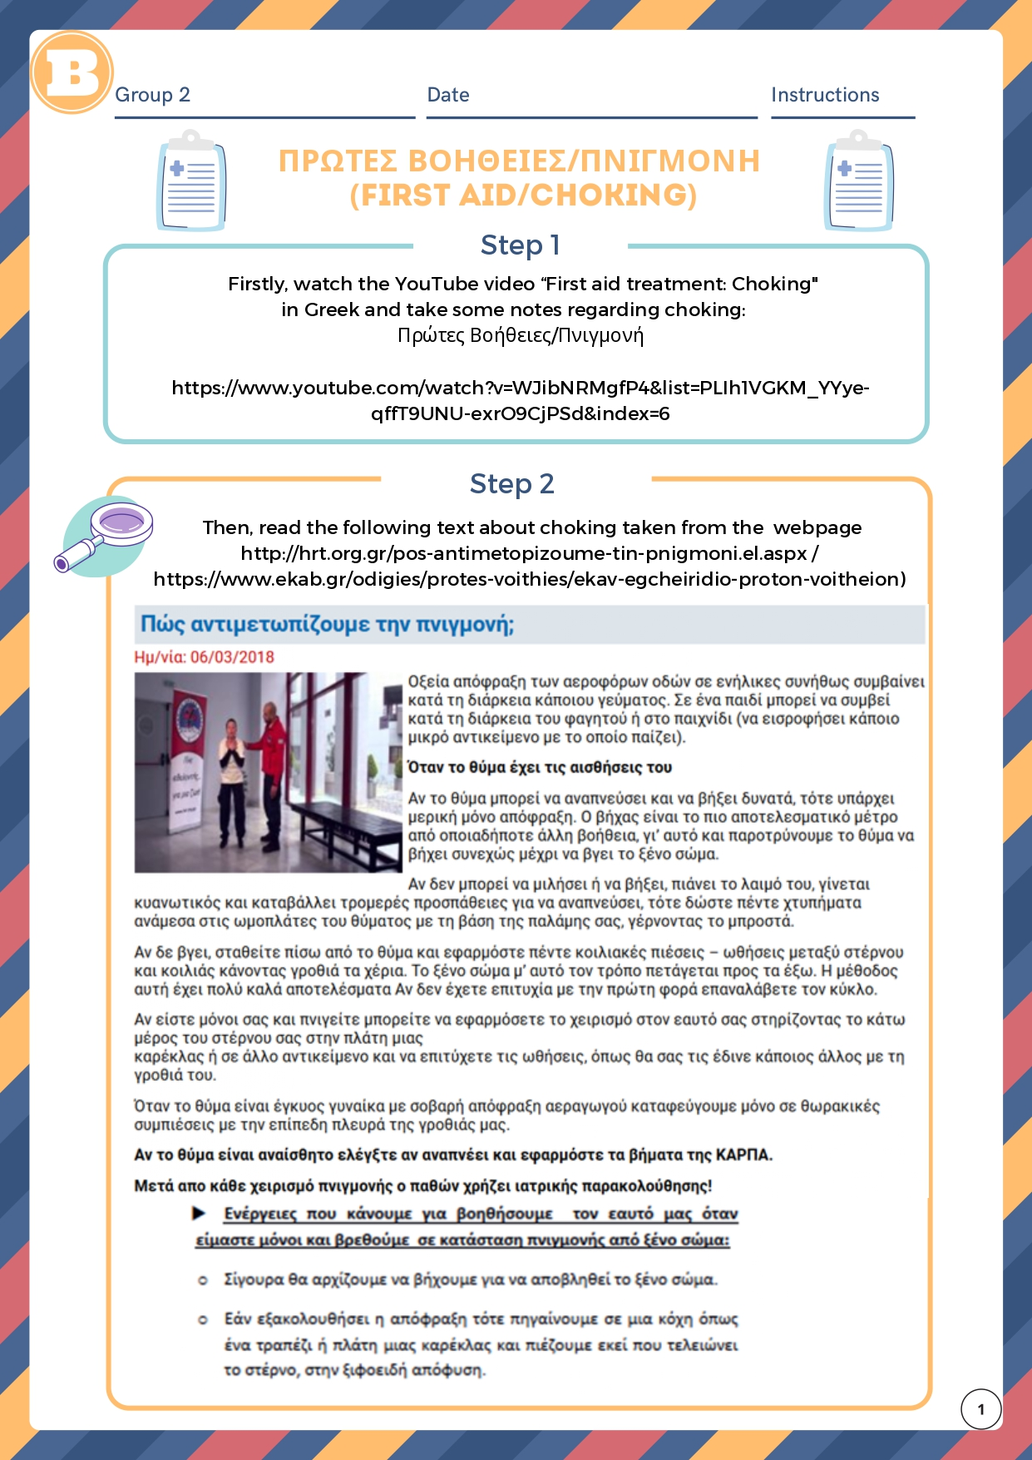

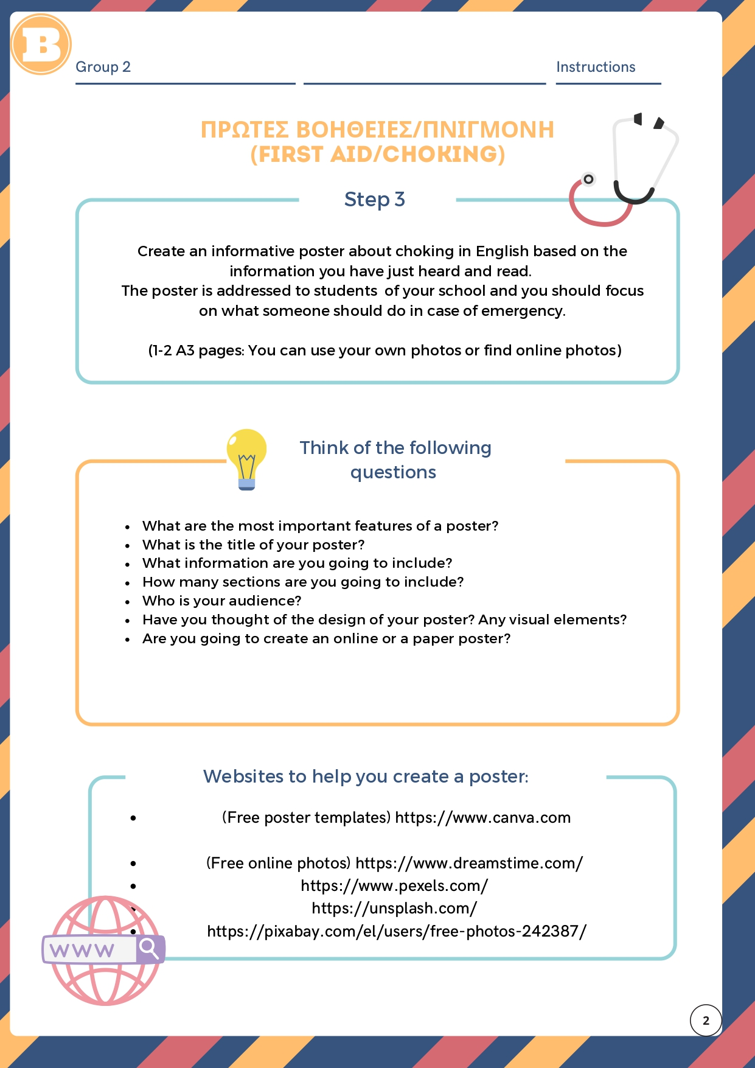

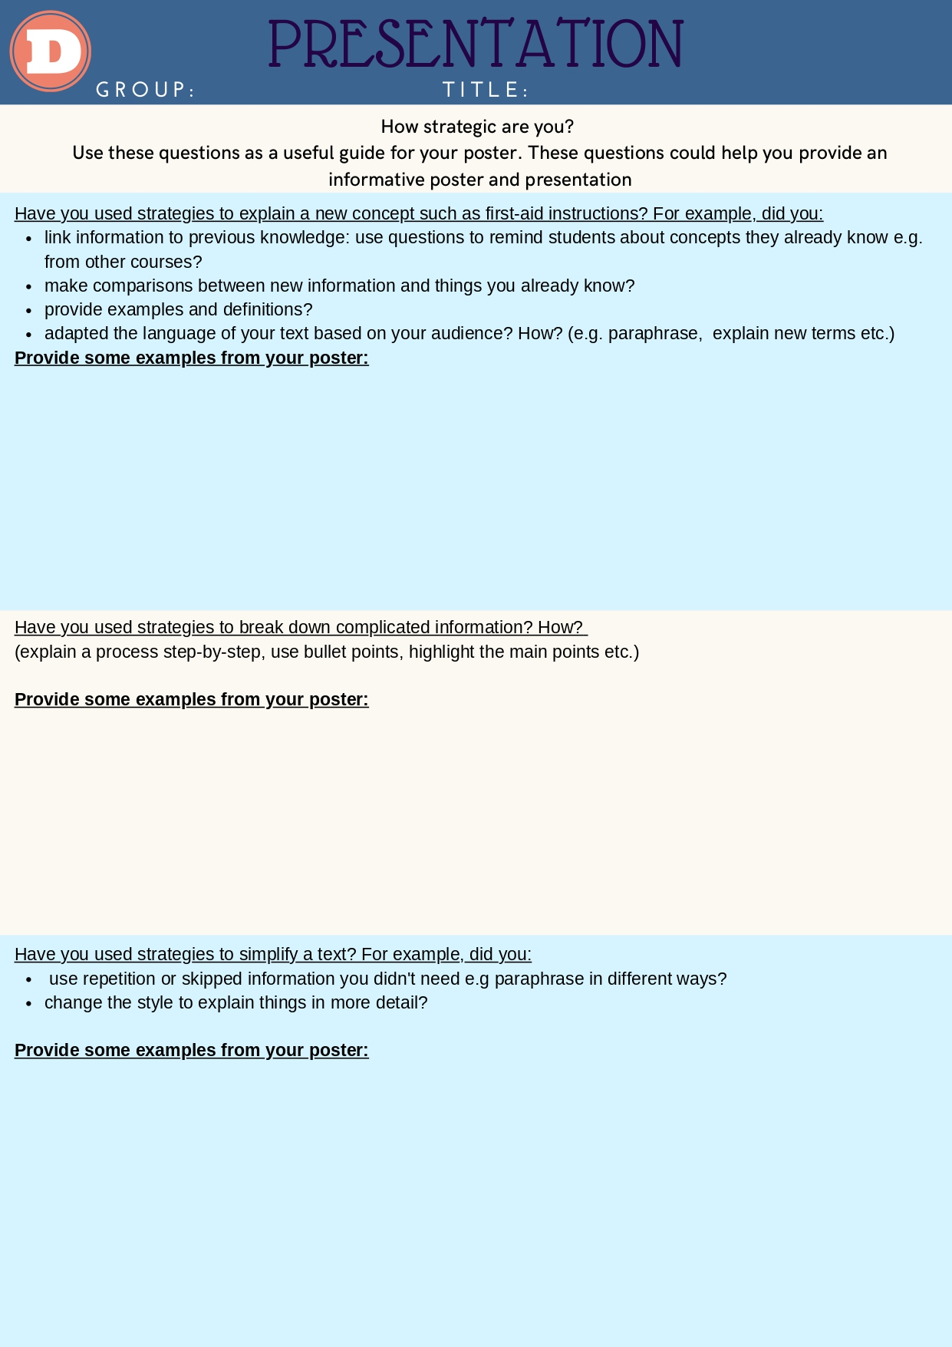

International Standard Classification of Education (ISCED) - Statistics Explained (europa.eu)

