FOR THE TEACHER
Taithí oibre don idirbhliain / Transition Year work experience
Type of task: Researching and planning Transition Year work placements and sharing the results of the research in a short video and text entry on a class Padlet.
Educational level: Transition Year, secondary school, Irish-medium education
- ISCED 2/3
Proficiency level: B1+
Short description and aim of the activity:
The aim of the task is to compile a class Padlet (in Irish) comprising a series of video and text summaries of information students gather online about work experience placements. Students firstly watch a video in which other students share ideas in English for work experience placements, then they use a specific web resource in English to learn about various work experience possibilities for their Transition Year placements. They choose an experience which interests them, and they learn relevant vocabulary in Irish related to careers to help them complete a task in Irish which involves contributing a video recording and short text to a class Padlet.

Background information: Transition Year students usually take part in 2-3 weeks of various work experience placements. This lesson could take place in the Irish language class or in the careers/work preparation class. The lesson is suitable for an Irish medium education school.

CEFR mediation scale and descriptor to which the activity refers:

RELAYING SPECIFIC INFORMATION IN SPEECH
- Can relay (in Language B) specific information given in straightforward informational texts (e.g. leaflets, brochure entries, notices and letters or e-mails) (in Language A).
RELAYING SPECIFIC INFORMATION IN WRITING
- Can relay in writing (in Language B) specific, relevant information contained in straightforward informational texts (in Language A) on familiar subjects.
PROCESSSING TEXT IN SPEECH
- Can collate short pieces of information from several sources (in Language A) and summarise them (in Language B) for somebody else.
- Can summarise (in Language B) the main points made in clear, well-structured texts (in Language A) on subjects that are familiar or of personal interest, although lexical limitations cause difficulty with formulation at times.

PROCESSING TEXT IN WRITING
- Can summarise in writing (in Language B) the main points made in straightforward, informational texts (in Language A) on subjects that are of personal or current interest, provided oral texts are clearly articulated.
FACILITATING COLLABORATIVE INTERACTION WITH PEERS
- Can collaborate in simple, shared tasks and work towards a common goal in a group by asking and answering straightforward questions.
COLLABORATING TO CONSTRUCT MEANING
- Can organise the work in a straightforward collaborative task by stating the aim and explaining in a simple manner the main issue that needs to be resolved.
ENCOURAGING CONCEPTUAL TALK
- Can ask why someone thinks something, or how they think something would work.

CEFR mediation strategies involved:

Strategies to simplify a text:
- Streamlining a text:
Can identify and mark (e.g. underline, highlight etc.) the essential information in a straightforward informational text, in order to pass this information on to someone else.
Strategies to explain a new concept:
- Adapting language:
Can paraphrase more simply the main points made in short, straightforward texts on familiar subjects (e.g. short magazine articles, interviews) to make the contents accessible for others.

Languages involved:
Language A: English
Language B: Irish

Linguistic objectives. Students will be able to:
- Choose relevant information from an online source
- Summarise the main points of information gathered online
- Understand and use vocabulary in Irish related to careers
- Use new vocabulary orally and in writing
- Collaborate on a task
- Give feedback/help to another student with the oral and written task
- Express opinions and give reasons for a choice.

Other competences involved:
Media and information literacy
- Ability to critically evaluate information and media content
- Ability to obtain and analyse information through ICT
Critical and innovative thinking
- Reasoned decision making
Interpersonal skills
- Communication skills – communicating the results of the research in 2 forms (oral and written), giving and receiving peer feedback, expressing opinions.
- Teamwork and collaboration – helping a peer rehearse the recording, giving and receiving feedback, helping to create a whole-class resource, collaborating on a task, pair work.

Time/lessons needed for the activity: 3 (45 min) lessons

Resources required:
- An internet connection (PC or tablet) for access to the website https://careersportal.ie/school/transition_year.php (accessed 8 August 2023)
- YouTube link https://www.youtube.com/watch?v=ElYwqJiDvVU&t=172s (segment from 1:35-2:17). (accessed 8 August 2023)
- Access to a Pallet which the teacher can create (example below). The tablet, PC or phone used to access the Padlet will need a recording function.
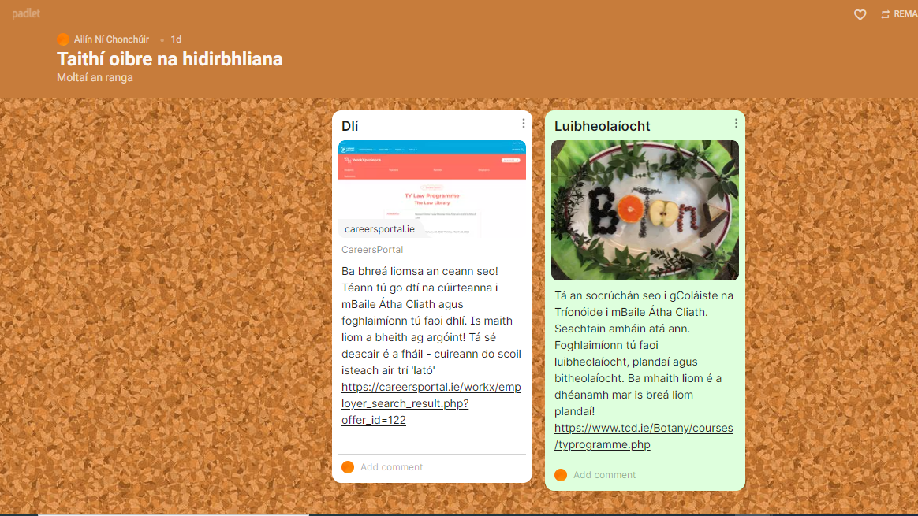
- Access to the terminology resource www.tearma.ie (accessed 8 August 2023) if needed.
- As this task is aimed at Irish-medium education, the student activity worksheet would be in Irish. An English translation of the instructions is provided in the Lesson Plan.
Procedure:
 |  | Class organisation | Ideas for differentiation
Step 1 | Activity Worksheet: Introduction  The teacher explains the aim of the task to the students in Irish:  (Rubric: You and your classmates will be putting together a class Padlet which will contain information you will gather about work placements for your Transition Year work experience. Each student will research placements using the website https://careersportal.ie/school/transition_year.php, they will choose a placement which interests them and share information about that placement with classmates through a video recording and short text on a Padlet.)  Activity Worksheet Task 1  The teacher asks general questions about the transition year work experience and elicits responses (in Irish).  Sample questions: Do you have any ideas about your work experience? What would you like to do? Where can you find information about placements? What do you think the aim of the work experience is? | plenary | This could be adapted for Leaving Certificate students to incorporate further education courses instead of transition year placements.
Step 2 | Activity Worksheet Task 2  Students discuss (in Irish) a question in pairs: ‘Do you have any plans or ideas for your transition year work experience/placement?’ They take notes of their ideas (in Irish). Each pair then shares their ideas with another pair.  (Rubric: You will be watching a video in which students talk in English about their work experience plans. They mention the following places. Put a tick next to words that you aren’t sure of.) | pairs and group
Step 3 | Activity Worksheet Task 3  Students watch a short video in which 5 students talk in English about their work placement plans. In preparation for this, students look at an Irish translation of the words that they will hear. They guess the meanings of words they mightn’t know (it is important that the teacher doesn’t provide the translations at this stage) and then after watching the video they discuss in Irish (teacher-led) whether seeing the words written in English on the screen in the video helped their comprehension of the Irish words.  Link to the video:  https://www.youtube.com/watch?v=ElYwqJiDvVU&t=172s (segment from 1:35-2:17). (accessed 11 August 2023)  (Rubric: Now watch the video. Are there any words you now understand that you didn’t understand earlier? Why? Discuss with your partner and class. What helped you understand?  Watch the video a second time and match each speaker on the left with the placements on the right.) | individual and whole class
Step 4 | Activity Worksheet Task 4  Students watch the video again and complete a comprehension task based on the video – the task is in Irish based on the English video.  - Students discuss which of the placements mentioned in the video would / wouldn’t interest them (in Irish).  (Rubric: If you had to choose one of the placements on the list above, which would you choose? Discuss and compare with your partner.) | individual, pairs
Step 5 | Activity Worksheet Task 5  The teacher demonstrates how to use the transition year search function on the Careers Portal website. https://careersportal.ie/school/transition_year.php  Students then work individually to research a placement which might interest them. They take notes and details in preparation for their Padlet entry, with the following questions in mind: What is it? Where is it? What do you have to do if you are interested in it? Why would you like to do it? The teacher reminds them that they are preparing for both a video and text entry to guide their research.  (Rubric: Your teacher will demonstrate how to use the website www.careersportal.ie to search transition year work experience options. Choose a placement which interests you and find the following information: (i) what is it? (ii) where is it? (iii) what do you need to do if you are interested in it? (iv) why would you like to do it? Don’t forget that the aim of your research is to make a short video recording and text to share that information on the Padlet. Take notes to help you as you research.) | individual
Step6 | Activity Worksheet Task 6  - Students look at a vocabulary sheet which has the careers vocabulary from the website (in English) and the Irish words for the general career categories. They work in pairs to match the Irish-language category with the English-language career.  - The teacher should explain that this is not a translation task – the Irish-language categories are general ones (for example, they match ‘science’ with ‘biological, chemical and pharmaceutical science’ and they match ‘business’ with ‘accountancy and taxation’).  (Rubric: Look at the vocabulary below. Can you match the general categories on the left with the careers on the right? | pairs
Step7 | Activity Worksheet Task 7  Once they have completed the vocabulary task students rehearse their Padlet recording in pairs and help each other write the entry. They can use the terminologywebsitewww.tearma.ie to help if needed. They give each other feedback on their rehearsing of the recordings and on the texts. They adapt accordingly.  (Rubric: Rehearse what you will say in your recording with your partner and listen to his/her rehearsal. Can you help each other? Give each other feedback. Use www.tearma.iefor words you might not know.) | pairs
Step8 | Activity Worksheet Task8  Students make the recordings on the Padlet and write their entries.  (Rubric: Now you are ready! Go to the Padlet, make your recording and write your short informational text about the placement you preferred.) | individual
Step 9 | Activity Worksheet Task 9  Students listen to and read other students’ entries and write comments and questions that they may have for each other. They answer questions that have been posed to them.  (Rubric: Look at the videos and the texts your classmates prepared on the Padlet, write questions you may have in the ‘comments’ and answer questions that you have been asked.) | individual / collaborative

Suggestions and ideas for adapting/differentiating for different contexts
- The careers/work preparation teacher and the Irish language teacher could collaborate on this task.
- The teacher may want to pre-teach the careers vocabulary depending on the class ability.
- The lesson could be followed up with how to apply for courses – preparing an application letter, a CV etc.
- This task could also be adapted for higher level classes i.e. Leaving Certificate students, but focus on the further education section of the website, instead of the transition year section.
- The task could be further developed later in the school year, after the placements – students could contribute to another Padlet describing how they got on in their placements.

FOR THE STUDENT: ACTIVITY WORKSHEET
Taithí Oibre don Idirbhliain / Transition year work experience
Treoir
Beidh tú féin agus na daoine eile i do rang ag cur Padlet ranga le chéile ina mbeidh eolas faoi shocrúcháin éagsúla do thaithí oibre na hidirbhliana. Déanfaidh gach duine sa rang taighde faoi shocrúcháin ar an suíomh https://careersportal.ie/school/transition_year.php, (accessed 19 October 2022) baileoidh siad eolas faoi cheann a thaitníonn leoagus roinnfidh siad an t-eolas trí mhír físe agus téacs gearr a chrochadh ar an Padlet.

Céim 1: Réamhobair
An bhfuil aon rud beartaithe agat don taithí oibre san idirbhliain? Pléigh le do pháirtí agus déan liosta de na smaointe atá agaibh. Ansin roinn na pointí a scríobh sibh le beirt eile.
Focail úsáideacha:
taithí oibre / socrúchán/ cur isteach ar / iarratas
tá sé i gceist agam / tá sé beartaithe agam / tá sé ar intinn agam

Céim2:Tasc stór focal

Beidh tú ag féachaint ar mhír físe ina bhfuil mic léinn ag labhairt faoi na socrúcháin atá beartaithe acu. Tá an liosta áiteanna a luann siad tugtha thíos. Cuir tic le haon fhocal nach dtuigeann tú.

Bunscoil
Réamhscoil
Óglaigh na hÉireann
Fisiteiripe
Teach altranais
Oifig dlíodóra
Ag obair le tréidlia
Innealtóireacht
Saotharlann

Céim3:Mír físe

Anois féach ar an mír físe. An bhfuil aon fhocal sa liosta thuas a thuigeann tú anois nár thuig tú roimhe seo? Cén fáth? Pléigh le do pháirtí. Cad a chabhraigh leat?

Féach ar an mír arís agus ceangail gach cainteoir leis an liosta ceart thíos.

Cainteoir 1 | IBM  Bunscoil  Réamhscoil
Cainteoir 2 | McDonald’s  Óglaigh na hÉireann
Cainteoir 3 | Fisiteiripe  Saotharlann eolaíochta  McDonald’s
Cainteoir 4 | Cúrsa ríomhaireachta  Teach altranais  Oifig dlíodóra
Cainteoir 5 | Ag obair le tréidlia  Innealtóireacht

Céim4: Plé

Dá gcaithfeá dhá shocrúchán as an liosta sin a roghnú, cad a roghnófá? Pléigh agus cuir i gcomparáid le do pháirtí.

Céim5: Taighde

Téigh go dtí an suíomh gréasáin www.careersportal.ie (accessed 19 October 2022). Taispeánfaidh an múinteoir duit conas taithí oibre agus socrúcháin na hidirbhliana a chuardach. Cuardaigh an socrúchán is mó a mbeadh spéis agat féin ann. Faigh eolas faoi na nithe seo a leanas maidir leis an socrúchán: (i) cén rud é (ii) cá bhfuil sé (iii) cad atá le déanamh má tá spéis agat ann (iv) cén fáth ar mhaith leat é a dhéanamh. Ná déan dearmad gurb é an aidhm atá le do chuardach ná taifeadadh beag físe agus téacs gearr a réiteach le roinnt ar an Padlet. Glac nótaí chun cabhrú leat.

Céim6:Stór focal

Anois féach ar an stór focal thíos. An féidir leat na focail sa cholún ar chlé a cheangal leis na cinn ar dheis?
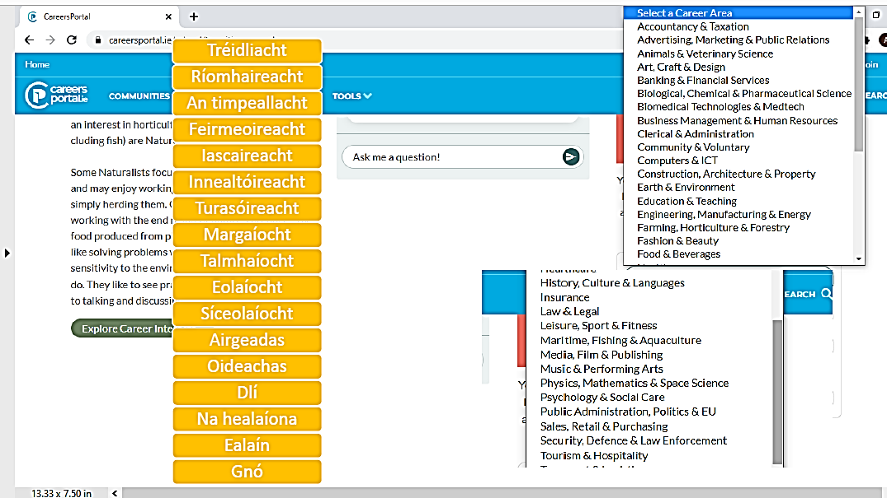
Source: www.careersportal.ie (accessed 19 October 2022)

Céim7: Cleachtadh agus aiseolas

Déan an méid a bheidh á rá agat i do thaifeadadh a chleachtadh le do pháirtí agus éist leis an méid a bheidh le rá aige/aici. An bhfuil aon chabhair is féidir libh a thabhairt dá chéile?Tugaigí aiseolas dá chéile. Bainigí úsáid as www.tearma.ie (accessed 19 October 2022) má tá focail nach bhfuil ar eolas agaibh.

Céim8:Taifeadadh
Anois tá tú réidh! Téigh go dtí an Padlet, déan do thaifeadadh agus scríobh an téacs beag eolais faoin socrúchán is fearr a chonaic tú.

Céim9:Aiseolas
Féach ar théacsanna agus ar mhíreanna físe na ndaltaí eile agus scríobh ceisteanna nó teachtaireacht chucu. Freagair aon cheisteanna a cuireadh ortsa.

The METLA team deeply thanks Ailin Ni Chonchuir for creating this activity.
International Standard Classification of Education (ISCED) - Statistics Explained (europa.eu)

