FOR THE TEACHER
Grocery List
Type of task: Role play

Educational level: Primary education - ISCED 1

Proficiency level: A1-A2 Level

Short description and aim of the activity:
Students should work in pairs (Student A-B). Each student will receive a different worksheet: Student A will receive the Worksheet Grocery List A in Language A. Following the scenario instructions on the worksheet, Student A should relay information related to food and practise polite question forms in Language B. Using the Worksheet Grocery List B, Student B listens carefully to the information introduced by Student A in Language B and then B selects the fruit and vegetables just mentioned by Student A and writes them down in Language B.

Background information (if applicable)
Students should already be familiar with the vocabulary related to food and numbers. Additionally, any culturally/language-specific forms (e.g., polite forms, irregular plurals, etc) should be discussed in advance.

CEFR mediation scale and descriptor to which the activity refers:

Processing text in speech
- A2 Level: Can convey (in Language B) the main point(s) contained in clearly structured, short, simple spoken and written texts (in Language A), supplementing their limited repertoire with other means (e.g., gestures, drawings, words from other languages) in order to do so.

Relaying specific information in writing
- A1 Level: Can relay (in Language B) the point made in short, clear, simple messages, instructions and announcements, provided these are expressed slowly and clearly in simple language (in Language A).

CEFR mediation strategies involved
* For A1-A2, there are no (relevant) mediation strategies provided in the CEFR-CV document.

Languages involved (Language A –Language B)
This task includes four versions depending on the languages involved:
- Version 1: Language A (Greek) – Language B (English)
- Version 2: Language A (English) – Language B (Greek)
- Version 3: Language A (English) – Language B (Finnish)
- Version 4: Language A (Finnish) – Language B (English)

Linguistic objectives. Students will be able:
- to remember and use words related to the topic of food (e.g., fruit, vegetables etc) and numbers
- to ask polite questions (e.g., could you please…?) in language B
- to use plural forms/partitive (e.g., two bananas, two μπανάνες, two banaania etc)

Other competences involved:
- Critical and innovative thinking: creativity
- Interpersonal skills: communication skills, teamwork

Time/lessons needed for the activity: 15-20 minutes

Resources required
- Handouts (Grocery Lists A and B) should be printed in advance.
- Teachers can print duplicate copies of each worksheet so that the students could swap roles and practise both speaking and written production.
Procedure:

 |  | Class organisation | Ideas for differentiation
Step 1 | Warm-up: The teacher asks questions related to food:  - What is your favourite dish?  - Can you tell me about the specific ingredients in language B?  - Have you tasted anything unusual?  - Can you tell me about a dish from another country?  - What is the most common dish in (your country)? | plenary
Step 2 | Role-play:  - The teacher organises the class into pairs, and gives Students A and Students B their respective Grocery List handouts. The teacher also reminds the class how to ask questions.  - Students read the instructions/scenario on their respective handouts, and are given five minutes to prepare their own part (e.g., find any unknown words). | pairs
Step 3 | In Language B, Student A should act out the scenario related to food from the handout Grocery List A (written in Language A), and practise polite question forms. | pairs | The teacher could encourage a student to paraphrase and /or describe the item when their partner cannot understand the word.
Step 4 | Student B listens carefully to the information; then, on the handout Grocery List B, selects the fruit and vegetables they have just heard from Student A, and writes them down in Language B. | pairs
Step 5 | Finally, Student A has to ask B for one additional fruit and one vegetable not included on Grocery List A; student B has to draw pictures of these two additional items on Grocery List B, and then write their names in Language B. | pairs
Step 6 | The teacher asks the students the Language B names of the items on the grocery lists and the extra fruit and vegetables they have just drawn. | plenary
Step 7 | *Extra* activity: The teacher could duplicate copies of the Grocery List handouts so that students could swap roles. | pairs
Step 8 | Homework: The teacher gives the students five popular dishes from around the world (e.g., carbonara, paella, etc) and asks the students to choose one of them. The students search for information in Language A, then draw a picture of it as part of their homework, and write all the ingredients of the dish in Language B. |  | This is still considered a cross-linguistic mediation activity as the students could search for the dish in Language A, make the drawing, and write the ingredients in Language B.
Extra resources
Students should know all the items mentioned on the shopping list, plus the names of the fruits and vegetables illustrated on worksheet B, plus several additional fruits and vegetables.
As an additional means of introducing chunks of language, include the appropriate descriptor for each item, e.g., loaves of bread, a package/box of pasta, a kilo of butter, a bottle of olive oil, etc.
Further tips and guidance:
We should always keep in mind that it is not only the language that we teach, but also the culture that comes with that language. You can find some helpful tips below on how you could also support this aspect of the lesson:
- Vocabulary:
- What products are available in each country?
- What would be included in a typical grocery list in countries where Language A and Language B are spoken?

The teacher should always keep in mind that certain items may not be available in all countries, and therefore care should be taken when introducing vocabulary. For example, in the Grocery List activity, when Greek was Language A, “olive oil” were used. However, for the same activity, when Finnish was Language A, "olive oil" was replaced by "butter", and the generic term "bread" by "rye bread", the most common type of bread in Finland.)
- Grammar:
  - How are polite forms expressed in Language A and Language B?
  - How are plural forms used together with numbers formed in Languages A and B?
There may also be grammatical differences between languages which the teacher should bear in mind. For example, the word “please” exists in both the Greek and English language, but there is not a similar word in Finnish. This should be taken into account, and the term should be explained in advance to the class when using Finnish as Language A or B.)
Another example is the different formation of plural forms from Greek (Language A) to English (Language B), where in general the suffix -sis used (except for some irregular nouns). However, when English was used as Language A and Greek as Language B, the more complicated formation of plural forms in Greek had to be dealt with.
Additionally, Finnish and English languages use different forms/cases with numbers. For example, plural forms are used in English after a number (e.g., two bananas); however, in the Finnish language, we use single form partitive after numbers (e.g. two banaania), a case that exists in Finnish but not in English.)

Suggestions and ideas for adapting/differentiating for different contexts
- If there are students with migrant backgrounds in your classroom, you can ask them about the traditional dishes of their countries.
- You can also ask your students if they have experienced a similar situation in their everyday life and ask them which languages they have used. In this way, even students who have not experienced a similar situation can be aware of the authenticity of this activity (intercultural awareness).

ACTIVITY WORKSHEET
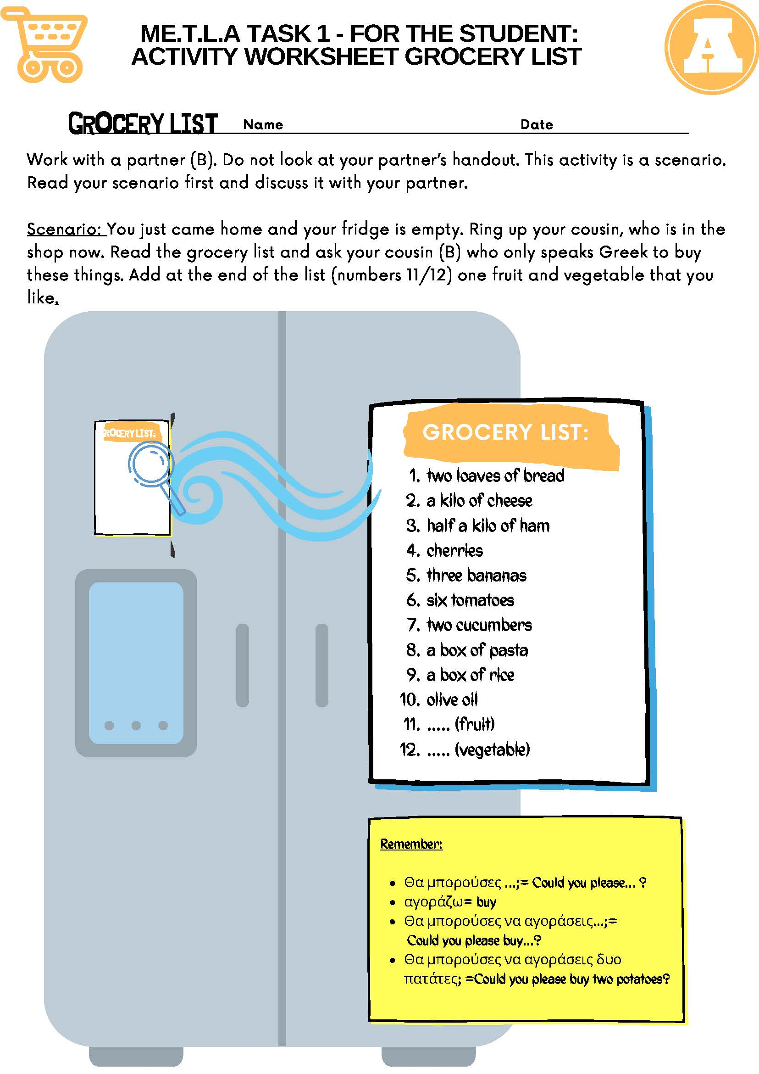

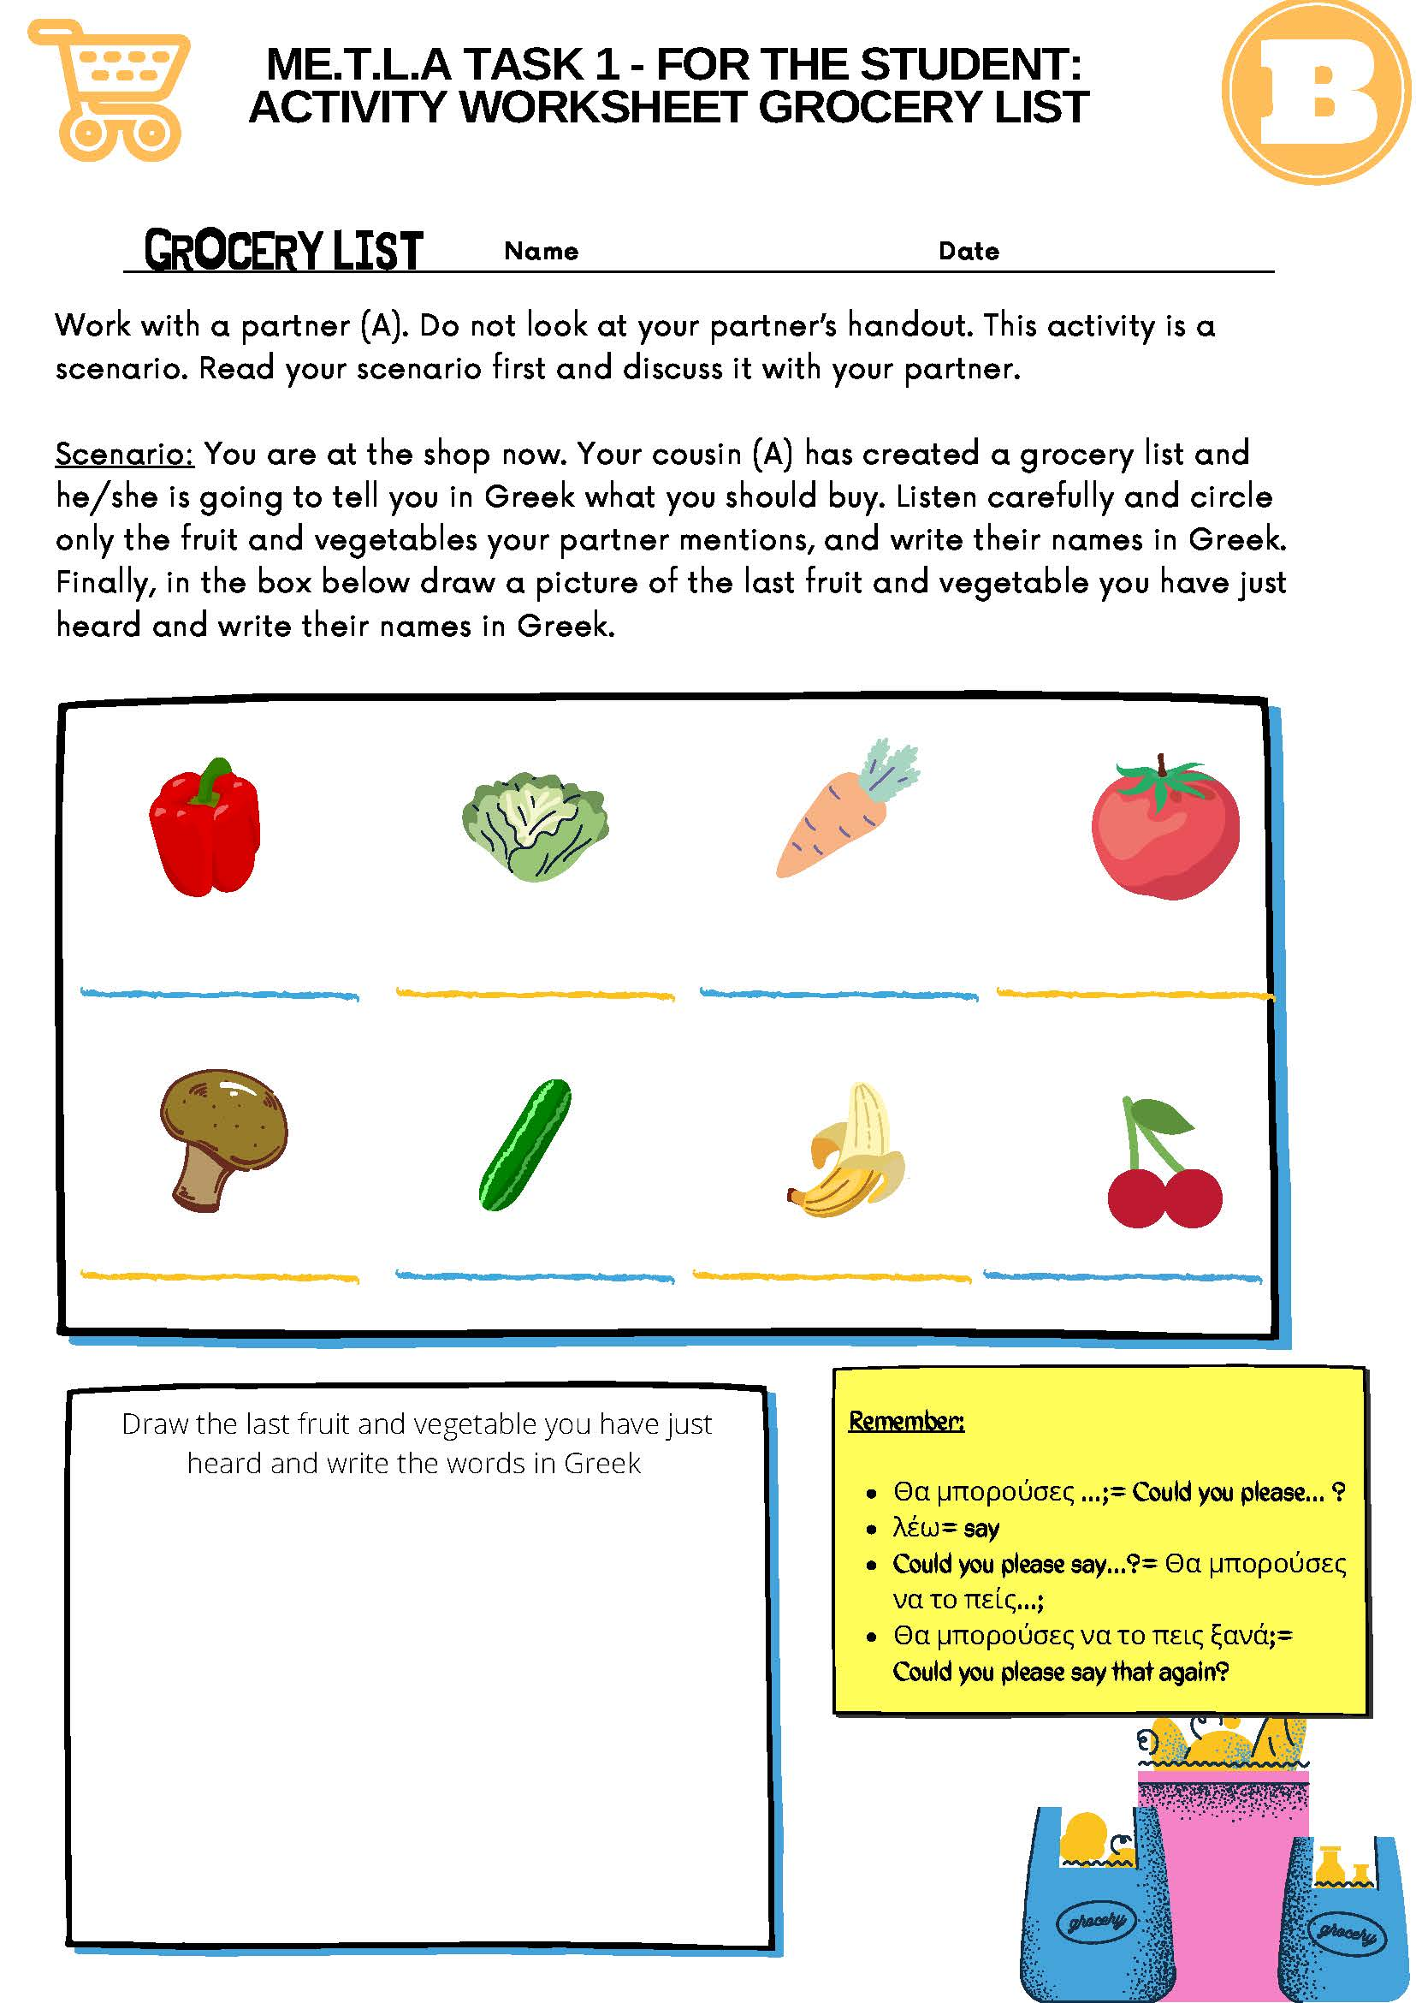

International Standard Classification of Education (ISCED) - Statistics Explained (europa.eu)

