Title: The concept of sustainability

Created by: Laila Palm, Stephanie Palm, Saskia Langer (Belgium)

Short description: In this activity, students learn the concept of sustainability, cultural differences in food and waste management, and sustainable practices. They practice vocabulary and get introduced to waste separation and making sustainable choices in the supermarket. It promotes speaking, listening, and critical thinking.

Language activity is designed for: German as foreign language.

Age group:
- 0-5
- 6-10
- 11-18
- 19-25
- 26-64
- 65+

Level:
- A1
- A2
- B1
- B2
- C1
- Teacher trainees

Learning outcomes:
- Comprehending the concept of sustainability and learning its related vocabulary at an A1/A2 level.
- Understanding cultural differences regarding food and waste management.
- Learning about the waste separation system in the region.
- Becoming familiar with sustainable choices in the supermarket and sustainable practices in the classroom.

Skills:
- Listening
- Speaking
- Reading
- Writing
- Interaction
- Vocabulary
- Grammar
- Mediation
- Pronunciation
- Intercultural
- Plurilingual

ICT tools used: Canva, Readlang, Brisk, Genially, Brisk, Google Docs

Duration in minutes:
- 15-30
- 30-60
- 60-90
- 90-120
- 120+

Will students be marked? No

Timing: Throughout 5 lessons, during the spring term after the regional clean-up campaign.

Description of each stage of the activity:

1 - Introduction: Cultural differences regarding food and waste management
A Canva presentation including AI-generated pictures of people from different backgrounds and their food as a discussion opener. (Prior knowledge: Food vocabulary). Objectives:
- Talking about differences and similarities between students and cultures.
- Talking about waste management in the different home countries.
- Scaffolding (vocabulary list, expressions, sentence structures)
https://www.canva.com/design/DAGjeHX9RC8/Hej_JnzFaCdwUhhSLp1paw/edit?utm_content=DAGjeHX9RC8&utm_campaign=designshare&utm_medium=link2&utm_source=sharebutton (Canva presentation hyperlink) [see Annex 1 if working offline]

2 - Reading comprehension: The concept of sustainability, Vocabulary practice and Quiz (Genially)
Students read an A2-level text about sustainability by using the tool Readlang, which allows them to directly translate difficult words to their mother tongue by clicking on them. After reading the text, they can use Readlang to learn difficult words by using Readlang’s “Explain” and “Words” functionalities. At the end of the lesson, they do a multiple-choice quiz about the text using Genially.

https://readlang.com/library/67ecf3f9ce23c9229cef85c0/from/0 [see Annex 2 if working offline]
https://view.genially.com/67ecf48455eb262710559a2f/interactive-content-nachhaltigkeit [see Annex 3 if working online]

3 - Waste separation in our region
Students receive a Canva-created worksheet and a ChatGPT-created overview about waste separation. The first exercise is a right or wrong exercise about the explanations in the overview. Afterwards, students have to assign waste examples to the fitting trash bin. Next is a discussion exercise about the importance of waste separation.

https://www.canva.com/design/DAGjeVyi8mU/fI-sz4i9mkqjwQoA4T15XQ/edit?utm_content=DAGjeVyi8mU&utm_campaign=designshare&utm_medium=link2&utm_source=sharebutton [see Annex 4 if working offline]

https://www.canva.com/design/DAGjeeyRAng/3cdtaZ16y59cq2I9E7jldw/edit?utm_content=DAGjeeyRAng&utm_campaign=designshare&utm_medium=link2&utm_source=sharebutton [see Annex 5 if working offline]

4 - How to make sustainable choices in the supermarket - Presentation and speaking activity
Students are shown a Brisk-created presentation about sustainable choices in the supermarket. Each slide contains speaking topics regarding different aspects of the general topic. There are also partner activities included, and by the end, students have to write down the changes they want to make in their own lives.

https://docs.google.com/presentation/d/1Yw1bvV4-iSHqE_W5CkbXGRjlaPEyc3bmfa7LHM-BBPE/edit?usp=sharing [see Annex 6 if working offline]

5 - Creating an overview of sustainable practices in the classroom

Students are shown an exemplary version of an overview created in Canva. Afterwards, they are asked to use their own Canva account on their laptop to create an overview on their own in groups.

https://www.canva.com/design/DAGjdzeP5_A/F0Tuer73oWpZfH5IkuV9hg/edit?utm_content=DAGjdzeP5_A&utm_campaign=designshare&utm_medium=link2&utm_source=sharebutton [see Annex 7 if working offline]

OR

Produce a video that explains the waste management based on the overview: https://lumen5.com/

Potential challenges/problems: Maybe sometimes too difficult for A1 students.

Suggestions for learner assessment/self-assessment/feedback/peer feedback:

- Self-assessment: Vocabulary Flash Cards (Readlang).
- Assessment: Genially Quiz about sustainability.
- Peer feedback: Speaking activity and reflection in pairs about sustainable choices - teacher walking around and listening to their speaking production (setting up a grid with key words, full sentences, pronunciation), presentation of the overviews: Sustainability in the classroom

Post-evaluation of the activity: Using Padlet or Mentimeter

Personal comments from the authors: The students should be allowed to use translation tools if the language level is too difficult.


Attribution: Original activity from “Use of ICT in support of language teaching and learning (ICT-REV)”, European Centre for Modern Languages of the Council of Europe. www.ecml.at/ictrev
Annex 1: Canva presentation

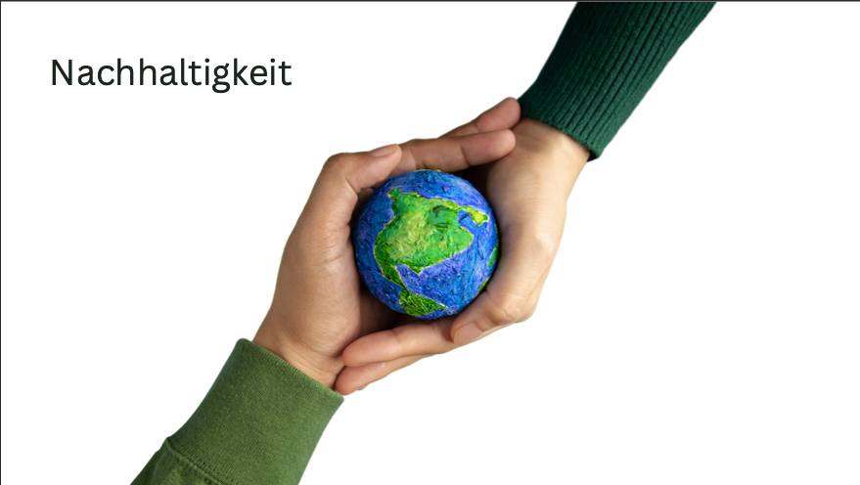
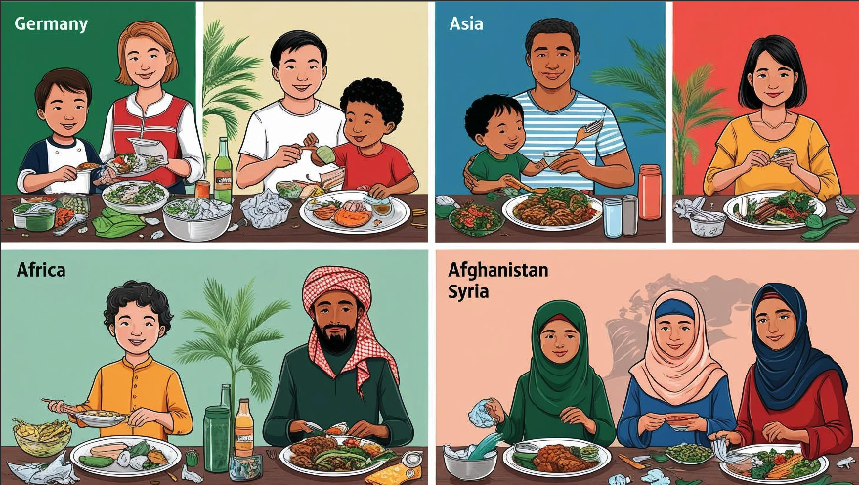
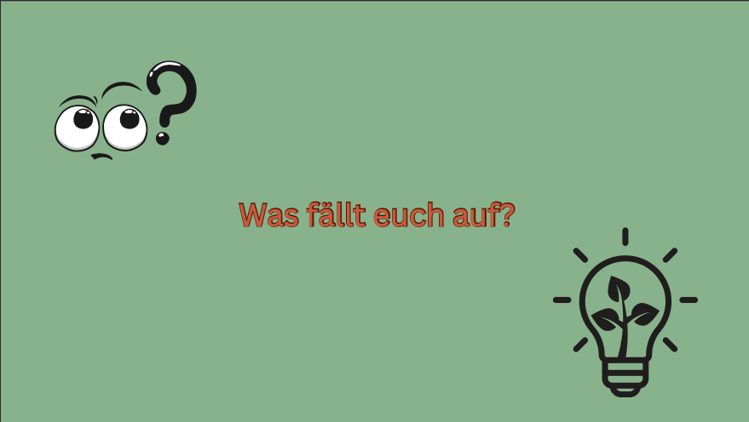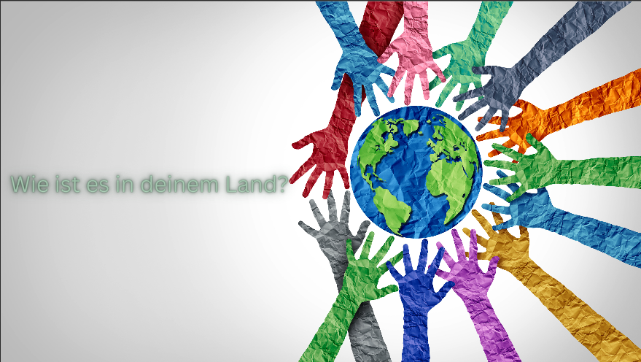

Annex 2: Text on Readlang
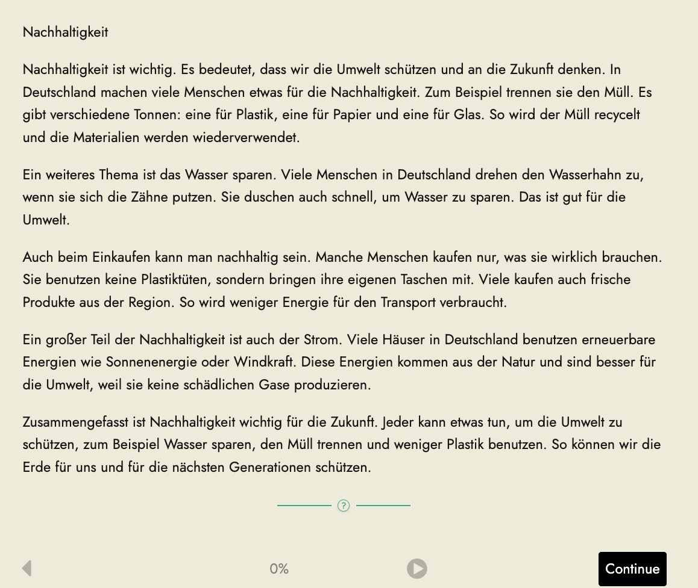

Annex 3: Genially quiz
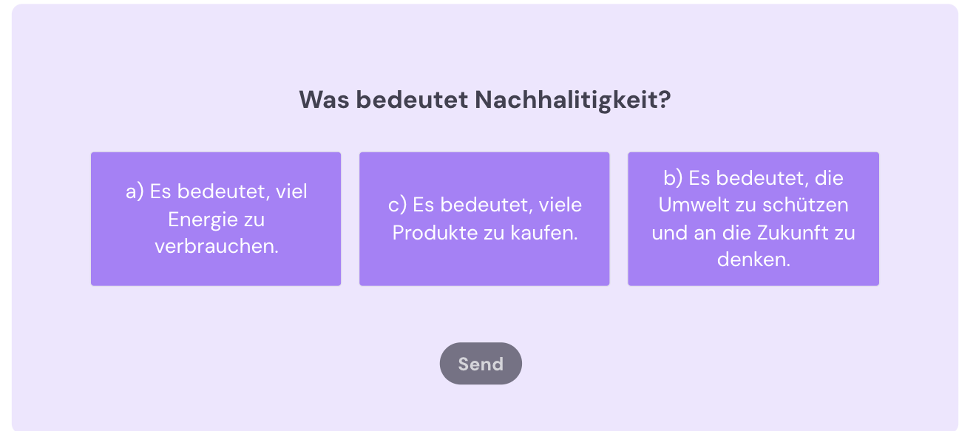
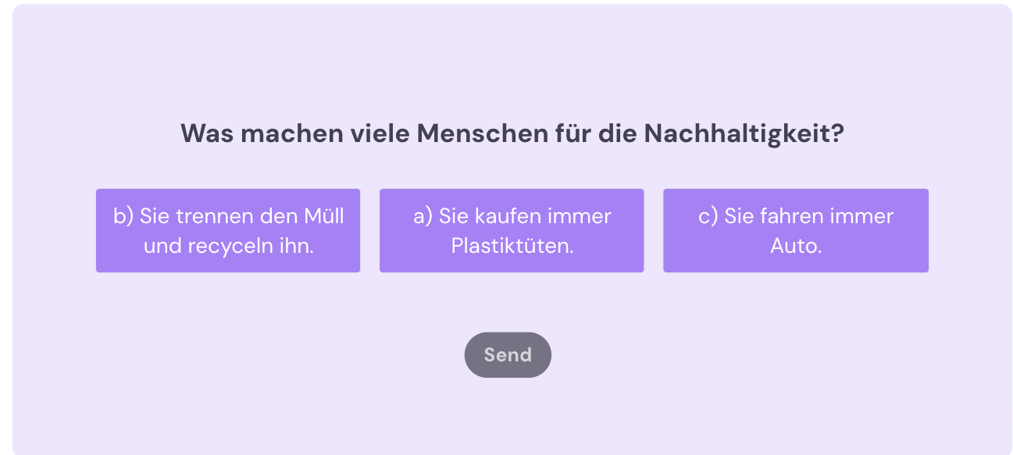
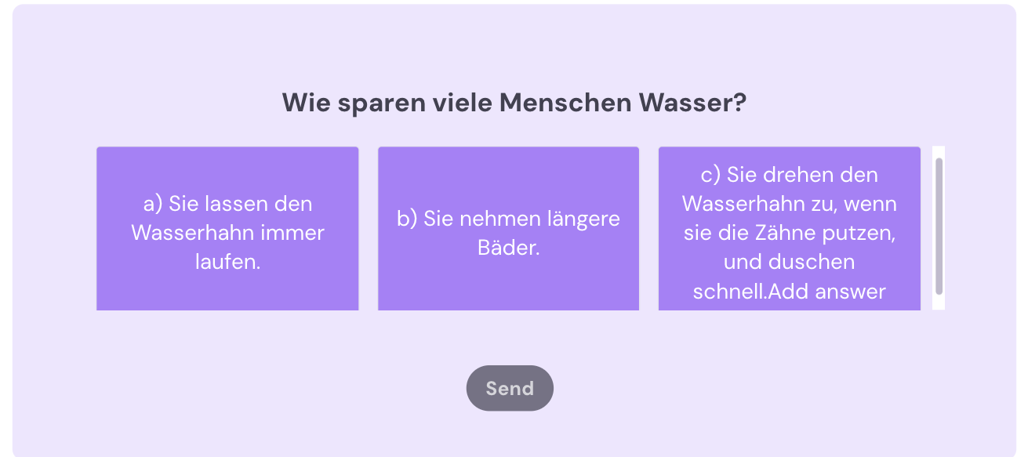
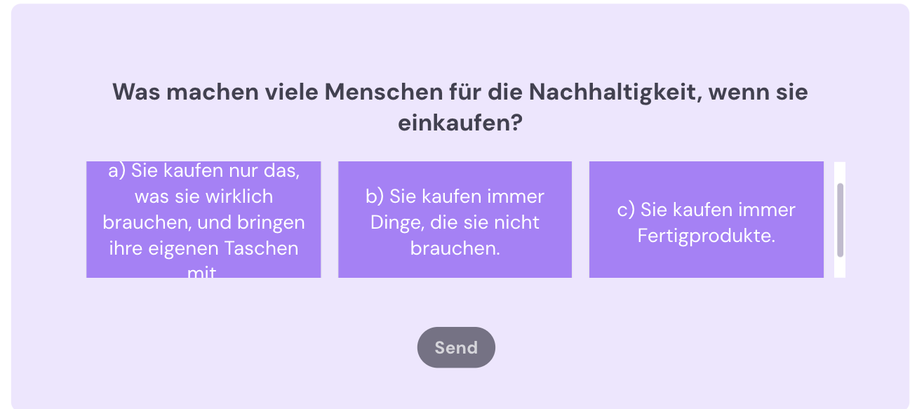

Annex 4: Canva worksheet
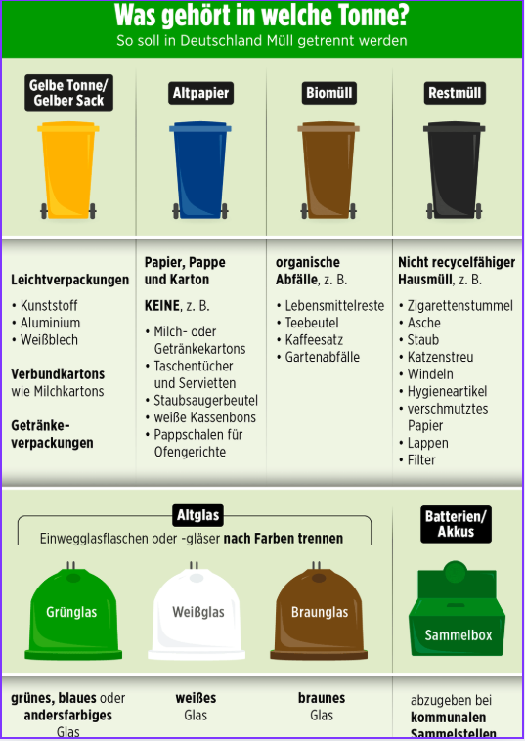

Annex 5: Canva worksheet

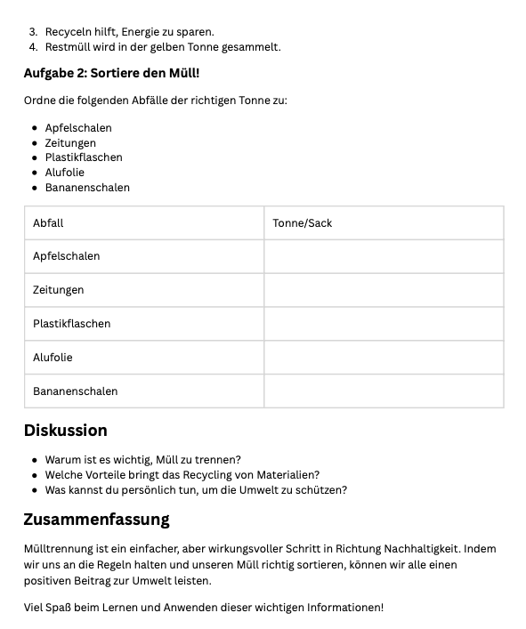

Annex 6: Brisk presentation
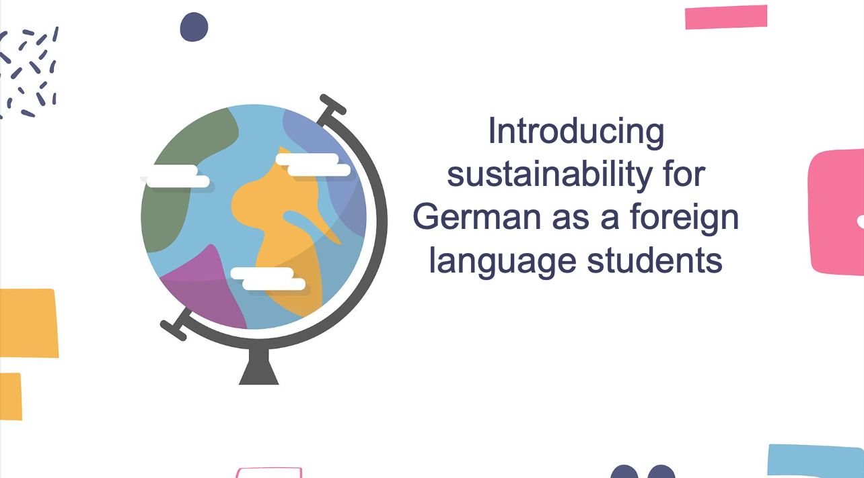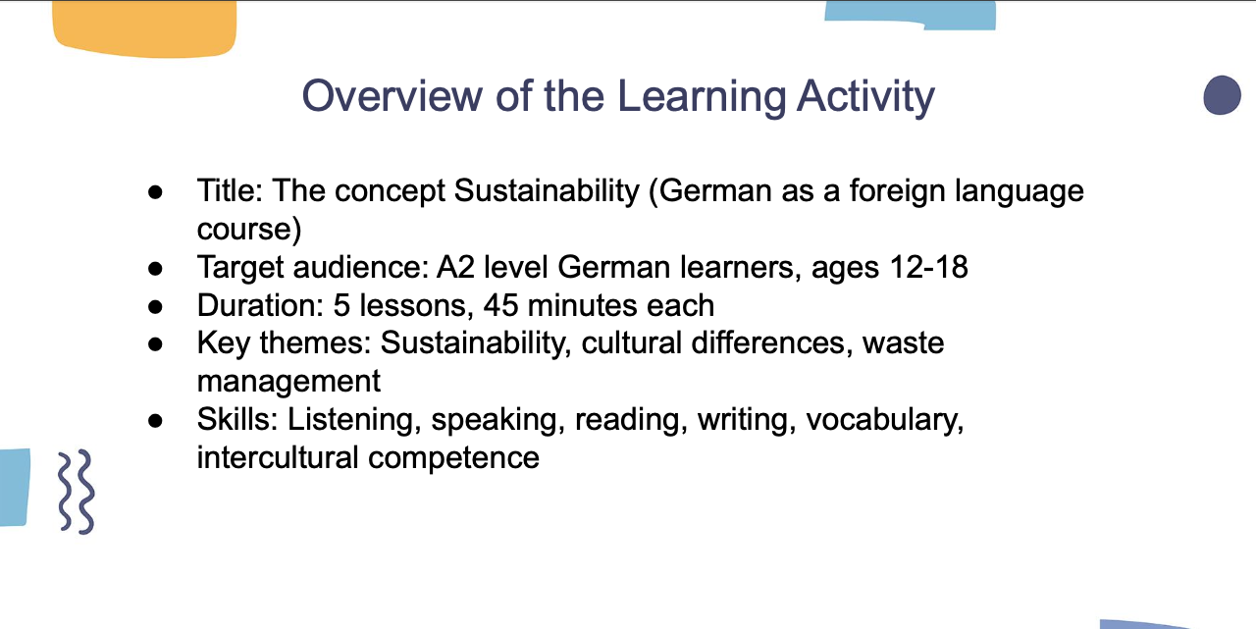
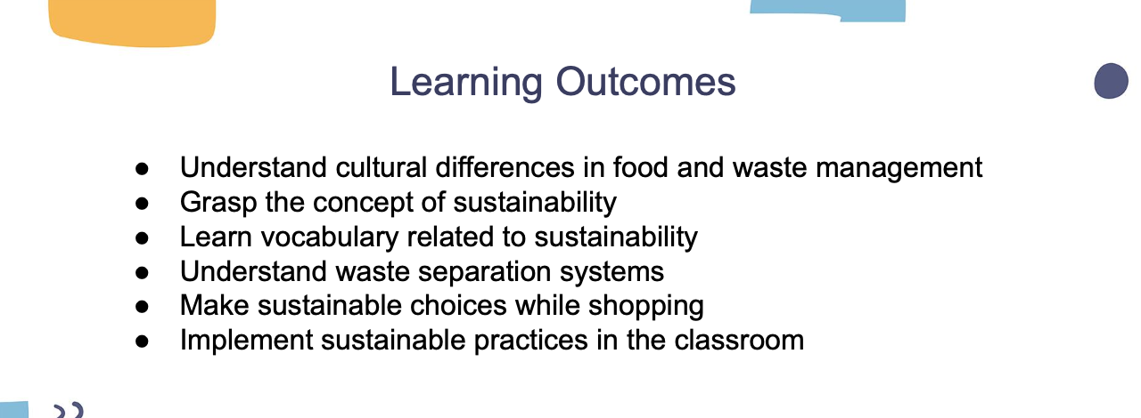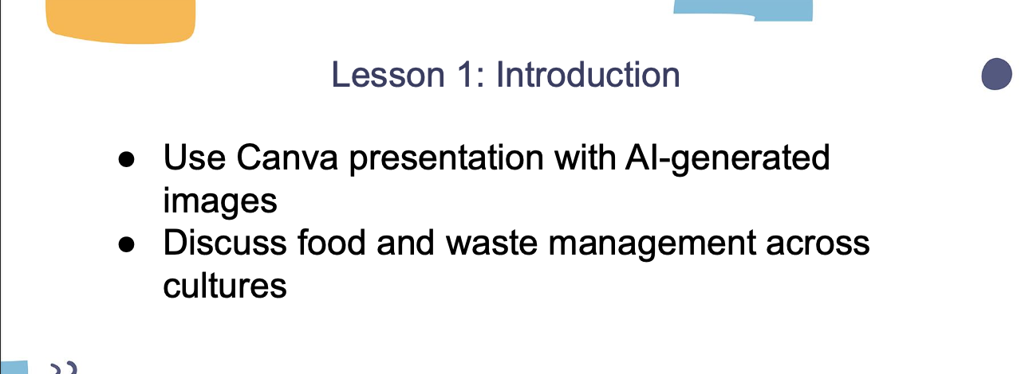
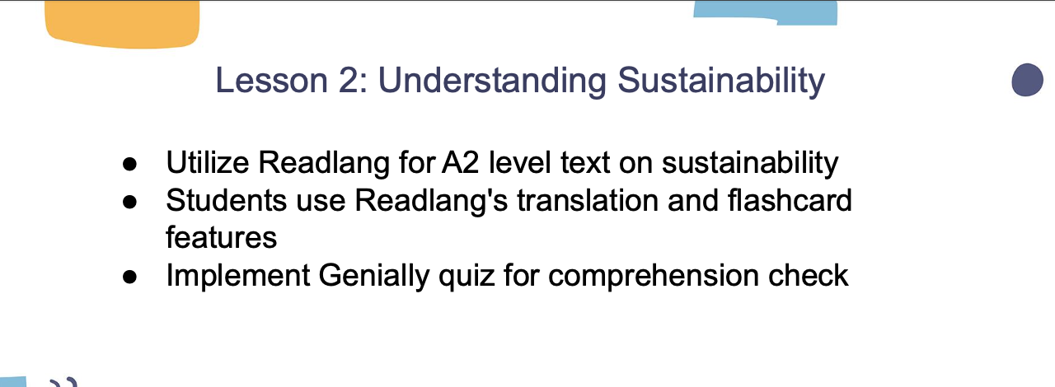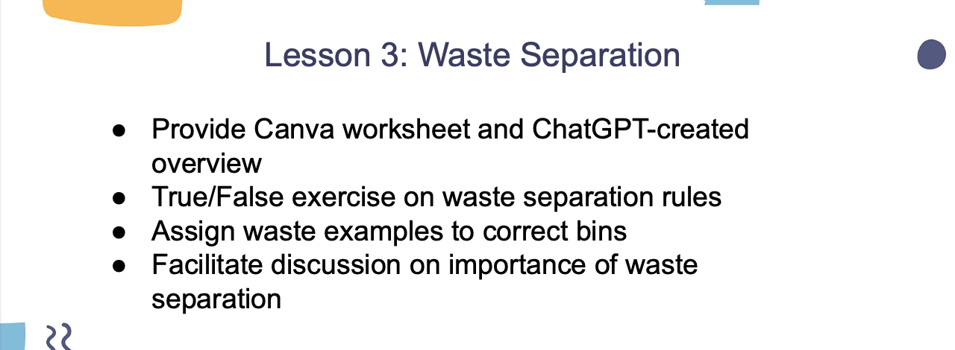
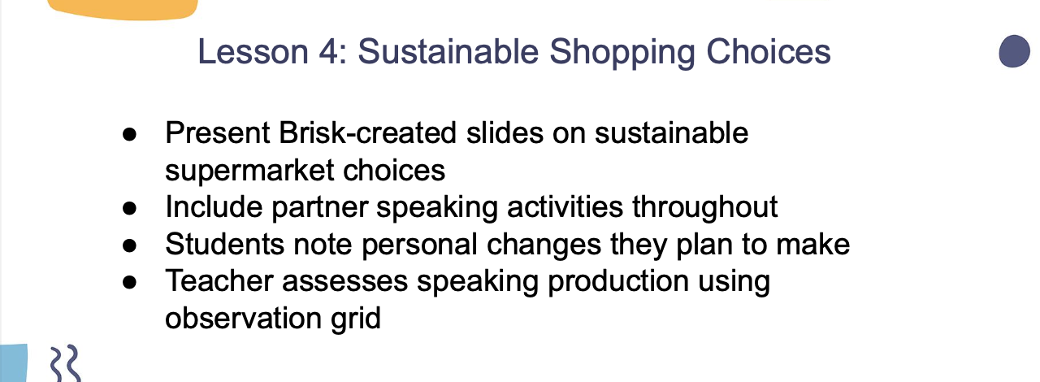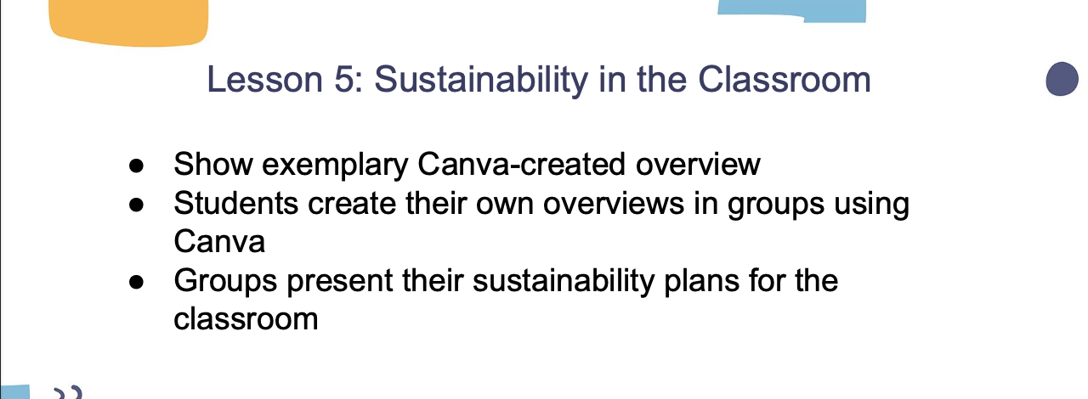
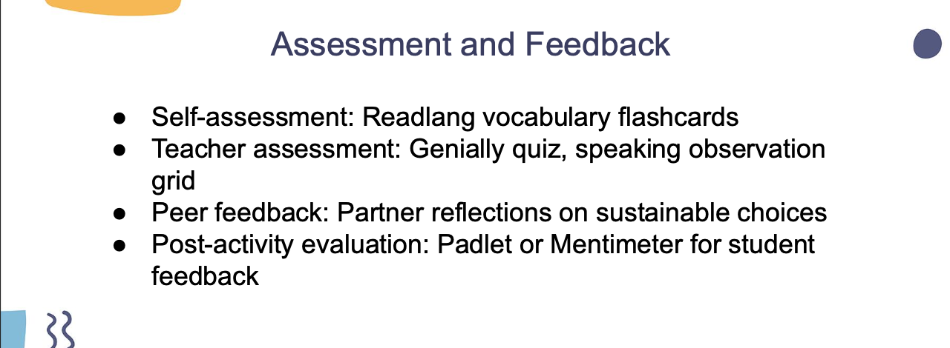

Annex 7: Canva overview of recycling practices

