Title: A Brave New World—Privileges and How to Fix Society

Created by: Emelie Hallquist, Sanna Hillerdal, Lena Hjelmstam, Martin Mirtorp, Elisabeth Nagy (Sweden)

Short description: In this learning activity, students explore the concept of privilege through group work, discussions, text analysis, and listening exercises, together with media and written production.

Language activity is designed for English.

Age group:
- 0-5
- 6-10
- 11-18
- 19-25
- 26-64
- 65+

Level:
- A1
- A2
- B1
- B2
- C1
- Teacher trainees

Learning outcomes:
- Develop pupils’ awareness of social equity and equality
- Empower pupils to take a stand on societal issues
- Being able to choose material to investigate living conditions, societal issues, and cultural aspects in English-speaking countries
- Being able to present findings as well as discuss (in speaking and writing) how their findings influence their view of society and themselves

Skills:
- Listening
- Speaking
- Reading
- Writing
- Interaction
- Vocabulary
- Grammar
- Mediation
- Pronunciation
- Intercultural
- Plurilingual

ICT tool(s) used: Canva (optional), Padlet, Edpuzzle, Socrative

Duration in minutes:
- 15-30
- 30-60
- 60-90
- 90-120
- 120+

Timing: Fall semester (but can work anytime during the year). Approximately 10-12 classes (one class being between 60 and 80 min)

Description of each stage of the activity:

Step 1 - Introduction: 2 classes
- Brainstorm on the whiteboard—what is privilege? Start with what they know and build on it.
- Students go through a checklist of privileges to visualise what they have now, here.

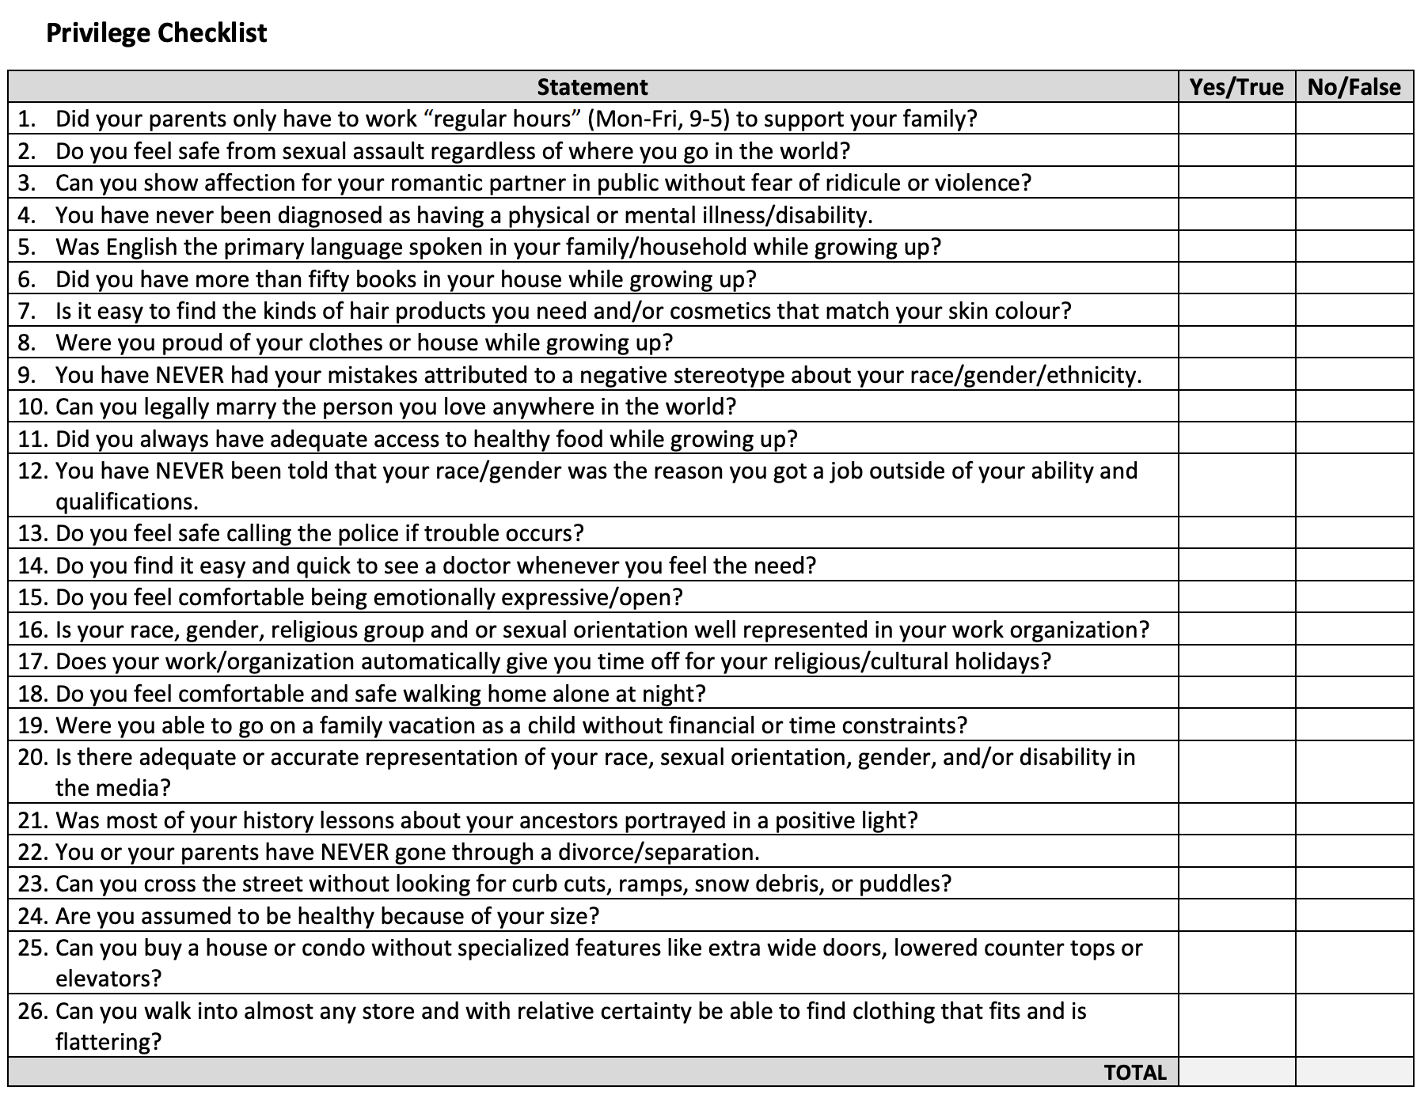

- 4 corners activity: an ethical dilemma in which the pupils take one stand and position themselves in the corner of the classroom that best matches their opinion on the dilemma. A couple of pupils can then explain why they chose the option that they did.
- Show a YouTube video about identifying privileges (the school that wanted to end racism, from a British documentary) here. Discuss the reactions students have!
- Gapminder—do the quiz “You are probably wrong about” here (to check the students’ world view)
*Optional 1: Privilegiepromenaden, here or here
*Optional 2: Kahoot has several free quizzes about privilege; pick one!
- At the end of class 4, a reflection (exit ticket, Socrative) - let the pupils
summarize what they have learnt so far or write what they would like to know more about connected to the topic.
Step 2 - Input
- 2 classes reading and listening:
  - TED talks with Jamila Lyiscott, Jamila Gordon or Chimamanda Ngozi Adichie).
  - Use Edpuzzle to create a listening exercise while watching.
- Reading an academic text: "Just So You Know; I'm Absolutely Completely Normal!" - An Empirical Investigation of Firstness” / "Bara så du vet - jag är fullkommen totalt normal!" - en empirisk undersökning av försthet På svenska, by Lovise Haj Brade http://dx.doi.org/10.1080/08038740.2015.1045939
- Vocabulary work - either the pupils choose words from texts/talks to learn or the teacher and the class together create a vocabulary list to work actively with to expand vocabulary during the project.

Step 3 - Work on production
- Introduce the group work, the countries, the topics, and the different forms of examinations.
  - Group size of 2-6 students (teacher’s preference can decide this)
  - Countries to choose from (pick one):
    - Australia
    - New Zealand
    - India
    - Singapore
    - Ghana
    - Nigeria
    - South Africa
    - Zimbabwe
    - Canada
    - The U.S
    - Barbados
    - Jamaica
    - Ireland
    - The U.K
    - Or use any from the list of countries ( where English is an official language.

- Topics to choose from (pick 3):
- Ability
- Class
- Education
- Ethnicity
- Gender/Gender Identity
- Passing (belonging)
- Religious
- Sexuality

- Search information on both .gov and .org sites and compile it.
Structure:
- Issue/problem
- Consequences
- Solutions/Actions taken by X?

Prepare to discuss your findings:
- What is the effect of the actions taken? Could they be negative or positive depending on perspective?
- What else needs to be done, and who may be stakeholders?

Share by producing a video and uploading it on Padlet.

Step 4 - Presentations
- Students record their presentations in groups and add their presentations to Padlet.
- Groups are then asked to view the presentations as well as comment on two (or more) presentations from other groups:
  - Encourage the students to keep the conversation going through their comments.
  - Students can also give feedback in terms of presentational skills.

Step 5 - Evaluation/Reflection
- Writing an individual reflection OR
- Discuss the project with other students
Questions:
- Based on what you have learned from this project, what is privilege?
- Have you learned anything new?
- Which changes do you think are needed to create a better world?
- How could this project be improved for next year?

Potential challenges/problems:

- Yes:
- It would be nice to collaborate with the social science teachers to get more time to work on the project but also to have the pupils make one project and get two evaluations; however, it may be hard to find a teacher to collaborate with and the time to plan it together, so it could be done only in English.
- Pupils not wanting to film/show their films to others
- Students who don’t want any changes.
- The project stretches over a rather long period; it could run out of steam.
- Collaboration with other teachers not always feasible
- Internet connection or other technical troubleshooting—most activities could be done analogically.

Suggestions for learner assessment/self-assessment/feedback/peer feedback:

- Students should make comments on a couple of videos made by classmates.
- Students should also write a discussion text that will be assessed by the teacher. The instructions for the written assignment could be based on the following questions:
  - What do you want to change? How?
  - What is your part in the world?
  - How can you use your privilege?
  - You can ask a number of different questions based on what you have focused on during the lessons. You can have one question or several!

Preferably the instructions should be written in an NDD format (adapted and easy to follow for those pupils who need extra support in organising an assignment)
- What are you going to do?
- What is the purpose?
- How are you going to do it?
- In what order are you going to do it?
- Who is going to do it?
- How long should it take?
- What happens next?

Post-evaluation of the activity: see step 5.

Personal comments from the authors:
Teacher’s notes:
- Please consider the organization of presentations before starting the project.
- And the appropriate vocabulary that the students might need in order to participate

For further reading:
- Toward a Theory of Anti-Oppressive Education https://projects.iq.harvard.edu/files/deib-explorer/files/toward_a_theory_of_anti-oppressive_education.pdf
- Form of Privilege: https://mediasmarts.ca/digital-media-literacy/media-issues/diversity-media/privilege-media/forms-privilege
- If It Were My Home: https://www.ifitweremyhome.com/
- Dollar Street: https://www.gapminder.org/dollar-street


Attribution: Original activity from “Use of ICT in support of language teaching and learning (ICT-REV),” European Centre for Modern Languages of the Council of Europe. www.ecml.at/ictrev

