Title: Speak Up, Step In: Students Making Sustainability Real

Created by: Pälvi Karlsson, Paula Oksanen, Salla Sissonen (Finland)

Short description: Students take action to implement Agenda 2030 targets into their own lives as well as their communities. Language arts are integrated into other subjects. The objective is to promote students’ agency, ability to participate in and influence the local community. This is more of a concept or framework of an activity that can be adapted to different language, contexts and student needs.
#agency #inquiry #multilingual #sustainable development goals

Languages activity is designed for: Works for any language.

Age group:
- 0-5
- 6-10
- 11-18
- 19-25
- 26-64
- 65+

Level:
- A1
- A2
- B1
- B2
- C1
- Teacher trainees

Learning outcomes:
Content
- Agenda 2030: Sustainable Development Goals and their implications in students’ own lives as well as the local community.
- Students apply their knowledge in creating practical approaches in promoting SDGs in their local communities.

Interaction and communication
- Students communicate both orally and potentially in writing on a topic of shared interest, also utilizing specific language.
- Students are able to communicate with different members of the local community or other specialists of their chosen topic.

Multilingual and Intercultural
- Students make use of their various language and cultural resources to reach the principles of the Sustainable Development Goals.
- Students are familiarized with a variety of languages and cultures in the classroom and their community.

Language reception and multiliteracy
- Students apply their metalinguistic skills in analyzing AI-generated resources.
- Students expand their vocabulary related to global, modern-day challenges.

Language production
- Students are able to communicate their ideas clearly and concisely to their target audience in the language of instruction

Skills:
- Listening
- Speaking
- Reading
- Writing
- Interaction
- Vocabulary
- Grammar
- Mediation
- Pronunciation
- Intercultural
- Plurilingual

ICT tools used:
- Generative AI, such as Copilot, ChatGPT or Gemini
- Students decide the different tools they need for research and presentation of their project.

Duration in minutes:
- 15-30
- 30-60
- 60-90
- 90-120
- 120+

Will students be marked for this activity? Yes, in several school subjects.

Timing: The activity is suitable for a longer period (e.g. 3 months of work depending on how many weekly hours can be dedicated to the project) preferably in the spring term.

Description of each stage of the activity:
- Introduction to the Agenda 2030 topics:
  - Considering the age of the students in the group, the teacher picks different Sustainable Development Goals as topics of the study. [see Annex 1]
  - In addition, the various subjects that are involved in the project must be decided in advance and the teachers must commit to cooperate to avoid overlaps or gaps.
  - The Sustainable Development Goals are introduced to the students, adapting to the languages spoken in the class and student needs.

- Group formation & choosing of topic:
  - Students pick individually what they want to study in detail within the given Agenda 2030 topics.
  - Students are accordingly split into groups of 3.
  - Groups formulate the research questions and how and to whom they will present their findings and conceptual background.
  - In addition, each group decides what concrete outcome/action they can take to promote the realization of the agenda in their surrounding society. (see point 4)
→ E.g., SDG 11 of Sustainable Cities and Communities could have the focal point of promoting sustainable commuting to school among the community the students are a part of.

- Reading and comparison of texts:
  - Previously, students study the topic in their strongest language in the school subjects closest to the theoretical topic. This way, all students, regardless of their skills in the language of instruction, will attain the content needed for the activity.
  - Students are then given a related original text in the language of instruction / target language.
  - Then two adaptations to their language level are produced using two different AI tools, while using the same prompt.
  - Their task is to compare the texts, looking for possible differences and analyzing the accuracy of the simplification.
  - In addition, the students consider critically whether the AI tool presented a reliable simplification of the original text.
→ E.g., a Venn diagram can be used to visualize the comparison of the two texts. [See Annex 1]
→ In addition, AI can be used to provide key concepts related to the topic.

- Design of a concrete outcome/action aligned with the Agenda 2030:
  - Students consider who they need to help them: a tutor, older students, experts outside the school, city officials, parents, community, etc.
  - Students create their own schedule for their project work based on the timeframe the teacher has given.
  - Students work on their project within the timeframe. The teacher, possible tutors, staff and community members support students with their project work. The presentation / outcome / action will be in the target language. Thus, language instruction is integrated into the project throughout the process.
  - The students present the knowledge they have acquired and the conclusions to which they have come to the target audience and take their action.
  - The final outcome, then, is a student-designed, participatory, multi-disciplinary hands-on action promoting the Sustainable Development Goals within the community of the students.
This can, e.g., be a product they make in handicrafts or arts, a dance, or cooperation with a local day-care center or home for the elderly.

Potential challenges/problems:
- The teacher must have in-depth knowledge of their students to be able to guide them through the multi-disciplinary approach. They must also find specific texts for each topic (step 3b).
- Cooperation among several subject teachers is required, which may entail issues with matching timetables.
- The teacher needs to ensure that all students are able to engage with their project on the level of their own learning and development.


Attribution: Original activity from “Use of ICT in support of language teaching and learning (ICT-REV)”, European Centre for Modern Languages of the Council of Europe. www.ecml.at/ictrev
Annex 1: The Sustainable Development Goals
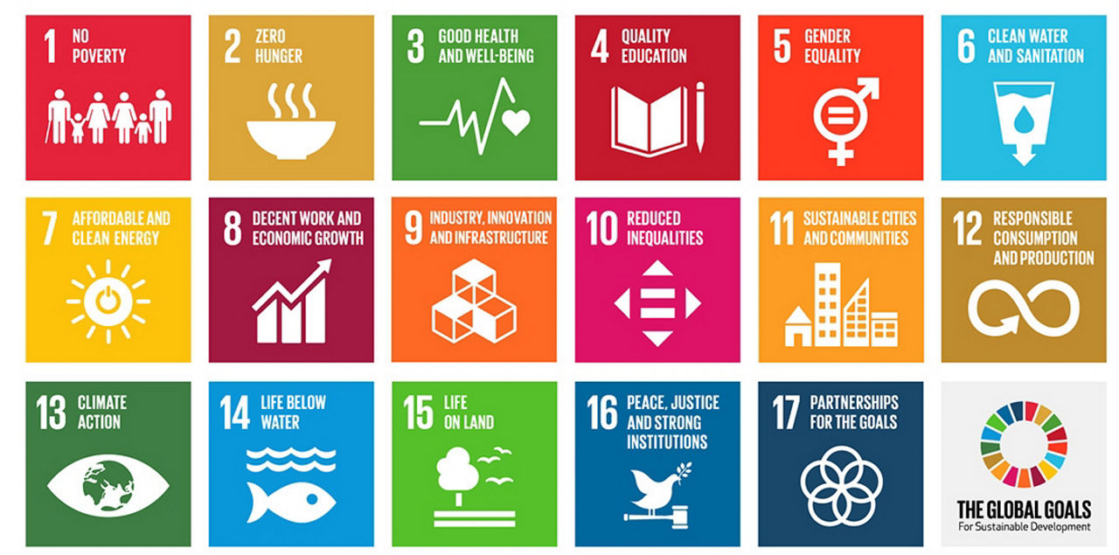

Annex 2: Example of Venn diagram
