Title: "If I Were an Avenger, I Would Be..."

Created by: Ana Cristina da Costa Nunes, Ana Sofia Fernandes Veigas, Helena Maria da Mota Lopes (Portugal)

Short description: In this activity, learners look at an Avengers movie trailer to understand how characters’ personality traits are presented in a short time span. Learners use creative writing to imagine themselves as superheroes and practise descriptive writing and character development.

Language(s) activity is designed for: English, adaptable to other languages.
Age group: 11-18
Level: B1

Learning outcomes: By the end of this lesson, students will be able to:
- Identify different personality traits
- Use creative writing to describe themselves or others
- Practise descriptive writing and character development
- Practise peer-reviewing

Skills: Writing, Vocabulary.

ICT tools used:
- Brisk (AI-powered lesson planner: https://www.briskteaching.com/)
- YouTube - Trailer of Marvel Studios' Avengers: Infinity War Official Trailer available at https://www.youtube.com/watch?v=6ZfuNTqbHE8
- Google Suite – Google Docs and Google Classroom [optional]
- Hero Forge (https://www.heroforge.com/) or Voki (https://www.voki.com/)
- Padlet (for sharing the final texts)

Duration in minutes: 30-60 minutes.

Timing: 1 lesson of 50 minutes, at any time of the school year.

Description of each stage of the activity:

- Show the students the Marvel Studios' Avengers: Infinity War Official Trailer at https://www.youtube.com/watch?v=6ZfuNTqbHE8
- Briefly discuss some key characteristics of the Avengers, such as:
- Special abilities or powers.
- Unique personalities.
- Roles within the team.
- Iconic catchphrases or actions.
- Explore vocabulary related to each character’s personality. You can use ChatGPT or CoPilot, for example, to help you with a list of adjectives, either beforehand or in class.
- Introduce the writing task by giving the prompt: “If I were an Avenger, I would be…”. Explain the writing task:
- Students will imagine themselves as a new member of the Avengers team.
- They should describe their superhero persona, including powers, personality, and role in the team.
- Encourage them to be creative and original.
- Have students take a few minutes to jot down ideas about their Avenger character. Prompt them to consider the following:
* What would their superhero name be?
* What special abilities would they have?
* What would their costume look like?
* How would they contribute to the team?
- Writing time (15 minutes): students write their "If I were an Avenger, I would be..." paragraphs on a Google Doc.
- Encourage them to use descriptive language and vivid details.
- Remind them to consider how their character would interact with other Avengers.
- As students finish their first draft, they share the document with two classmates for peer-reviewing.
- Students finish their text by incorporating their classmates’ feedback.

Homework assignment:
- Students should finish their text if not completed in class.
- They create an Avatar of their character on Hero Forge or Voki.
- Finally, students post both text and avatar on a class Padlet (to be created).
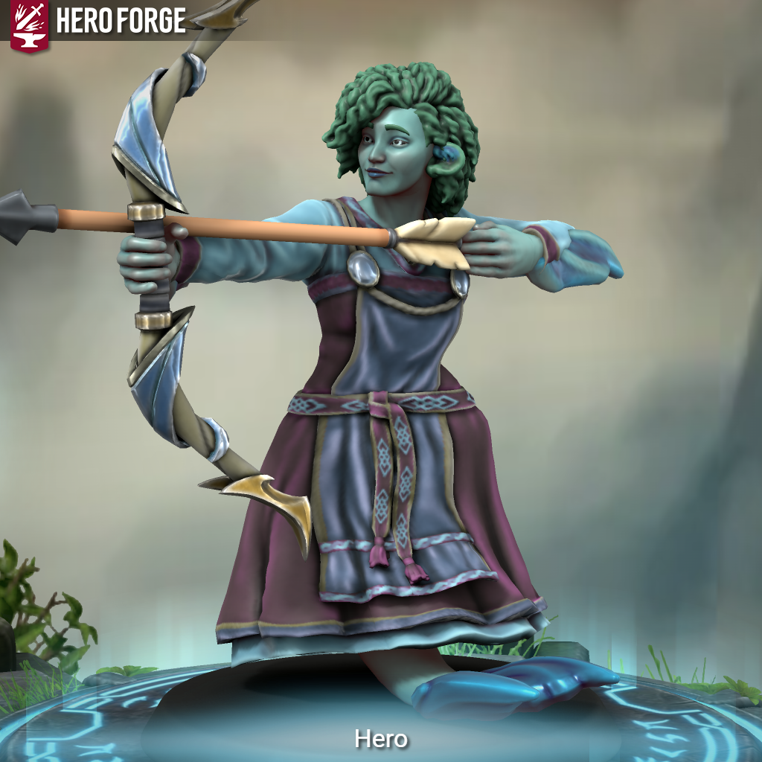
Example of an avatar created using Hero Forge: https://www.heroforge.com/

Potential challenges/problems: There might be time management issues, depending on students’ writing proficiency.

Suggestions for learner assessment/self-assessment/feedback/peer feedback: Rubrics for assessing writing (self and peer assessment) - teachers can use AI to create them.

Post-evaluation of the activity (e.g., Once you have carried it out, how will you gauge whether it has been successful? How will you get feedback from students? etc.): Observation of task completion and oral feedback from the students after the task.


Attribution: Original activity from “Use of ICT in support of language teaching and learning (ICT-REV)”, European Centre for Modern Languages of the Council of Europe. www.ecml.at/ictrev

