Title: Learning about Ukrainian culture and history through AI translation

Created by: Sandra Hadzihalilovic, Kateryna Kharytych (Germany)

Short description: This activity is about getting to know Ukrainian culture and history through different AI language translation. Learners will evaluate the quality of texts translated by AI in their languages, editing them based on speech style, stress and intonation patterns of a particular language.

Languages activity is designed for: all

Age group:
- 0-5
- 6-10
- 11-18
- 19-25
- 26-64
- 65+

Level:
- A1
- A2
- B1
- B2
- C1
- Teacher trainees

Learning outcomes:
- Learn more about Ukrainian culture and history;
- Understand the basics of AI translation;
- Evaluate AI translations, identify mistakes, and provide explanations for different translation options.

Skills:
- Listening
- Speaking
- Reading
- Writing
- Interaction
- Vocabulary
- Grammar
- Mediation
- Pronunciation
- Intercultural
- Plurilingual

ICT tools used: ElevenLabs, DeepL, Flinga.

Duration in minutes:
- 15-30
- 30-60
- 60-90
- 90-120
- 120+

Will students be marked for this activity? Yes

Timing: 1 lesson at the start of the academic year (or at the end).

Description of each stage of the activity:
- Learners read or listen (the teacher reads it out loud, or is converted into an audio through a text-to-speech tool such as ElevenLabs) the text in either Ukrainian or German [for the original texts, see Annex 1 and 2]
- Afterwards they translate it into their mother language with the help of DeepL.
- Then they evaluate the quality of the AI translation.
- They correct/revise it, using the help of DeepL, and more concretely by looking at the different translation options it offers. In doing so, they detect and reflect upon translation inaccuracies.
- Then, they introduce the revised translation into ElevenLabs to transform speech into audio.
- They evaluate ElevenLabs’ text-to-speech conversion for inconsistencies and deviation from the norm, particularly regarding pronunciation.
- After editing both the written translation and the text-to-speech conversion in their translation language, they share it with the other groups.
- They critically discuss the two processes, arguing for their translation options and pointing out ElevenLabs text-to-speech conversion’s mistakes.
- They receive feedback and produce the final translation version accordingly.

Potential challenges/problems:
- Learners may not be able to give their opinion if they are not familiarized with Ukrainian culture or the culture the text is about in case the learning activity is adapted to another case.
- If they are not familiar with the original text language, they might not recognize the problem in AI translation, pronunciation, etc.
- If they are not familiar with AI, they might not be able to evaluate it right.

Post-evaluation of the activity:
- Create a short post-activity survey about the learning activity outcomes (https://flinga.fi/s/FYVRX2E) and give them results about their editing work
- Let them find similar texts about other countries.


Attribution: Original activity from “Use of ICT in support of language teaching and learning (ICT-REV)”, European Centre for Modern Languages of the Council of Europe. www.ecml.at/ictrev
Annex 1: Original Text in Ukrainian
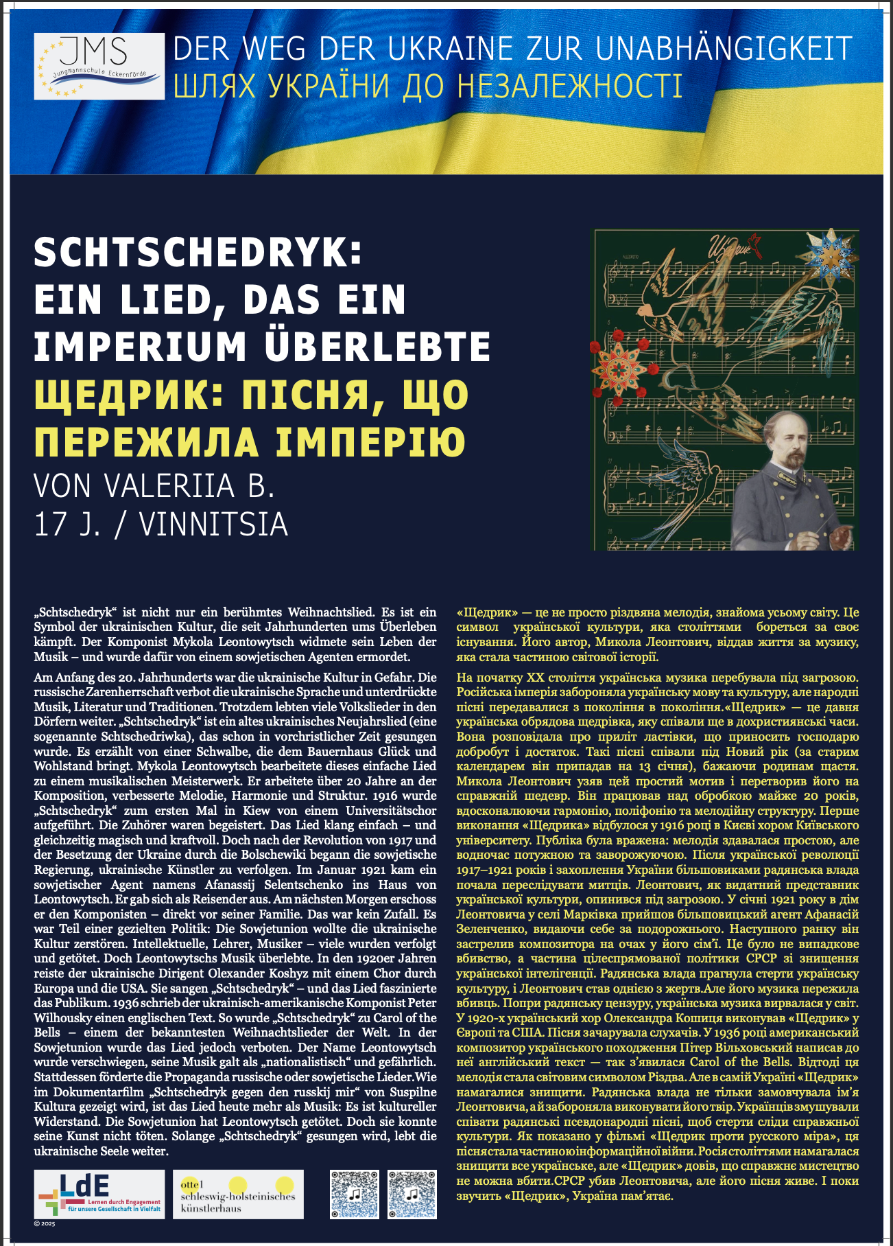

Annex 2: Original Text in German
